SUBCOURSE EDITION
IT0566 B

US ARMY INTELLIGENCE CENTER

PREPARE ANALYSIS OF THE

BATTLEFIELD AREA

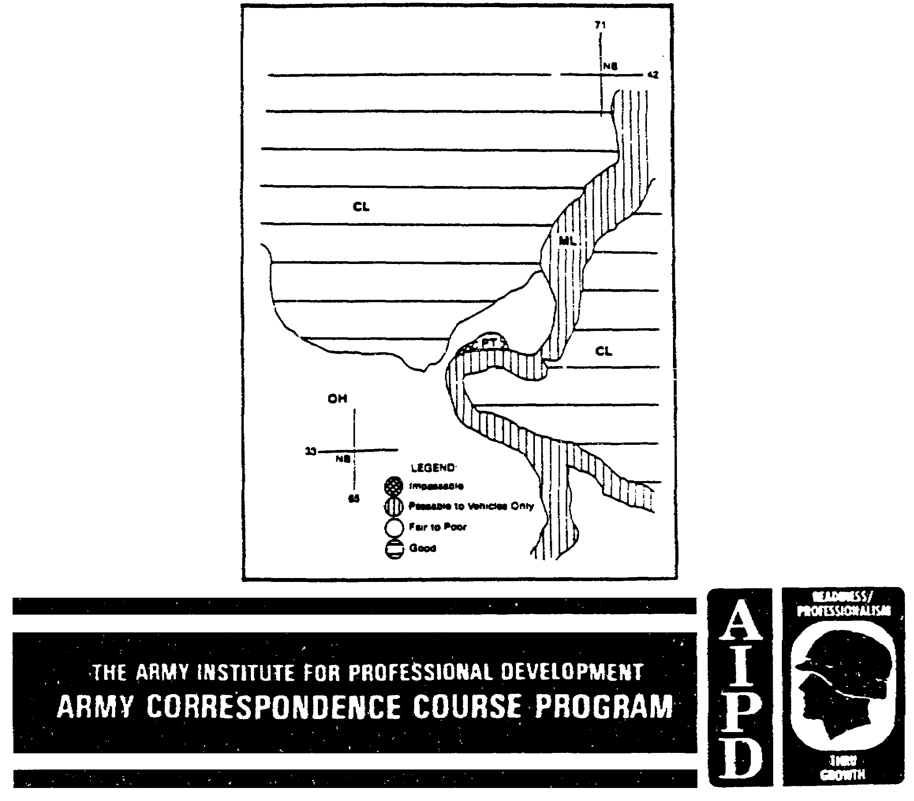
ANALYSIS OF THE BATTLEFIELD AREA

Subcourse Number IT 0566

EDITION B

US Army Intelligence Center
Fort Huachuca, AZ 85613-6000

8 Credit Hours

Edition Date: September 1998

SUBCOURSE OVERVIEW

This subcourse is designed to teach you the fundamentals in preparing the analysis of the battlefield area. Contained within this subcourse are instructions on how to prepare the analysis of the battlefield area. Furthermore, it includes the format for the analysis, purpose and limiting considerations, general description, military aspects, and effects of the characteristics of the area.

There are no prerequisites for this subcourse.

This subcourse reflects the doctrine which was current at the time the subcourse was prepared.

Unless otherwise states, the masculine gender of singular pronouns is used to refer to both men and women.

TERMINAL LEARNING OBJECTIVE:

ACTION: You will be able to prepare a written analysis of the battlefield area.

CONDITION: You will have access to extracts from FM 34-3, FM 34-130, and FM 101-5.

i IT0566
TABLE OF CONTENTS

Section Page

Subcourse Overview i

Lesson 1: Analysis of the Battlefield Area in General 1-1
Part A: The Battlefield Area 1-2
Part B: The Intelligence and Electronic Warfare Mission 1-3
Part C: Friendly Courses of Action 1-4
Part D: Format for the Analysis of the Battlefield Area 1-5
Practice Exercise 1-9
Answer Key and Feedback 1-12

Lesson 2: Heading, Purpose and Limiting Considerations, and General Description
Of the Area 2-1
Part A: Heading Data 2-2
Part B: Purpose and Limiting Considerations 2-5
Part C: General Description of the Area 2-6
Practice Exercise 2-20
Answer Key and Feedback 2-22

Lesson 3: Military Aspects of the Area 3-1
Part A: Definitions and Description of Paragraph 3 3-1
Part B: Application of Paragraph 3 3-12
Practice Exercise 3-27
Answer Key and Feedback 3-32

Lesson 4: Effects of Characteristics of the Area and Analysis Ending Data 4-1
Part A: Effects of Characteristics of the Area 4-1
Part B: Analysis Ending Data 4-15
Practice Exercise 4-17
Answer Key and Feedback 4-18

Appendix A: Acronyms A-1

Appendix B: Acronyms and Abbreviations B-1

IT0566 ii
LESSON 1

ANALYSIS OF THE BATTLEFIELD AREA IN GENERAL

CRITICAL TASKS: 301-336-1100
301-372-2050
301-372-3050

LESSON DESCRIPTION:

In this lesson you will learn to describe the analysis of the battlefield area in general, and its format.

TERMINAL LEARNING OBJECTIVE:

TASK: Describe the analysis of the battlefield area in general and the format used.

CONDITION: You will be given access to extracts from FM 34-3, FM 34-130, and FM 101-5.

STANDARD: Description of the analysis of the battlefield area in general and its format will be in accordance with FM 34-3, FM 34-130, and FM 101-5.

REFERENCES: The material contained in this lesson was derived from the following publications:

FM 34-3.
FM 34-130.
FM 101-5.

INTRODUCTION

Battlefield areas are important to the intelligence analyst because they contain the enemy forces, weather, and terrain about which the commander needs intelligence to make sound tactical decisions. The analysis of the battlefield area is a study to determine the effects of the battlefield areas on the general courses of action that the enemy and friendly forces may adopt. The G2 has primary staff responsibility for initiating, coordinating, and ensuring completion of the analysis.

1-1 IT0566
PART A: THE BATTLEFIELD AREA

1. Commanders consider the battlefield area in terms of the time and space necessary to defeat an enemy force or complete an operation before the enemy can reinforce. They view the battlefield as having two distinct areas (Figure 1-1):

- Area of Operations (AO).

- Area of Interest (Al).

a. The AO is that portion of an area of conflict necessary for military operations. The AO is assigned by the next higher commander and designated by lateral and rear boundaries. It carries with it the authority and responsibility to conduct operations therein. The commander must coordinate with adjacent commanders before conducting maneuver and fire support (FS) activities outside the designated AO.

b. The Al is that area of concern to the commander which includes the AO and areas adjacent thereto. It includes areas forward of, and to the flanks and rear of the AO. It encompasses areas either occupied by enemy forces that could jeopardize friendly mission accomplishment and/or which includes the objectives of friendly current or planned operations.

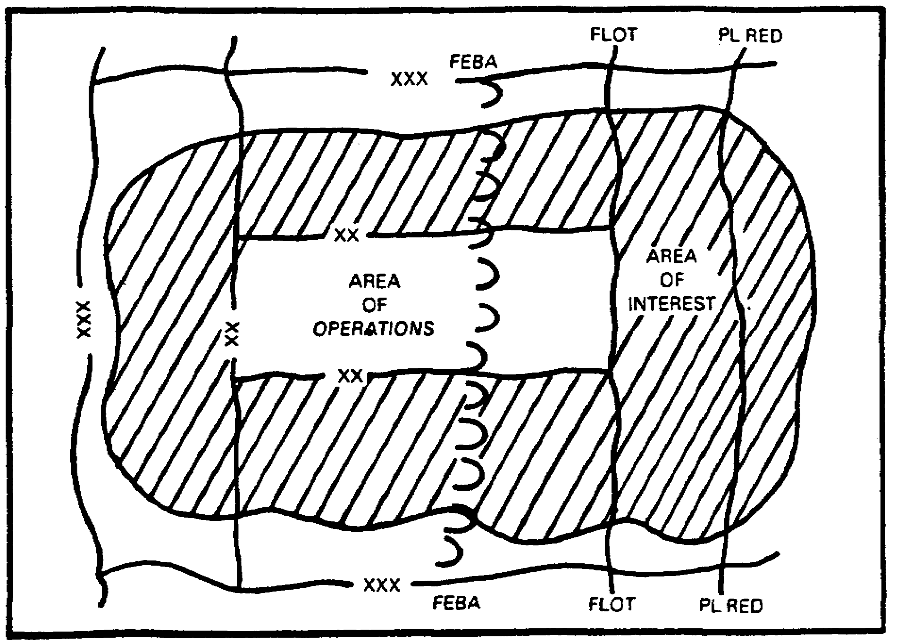

Figure 1-1. Battlefield areas.

IT0566 1-2
2. Each commander determines the unit's own Al. The commander generally relies on higher headquarters and adjacent units to provide information and intelligence about enemy forces in that area.

3. Battlefield areas are important to the intelligence analyst because they help focus the information requirements of commanders concerning the weather, terrain, and enemy forces from battalion to echelons above corps (EAC). Specific information requirements are dependent on the mission and the tactical situation. Usually, in conventional operations, information requirements (IR) on enemy forces are based on the one-up and two-down formula. Commanders require detailed information about enemy forces at their equivalent levels of command as well as one level above and two levels below their own. For example, brigade commanders need information about enemy regiments (equivalent level), enemy divisions (one-up), and enemy battalions (one down) and companies (two-down). Generally, the enemy forces of concern to each commander are found within the command's AO and Al.

PART B: THE INTELLIGENCE AND ELECTRONIC WARFARE MISSION

1. The intelligence and electronic warfare (IEW) mission includes four major tasks:

- Situation development.
- Target development.
- Electronic warfare (EW).
- Counterintelligence (CI).

2. Situation development provides commanders with the intelligence they need to make sound tactical decisions. It is a continuing estimate of the situation that projects enemy intentions and the effect of the weather and terrain. Situation development helps commanders—

a. Find and follow enemy forces.

b. Determine enemy capabilities, vulnerabilities, and intentions.

c. Identify the enemy main effort.

d. Determine how the weather and terrain will affect friendly and enemy operations.

e. Detect opportunities to exploit enemy weaknesses and seize or retain the initiative.

f. Assess the relative value of enemy combat systems, which serves as a basis for selecting high value targets (HVTs).

3. Target development provides combat information, targeting data, and correlated target information which support the commander's tactical plans. It focuses on high payoff targets (HPTs) which have been selected, through the targeting efforts of the G2 or S2, the G3 or S3, and the fire support element (FSE), and approved by the commander. Target development identifies, locates, and tracks HPTs until they are neutralized. Target development operations must provide sufficiently accurate targeting data to attack by fire, maneuver, or electronic means.

1-3 IT0566
NOTE: Situation and target development provide the intelligence required to fight the operation. Both are distinct tasks, but are interrelated and totally integrated to provide an accurate picture of the battlefield.

4. Electronic warfare (EW) exploits, disrupts, and deceives the enemy command and control (C²) system while protecting friendly use of communications and noncommunications systems. It is a significant force multiplier when integrated and employed with fire and maneuver. EW consists of the following functions:

a. EW support (ES), which provide commanders the capability to intercept, identify, and locate enemy emitters.

b. Electronic attack (EA), which provide commanders the capability to disrupt enemy use of the electromagnetic spectrum.

c. Electronic protection (EP), which is used to protect friendly command, control, and communications (C³) systems against enemy radioelectronic combat (REC) activities.

5. Counterintelligence (CI) includes specific actions which support the protection of the friendly force. Enemy commanders, to succeed against friendly forces, must employ all-source analysis systems to collect information about friendly forces. Depriving enemy commanders of vital information about friendly forces is crucial to friendly success on the battlefield. CI enhances the operations security (OPSEC) of the command by supporting the following actions:

a. Countering the hostile intelligence threat.

b. Safeguarding the command from surprise.

c. Deceiving the enemy commander.

d. Countering enemy sabotage, subversion, and terrorism.

e. Developing essential elements of friendly information (EEFI).

PART C: FRIENDLY COURSES OF ACTION

1. The intelligence analyst bases the analysis of the battlefield area on the commander's mission statement. When the prehostility intelligence preparation of the battlefield (IPB) analysis nears completion, the G2 uses all available data and analysis to determine the effects of the characteristics of the battlefield area on both friendly and anticipated enemy capabilities and courses of action.

2. Written and oral analysis. An analysis of the battlefield area is prepared at all echelons. A written analysis is normally completed only at corps and EAC to support projected operations. At division, a written analysis may be prepared for projected operations, such as airborne operations. Most division operations, however, will use the corps analysis of the battlefield area supplemented by IPB information pertinent to the division. Also, at division and below, an abbreviated analysis can be given orally.

IT0566 1-4
3. Documentation. The size of the analysis of the battlefield area increases as the location of military operations changes from a built-up area to a more remote area on which little or no documentation is available.

4. Frequency of preparation. An analysis of the battlefield area is required for each mission. It may involve the preparation of an entirely new analysis or the updating of an existing one. It is started well in advance of hostilities and it is based on the intelligence officer's anticipation of future operations. Upon receipt of an actual mission, the analysis must be reevaluated. It must be prepared and sent out early to all subordinate units to apply the information in their areas of responsibility.

5. Sources of information. An analysis of the battlefield area relies on different sources of information for the data used in the study. They include:

a. Analysis performed by higher or other headquarters for the same area.

b. G3 missions and courses of action.

c. G5 information on sociology, government, economics, and psychology.

d. Engineer terrain studies.

e. Staff weather officer (SWO) operational weather forecasts and climatic data, to include light data.

f. Provost marshal (PM) analysis of route reconnaissance and information on our rear area activities.

g. Fire support coordinator (FSCOORD) enemy fire support capability data.

h. Unconventional warfare (UW) section (normally found in the J2 at joint task force level) information from areas not under control of friendly forces.

i. Maps, imagery, technical reports, and aerial and ground reconnaissance reports.

j. National intelligence surveys.

k. Locally produced studies and periodicals.

PART D: FORMAT FOR THE ANALYSIS OF THE BATTLEFIELD AREA

Figure 1-2 shows an analysis of the battlefield area report format. It consists of heading information, four main paragraphs, and ending data. The separate elements of the four main paragraphs are described in detail in the remainder of this subcourse.

NOTE: Format for paragraphs and subparagraphs is standard; however, items under sub-subparagraphs can differ.

1-5 IT0566
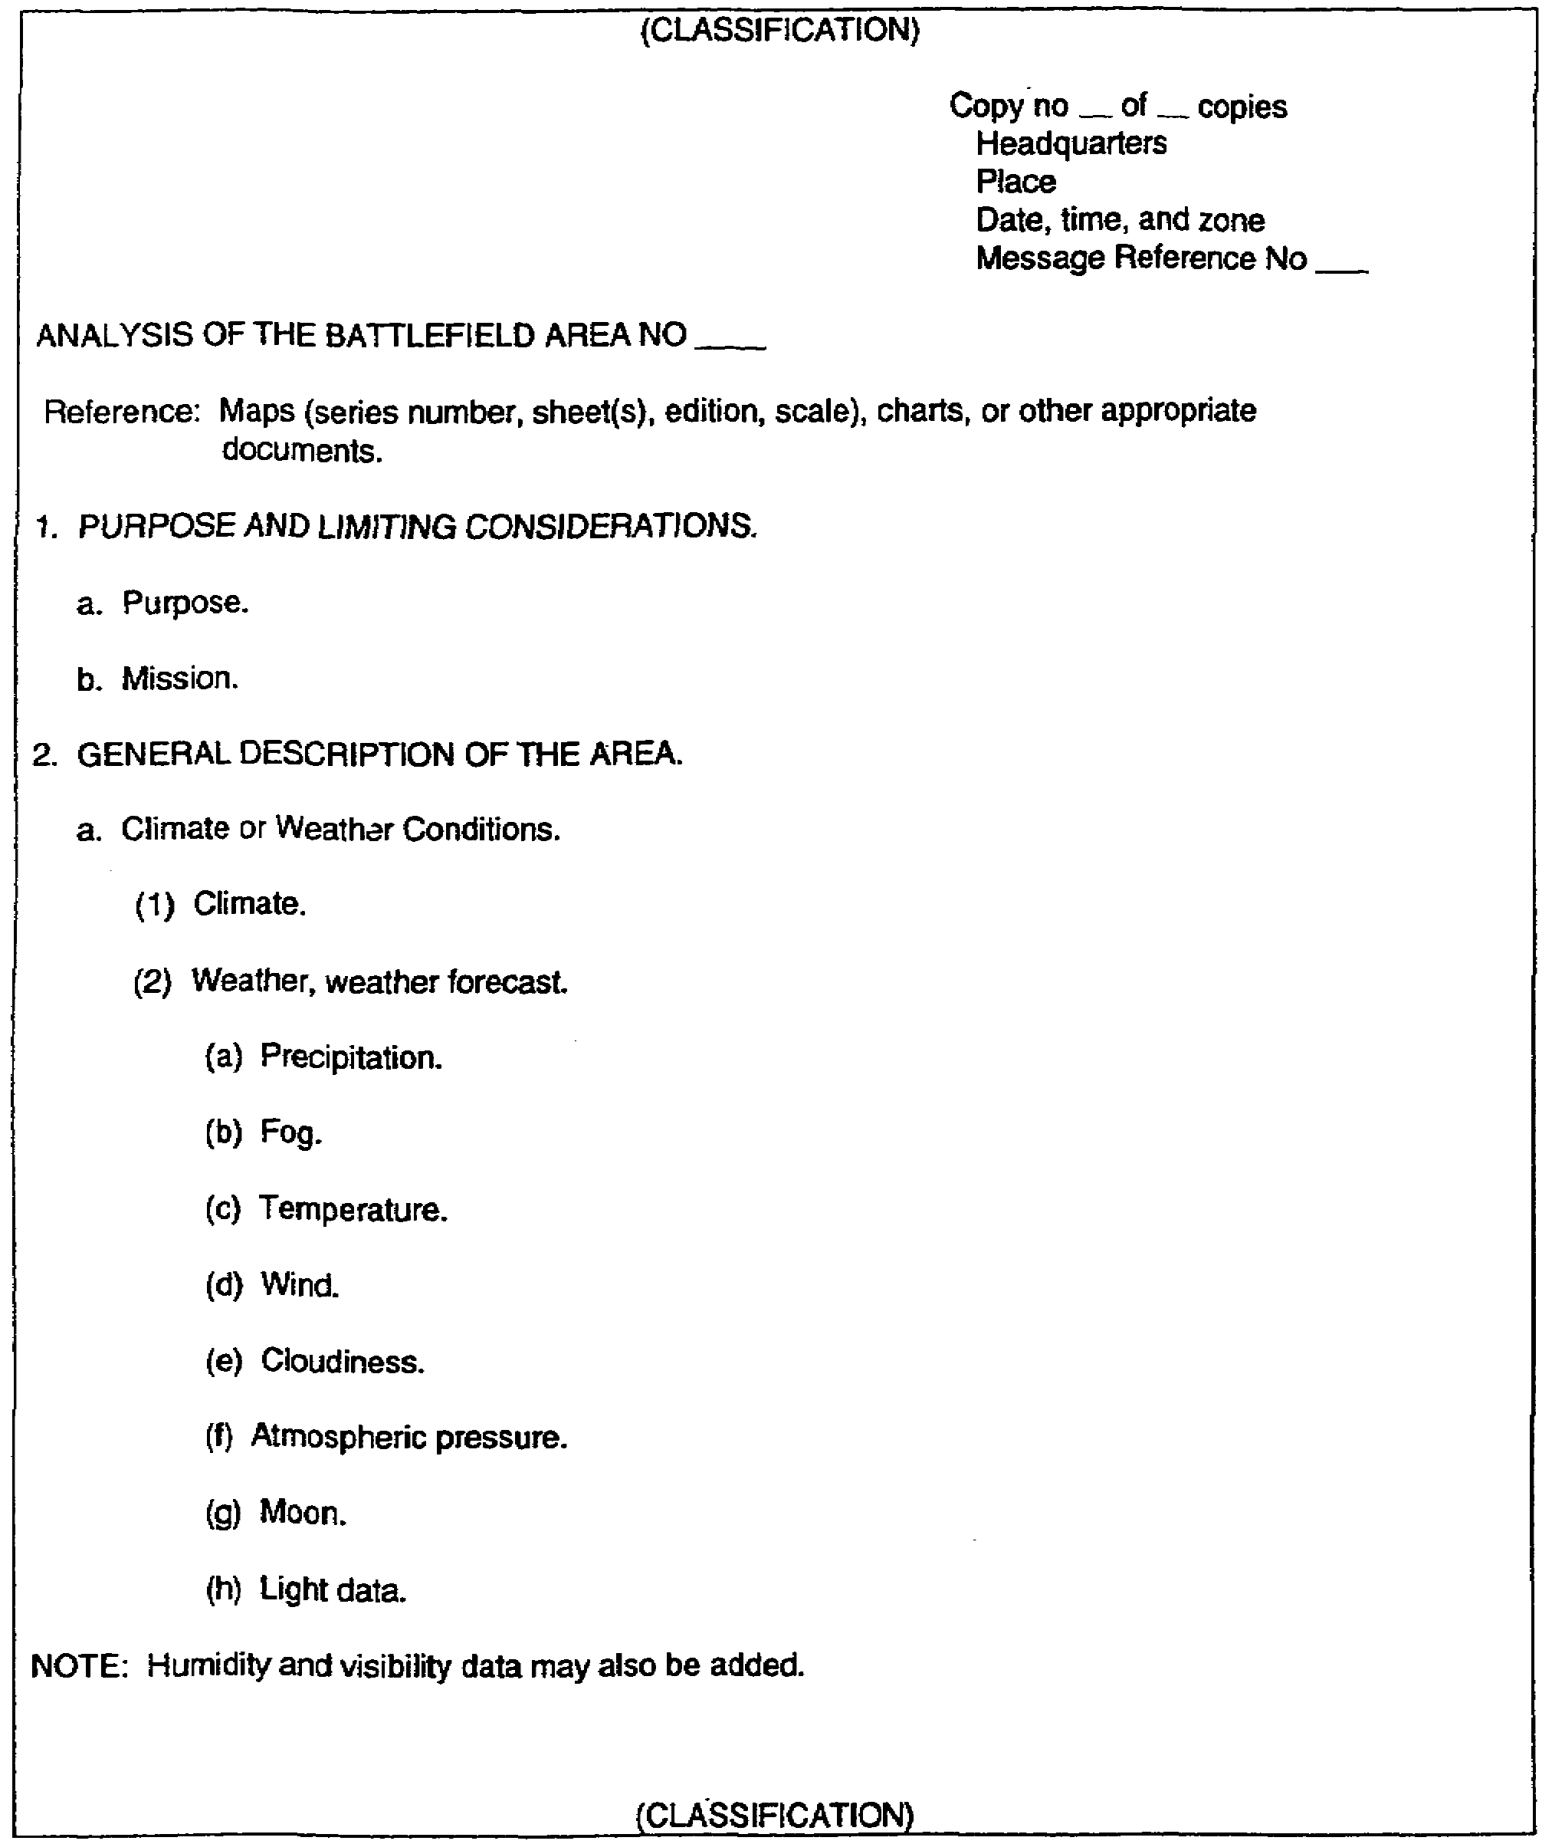

Figure 1-2. Format for the analysis of the battlefield area.

IT0566 1-6
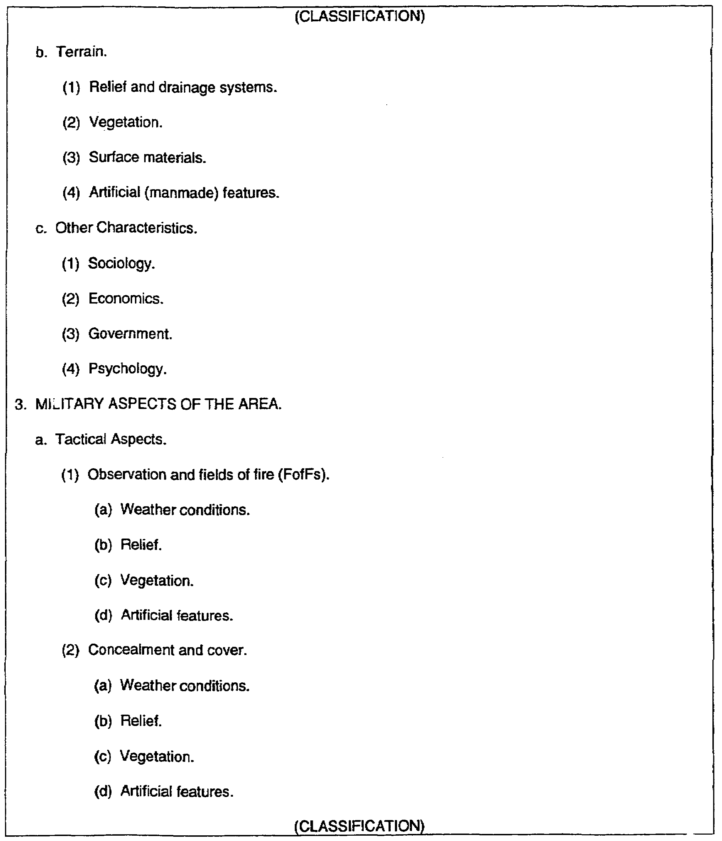

Figure 1-2. Format for the analysis of the battlefield area (continued).

1-7 IT0566
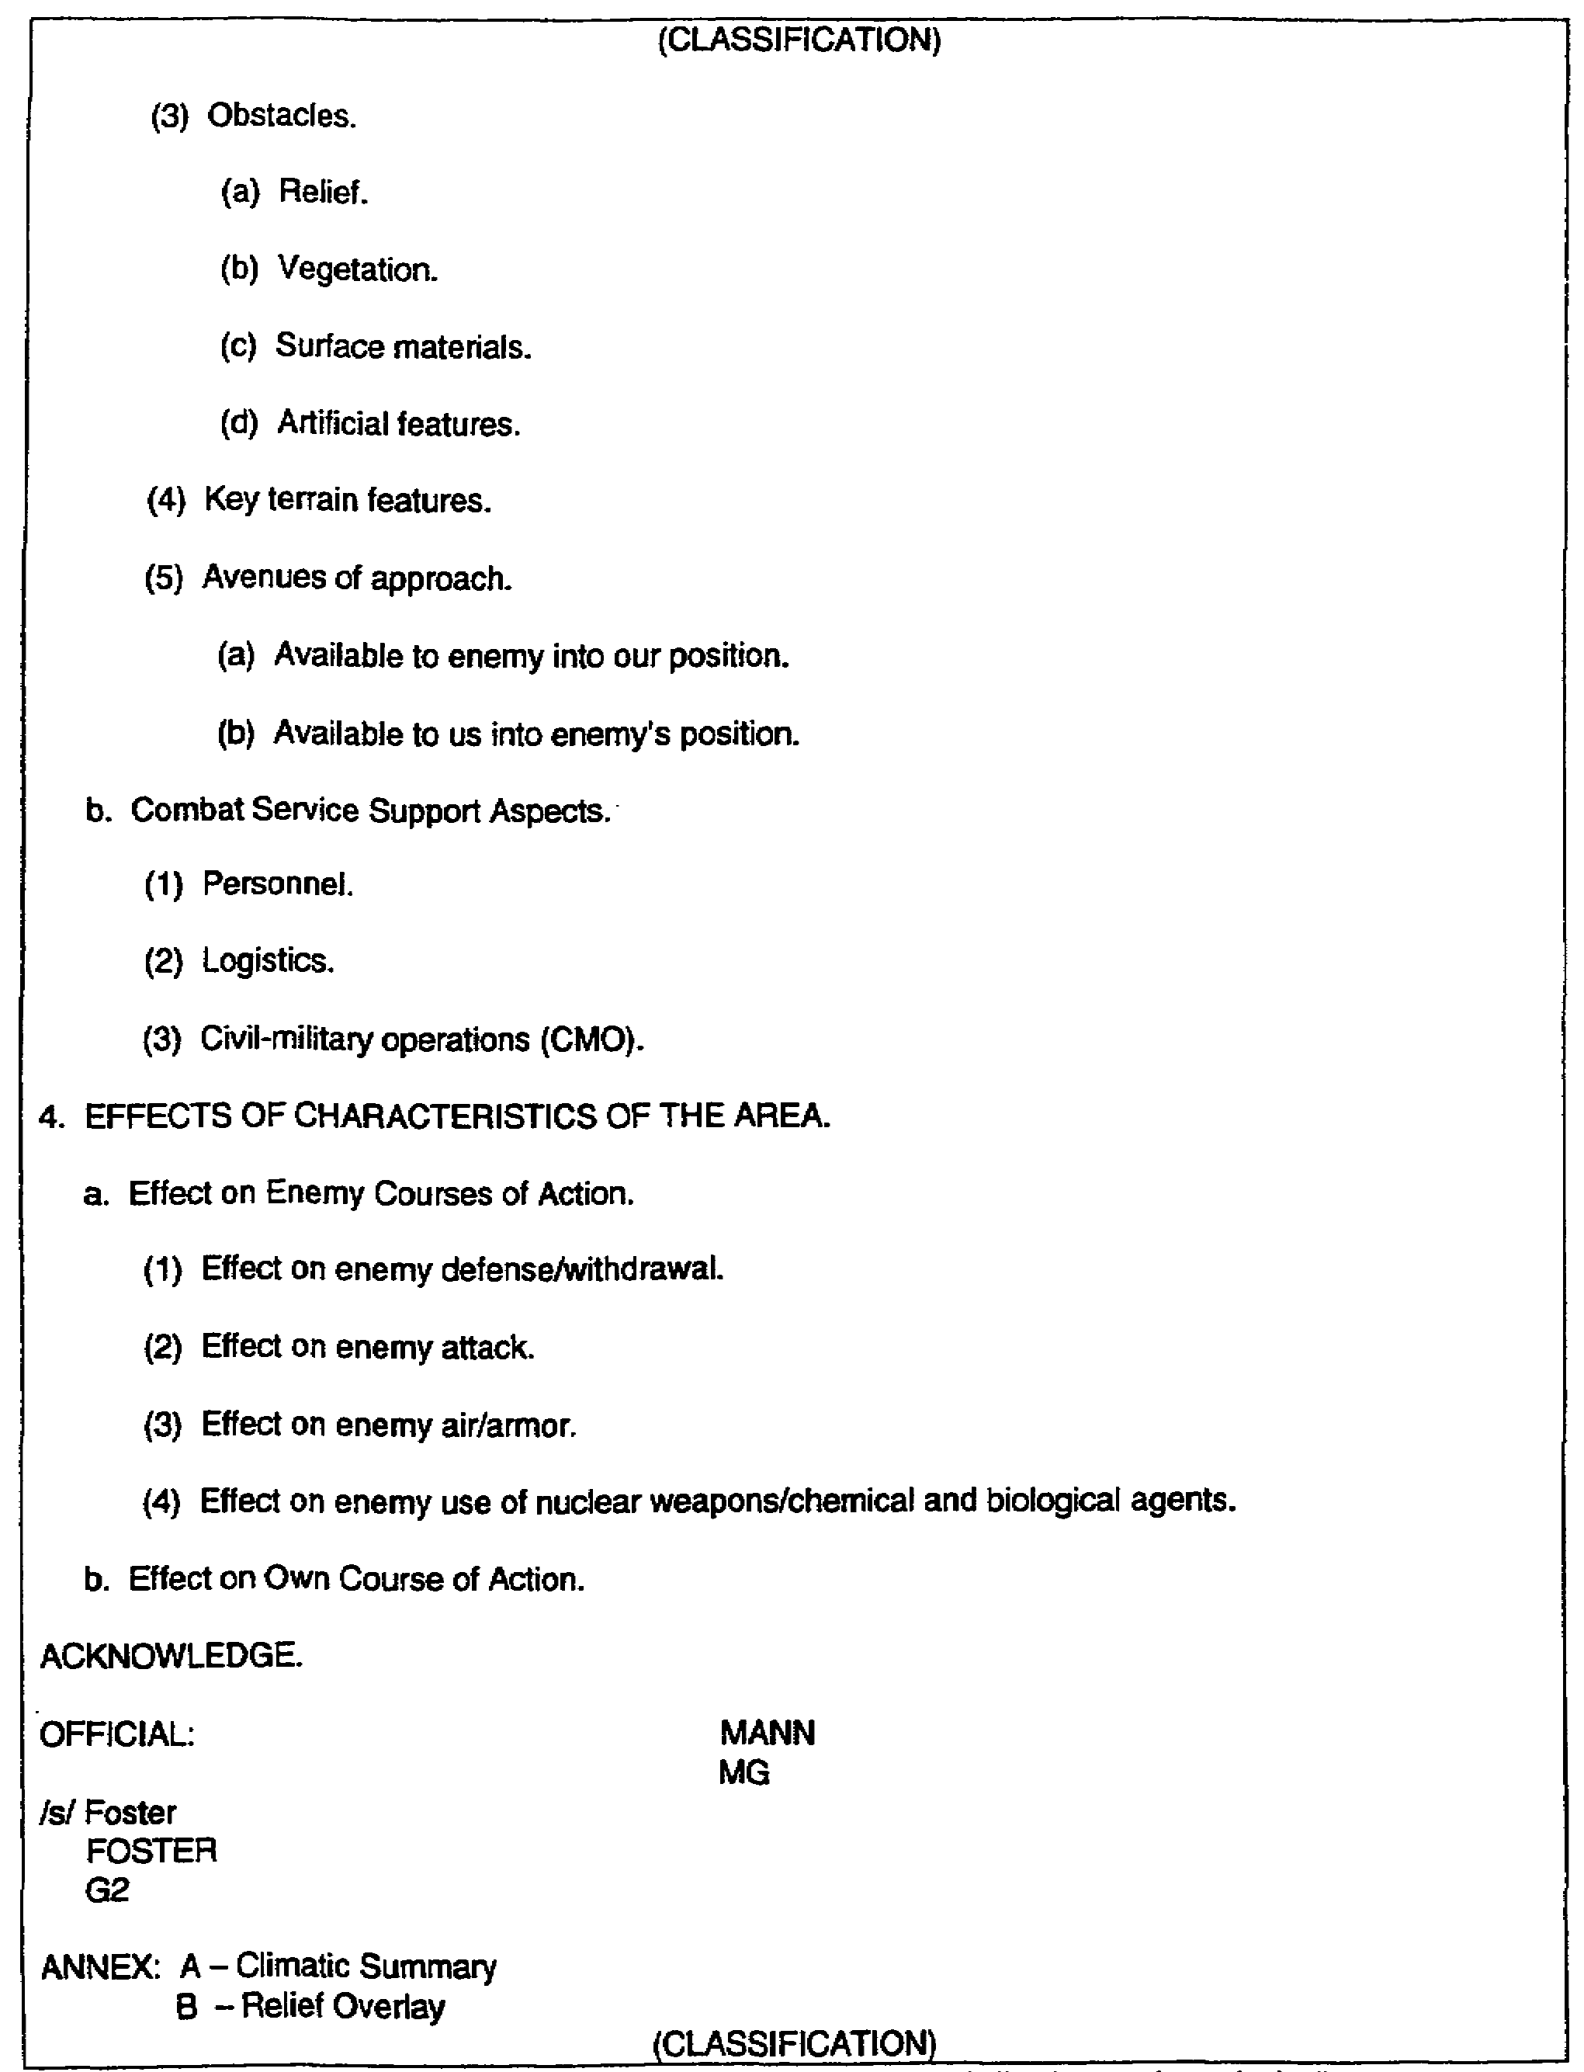

Figure 1-2. Format for the analysis of the battlefield area (concluded).

IT0566 1-8
LESSON 1

PRACTICE EXERCISE

The following items will test your grasp of the material covered in this lesson. There is only one correct answer for each item. When you have completed the exercise, check your answers with the answer key that follows. If you answer any item incorrectly, study again that part of the lesson which contains the portion involved.

1. Which formula should you use in conventional operations for information requirements on enemy forces?

A. One unit up and one unit down.

B. One unit up and two units down.

C. Two units up and one unit down.

D. Two units up and two units down.

2. When should the analysis of the battlefield area be in written format?

A. When you are preparing it for battalion.

B. When you are preparing it for brigade.

C. When you are preparing it for division.

D. When you are preparing it for corps.

3. When should you prepare an analysis for the battlefield area?

A. For each mission.

B. For each tactical aspect.

C. For limiting considerations.

D. To highlight characteristics.

1-9 IT0566
4. What action should you take once the actual mission is received by the G2 section, and an assumed analysis was previously accomplished?

A. Evaluate the request.

B. Reevaluate the analysis.

C. Disregard.

D. Write a new analysis.

5. Which information should you report in paragraph 3a(2)(d) of the analysis of the battlefield area?

A. Weather conditions.

B. Relief.

C. Vegetation.

D. Artificial features.

IT0566 1-10
LESSON 1

PRACTICE EXERCISE

ANSWER KEY AND FEEDBACK

Item Correct Answer and Feedback

1. B. You should use the one-up and two-down formula in conventional operations for information requirements on enemy forces (page 1-3, para 3, Part A).

2. D. The analysis of the battlefield should be in written format when you are preparing it for corps and EAC (page 1-4, para 2, Part C).

3. A. You should prepare an analysis of the battlefield area for each mission (page 1-5, para 4, Part C).

4. B. You should reevaluate the analysis once the actual mission is received by the G2 section and an assumed analysis was previously prepared (page 1-5, para 4, Part C).

5. D. You should report artificial features in para 3.a. (2)(d) of the analysis of the battlefield area (page 1-.7, para 3, fig 1-2).

IT0566 1-12
LESSON 2

HEADING, PURPOSE AND LIMITING CONSIDERATIONS,
AND GENERAL DESCRIPTION OF THE AREA

CRITICAL TASKS: 301-336-1100
301-372-2050
301-372-3050

OVERVIEW

LESSON DESCRIPTION:

In this lesson you will learn to prepare the heading and paragraphs 1 (purpose and limiting considerations) and 2 (general description of the area) of the analysis of the battlefield area.

TERMINAL LEARNING OBJECTIVE:

TASK: Prepare the heading and paragraphs 1 and 2 of the analysis of the battlefield area.

CONDITION: You will be given access to extracts from FM 34-3, FM 34-130, and FM 101-5.

STANDARD: Heading and paragraphs 1 and 2 of the analysis of the battlefield area will be in accordance with FM 34-3, FM 34-130, and FM 101-5.

REFERENCES: The material contained in this lesson was derived from the following publications:

FM 34-3.
FM 34-130.
FM 101-5.

INTRODUCTION

You should prepare the analysis of the battlefield area by first describing the heading, followed by paragraph 1, purpose and limiting considerations, and paragraph 2, general description of the area. These items are addressed in this lesson. The remaining two paragraphs are discussed in lessons 3 and 4.

2-1 IT0566
PART A: HEADING DATA

1. The heading includes the following items (Figure 2-1):

- Classification.

- Copy number.

- Preparing unit.

- Official location.

- Date-time group (DTG).

- Message reference number.

- Title line.

- Reference line.

- Time zone indication.

2. Classification.

a. The overall classification of your analysis of the battlefield area must be the highest classification of the information contained therein. For example, you are preparing an analysis at division and using a corps analysis containing an overall classification of SECRET. If the information you are extracting is classified CONFIDENTIAL and no other information contained within your analysis is classified higher, the overall classification of your analysis would be CONFIDENTIAL.

b. The overall classification must be conspicuously marked or stamped at the top and bottom of both the front and back pages in larger than any other lettering.

c. All other pages must also be marked or stamped, top and bottom, with the highest classification of information appearing thereon, to include the designation "UNCLASSIFIED, when appropriate.

d. The three security classification to be used are:

- TOP SECRET.

- SECRET.

- CONFIDENTIAL.

3. Copy number. Enter the copy no of copies assigned by the issuing headquarters. Copy number is used for control purposes. The original copy of the analysis (copy number 1) is normally retained and filed in the G2/S2 section.

IT0566 2-2
4. Preparing unit. Enter the official designation of the office and unit preparing the analysis. For example, if you are assigned to the G2 section, 52d Infantry Division (Mechanized) and preparing the analysis, this entry would be: G2, 52d Inf Div (Mech).

5. Place of issue. Enter the actual location of the preparing headquarters to include the coordinates, state, or country. For example, although your division headquarters may be located in BAD HERSFELD, GERMANY, the 52d Division (your unit of assignment) is located at GERTERODE. Your entry would, therefore, be: GERTERODE (NB4843), GERMANY.

6. DTG. Enter the Date-Time Group including time zone designator. DTG is the time the analysis is signed by your G2 or commander and the effective time of the intelligence estimate

a. The DTG consists of:

- The day, for example, “31."

- The time, for example, "1100.

- The time zone suffix, for example, "T."

- The month, for example, "August."

- The year, for example, “1998.”

NOTE: The time zone suffix will depend on your location. The suffix for your location has been predetermined and is included in your unit standing operating procedure (SOP).

b. For example, the above DTG is written as 311100T Aug 1998.

7. Message reference number.

a. This number is used when the analysis is distributed outside the headquarters for the purpose of acknowledgement in the clear. In the tactical situation, it is highly probable the enemy will be monitoring your radio communication. It may even know the purposes of the intelligence products being disseminated from unit to unit. To avoid a security violation, it is essential intelligence products discussed over nonsecure communication lines not be referred to by name. Rather, a message reference number, consisting of a combination of letters and numbers and which in no way refers to the intelligence product, is used.

b. All appended material to the analysis having the same distribution bears the same reference number.

c. The message reference number may be provided by the communications-electronics (C-E) officer, the G2/S2, or by consulting your local unit SOP.

d. For example: BZ49.

8. Title line. The title line identifies the analysis by number consecutive throughout the calendar year. Enter the title line below the heading data block at the left margin.

2-3 IT0566
NOTE: To avoid a security violation, do NOT use this number when acknowledging or discussing the analysis over nonsecure communications. The message reference number should be used in lieu of the estimated number.

9. Reference line. In order to understand the analysis, the recipient/user must obtain the same map sheets used by the originator.

a. The reference will list maps, charts, or other documents required to understand the analysis. References to maps include:

- Map series number, edition (if required).

- Country or geographic area (if required).

- Map sheet number.

- Map sheet name (if required).

- Edition.

- Scale.

b. For example, map series M745, Bad Hersfeld, sheet L5124, edition 2, 1: 50,000.

10. Time zone suffix designator. Pertinent time zone suffix designator should be shown, for example, time zone used throughout the analysis: ALPHA.

NOTE: Time zone suffix designation can be added to the reference line or appear separately under the reference line.

IT0566 2-4
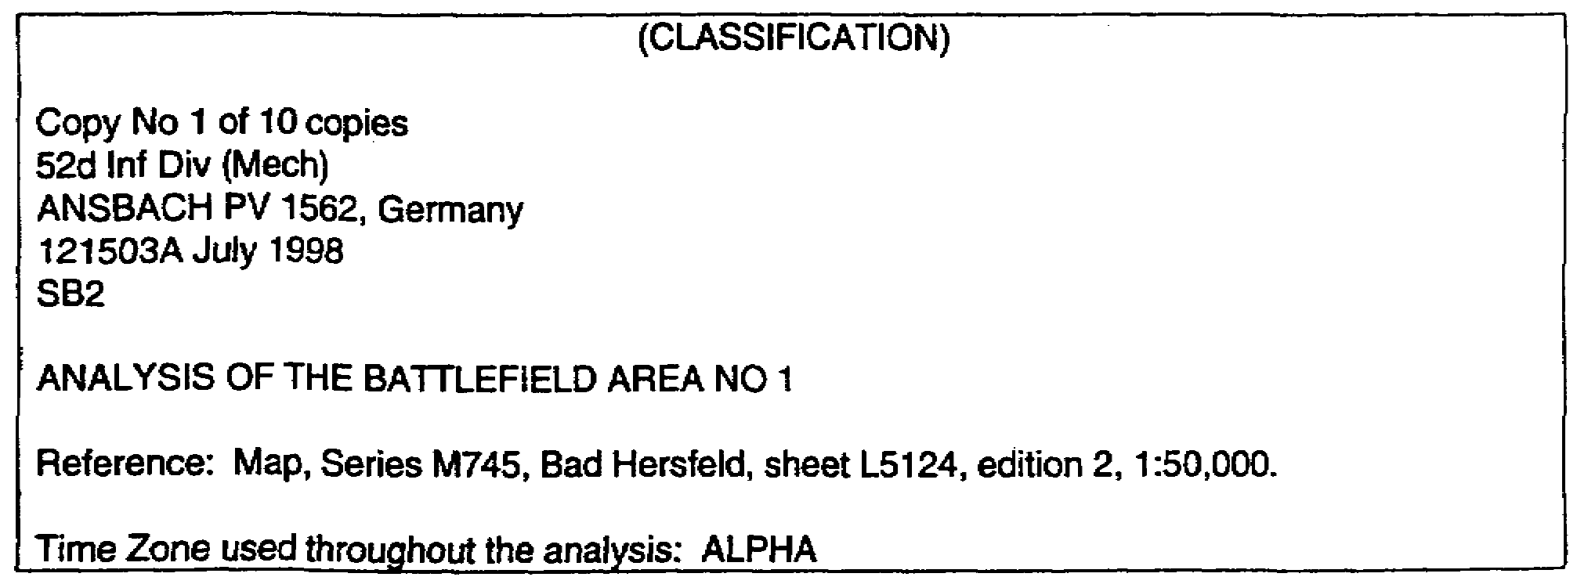

Figure 2-1. Heading example.

PART B: PURPOSE AND LIMITING CONSIDERATIONS
1. Paragraph 1 of the analysis of the battlefield area is entitled "Purpose and Limiting Considerations."

2. Paragraph 1a is entitled "Purpose." It should contain a statement on the purpose of the analysis and a description of the exact limits of the area to be studied, which is focused upon the mission (stated in subparagraph 1b)(Figure 2-2).

3. Paragraph 1b is entitled "Mission." It should contain a statement about the unit mission and list any considerations that limit the application of the study. Limitations may include time constraints, the commander's plan of action, and the enemy's capabilities (Figure 2-2).

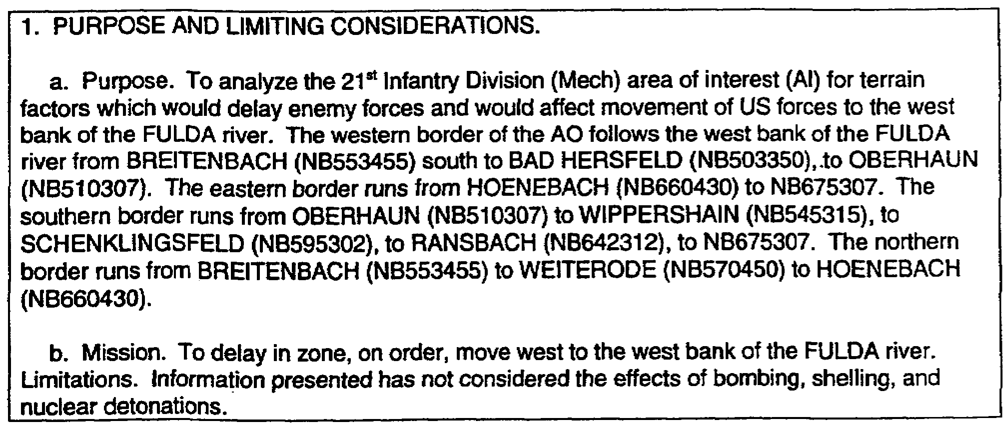

Figure 2-2. Example of paragraph 1-purpose and limiting considerations.

2-5 IT0566
PART C: GENERAL DESCRIPTION OF THE AREA

1. Paragraph 2 of the analysis of the battlefield area is entitled 'General Description of the Area." It contains a list of the facts pertinent to the purpose and limiting considerations of the study for use as a basis for succeeding paragraphs.

2. Paragraph 2a is entitled 'Climate or Weather Conditions" and contains information on meteorological conditions.

a. Paragraph 2a (1) covers the climate. This entry is usually attached to the study as an annex and in the form of a climatic summary or climatic study. It includes long-term weather data stated in the form of averages, extremes, and frequency of occurrences for a specified period of time and geographic area.

b. Paragraph 2a(2) covers weather conditions including:

- Precipitation.

- Fog.

- Temperature.

- Relative humidity.

- Cloud conditions.

- Visibility.

- Atmospheric pressure.

- Wind.

- Light data to include moon data, moonrise, and moonset.

- Magnetic phenomena (when appropriate).

NOTE: Paragraph 2a(2) lists data to be considered by aviation units. It is used in calculating aircraft performance and altimeter setting. Light data are always given, as they are necessary for the selection of courses of action. The BMNT and the EENT are the beginning and end, respectively, of enough light for limited visibility. The BMCT and the EECT are the beginning and end, respectively, of adequate light for large scale operations.

IT0566 2-6
c. Weather information will normally be received from the staff weather officer (SWO) of the Air Force weather service detachment that supports units of division size and larger. Current weather data can also be obtained from the forward area limited (weather) observation program (FALOP) prepared by the maneuver battalion or brigade S2, the artillery meteorological section of division artillery, and the aviation unit in support of the division. The following is an example of a weather forecast (Figure 2-3).

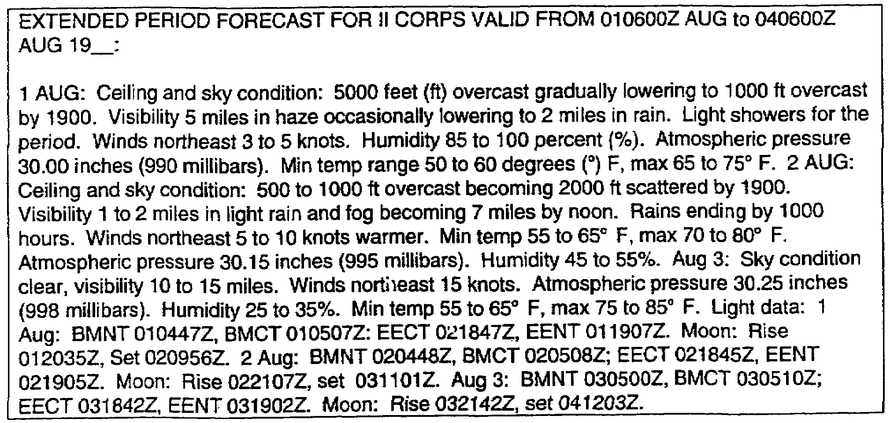

Figure 2-3. Example weather forecast.

NOTE: You may also find upper air wind data used for radiological fall out predictions. Consult Appendix A for definitions of light columnar headings (BMNT, etc.).

d. The following is an example of how this weather forecast is used to prepare paragraph 2a (Figure 2-4):

2-7 IT0566
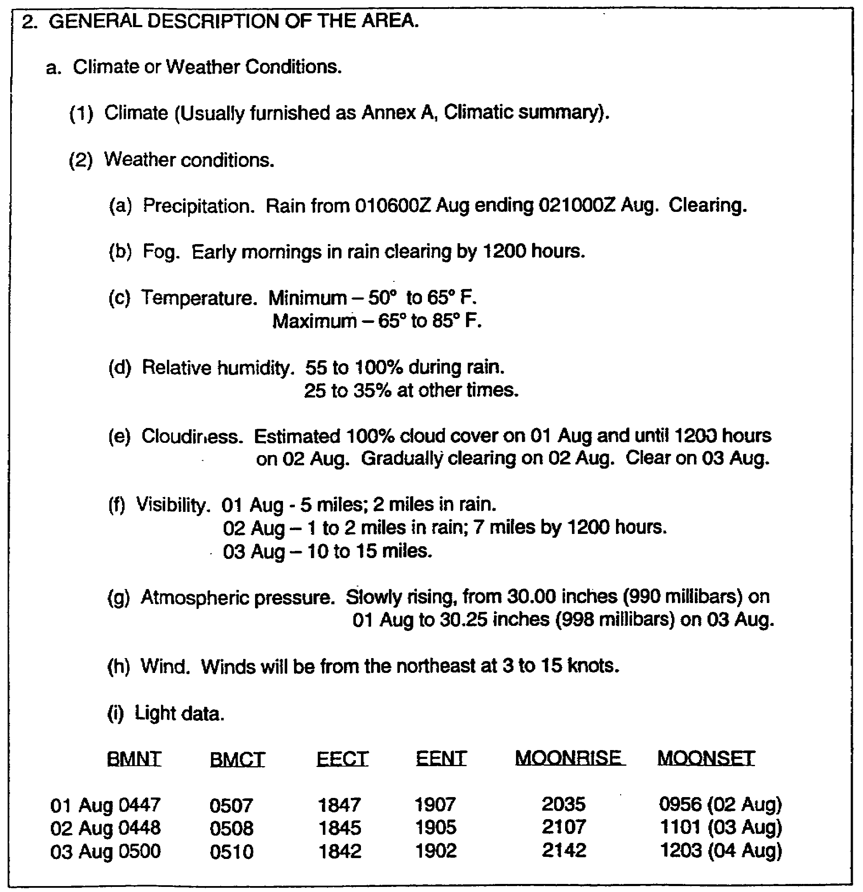

Figure 2-4. Example of paragraph 2a -climate or weather conditions.

IT0566 2-8
3. Paragraph 2b is entitled "Terrain." It is normally a combination of information and graphic portrayals produced by the engineer staff section and the intelligence analyst a division and above. You should use specially colored maps or overlays to the maximum extent possible to illustrate each of the characteristics and the effect of predicted weather conditions on them. There are four major characteristics of information included under this subparagraph:

- Relief and drainage systems.

- Vegetation.

- Surface materials.

- Artificial (manmade) features.

a. Paragraph 2b(1), relief and drainage systems. These are the basic elements in studying terrain as they clearly indicate the general shape of the ground. Under each characteristic, include facts to assist in subsequent determination of the effects of the characteristic on the use of nuclear weapons, chemical agents, and important devices and equipment used in implementing course of action (do not include here the interpretation of these effects on friendly or enemy possible courses of action). This study includes information on—

- Configuration of the ground, especially considering slopes for personnel and vehicles.

- Critical relief for equipment dependent on line-of-sight (LOS).

- Configuration and conditions of rivers and streams, including depth, width, slope, conditions of banks and bottoms, and location of crossing sites.

NOTE: Named localities are located by grid coordinates the first time they appear in the analysis. Grid coordinates are repeated only if required for ease of reference.

NOTE: The following are relief and drainage examples that may be provided to you by the engineer section. The examples presented are used for illustrative purposes and do not reflect the actual format of drawings that you may receive. Further, the overlays depict only a part of the area of the analysis. In a field situation, you may receive, or possibly have to prepare an overlay that would cover the entire area under study (Figure 2-5).

2-9 IT0566
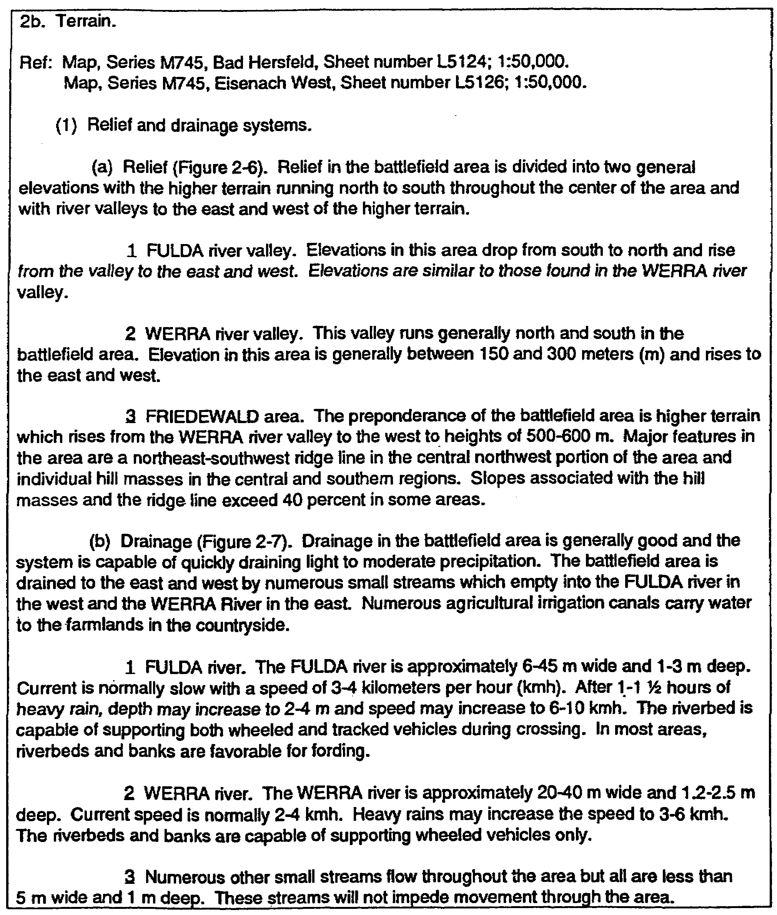

Figure 2-5. Example of paragraph 2b(1) -terrain, relief, and drainage systems.

IT0566 2-10
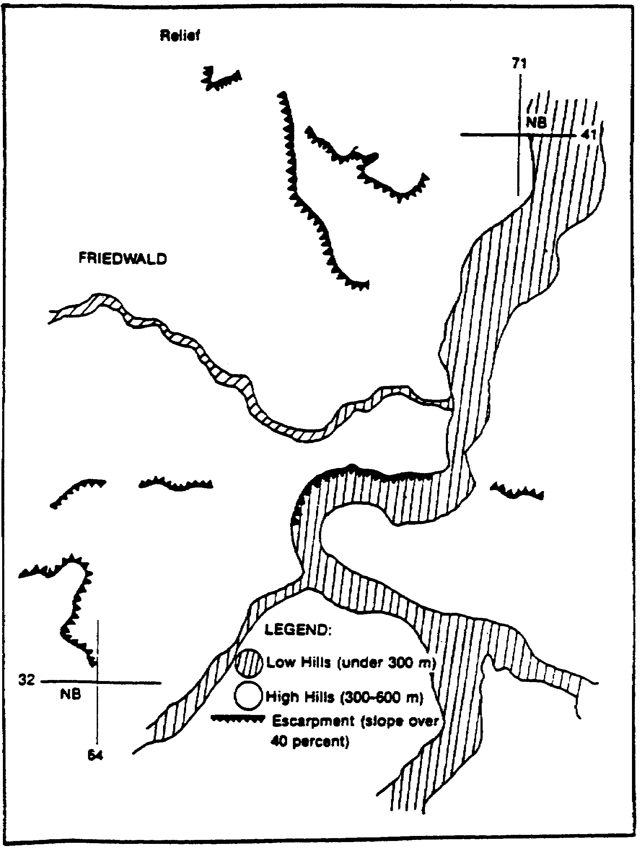

Figure 2-6. Example -relief.

2-11 IT0566
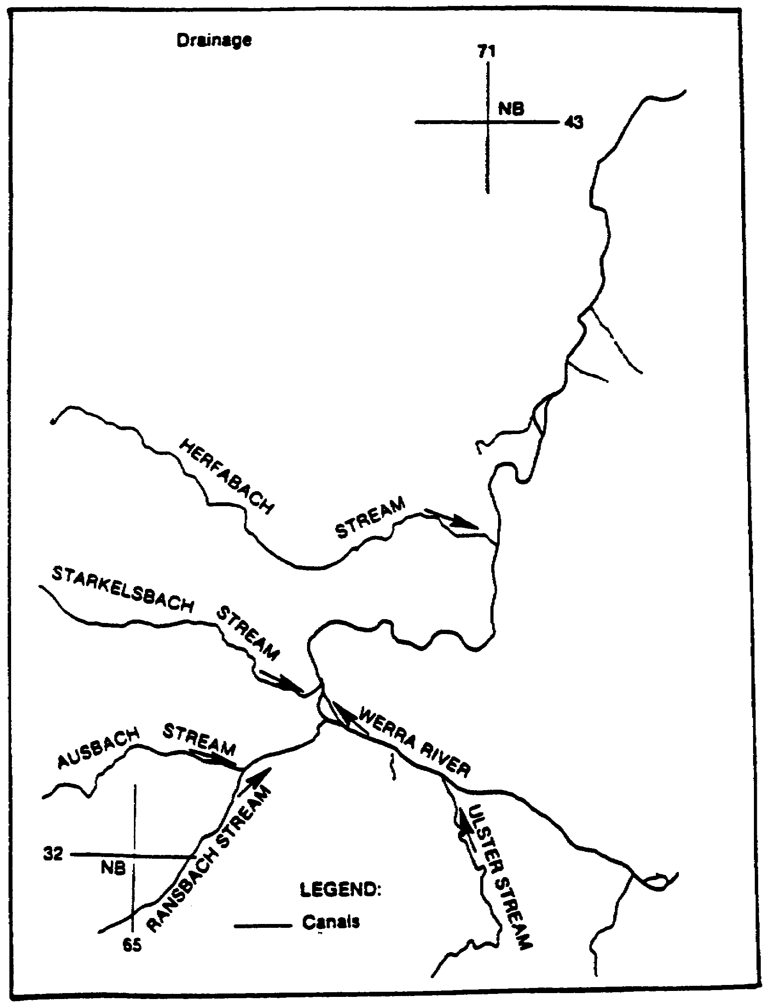

Figure 2-7. Example -drainage.

IT0566 2-12
b. Paragraph 2b(2), describes vegetation. In this paragraph, indicate wooded areas. Vegetation studies are best given in the form of a tinted, or otherwise marked overlay. Again, the engineer section should assist you through its studies of the area. Items included under this section on wooded areas include:

- Locations of trees.

- Diameter of trunks.

- Density of the trees.

- Crown cover (tops of the trees).

- Undergrowth.

- Types of natural and cultivated vegetation of nonwooded area.

NOTE: An example of how vegetation is discussed follows. Notice the discussion and overlays are a continuation of the engineers terrain study (Figures 2-8 and 2-9).

2-13 IT0566
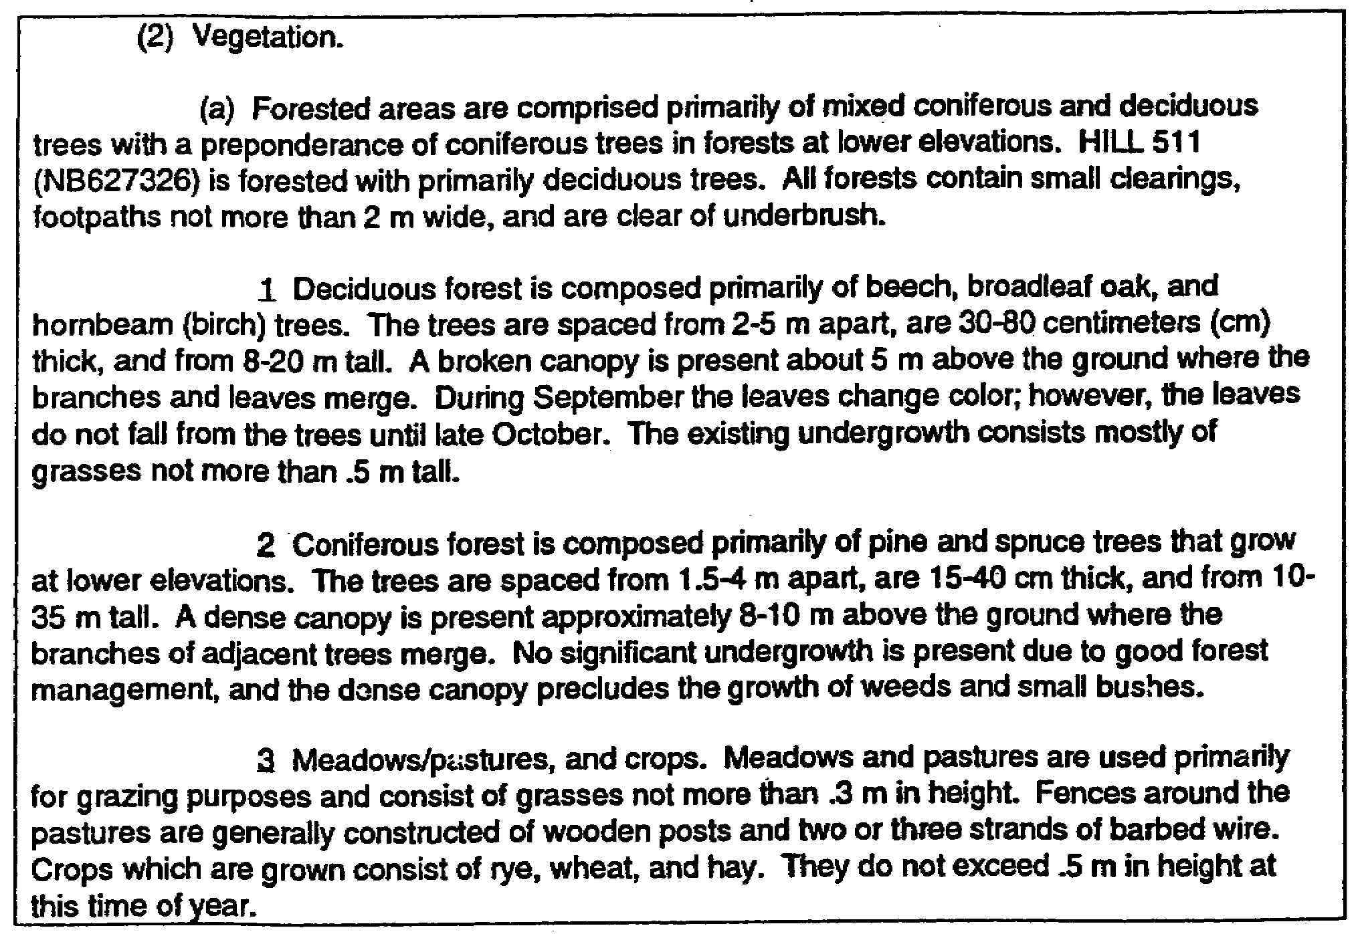

Figure 2-8. Example -vegetation.

IT0566 2-14
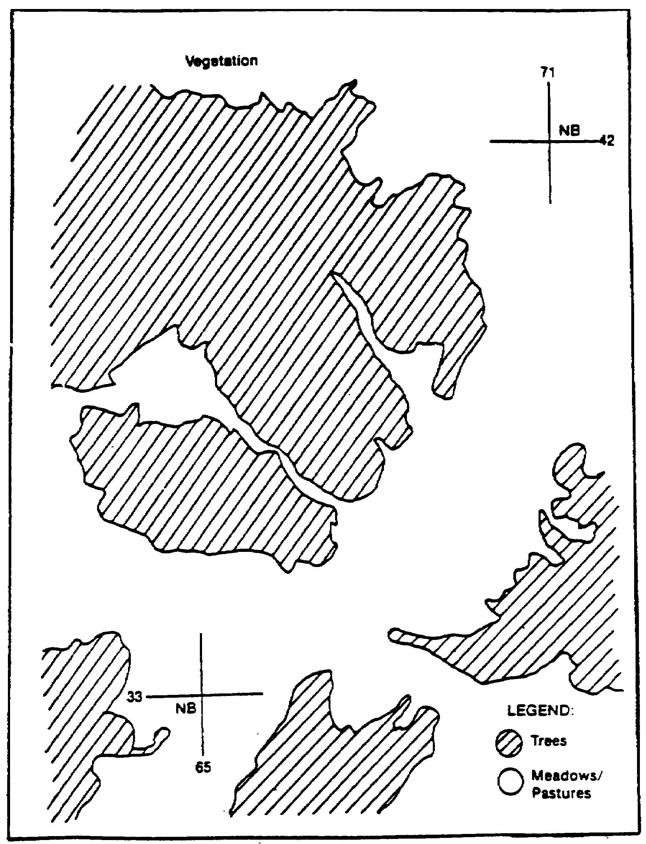

Figure 2-9. Vegetation overlay.

2-15 IT0566
c. Paragraph 2b(3) shows surface materials. The information on surface materials is best presented on a colored or marked overlay. Of concern are the various types of soils and the subsurface and surface rock structures. This information is used to prepare a trafficability map or overlay and a map that depicts areas susceptible to induced nuclear radiation. An example concerning surface materials is shown in Figure 2-10. Included is an overlay that illustrates the various types of soils and the trafficability of the area (Figure 2-11). Again, this is part of the engineer sections terrain study.

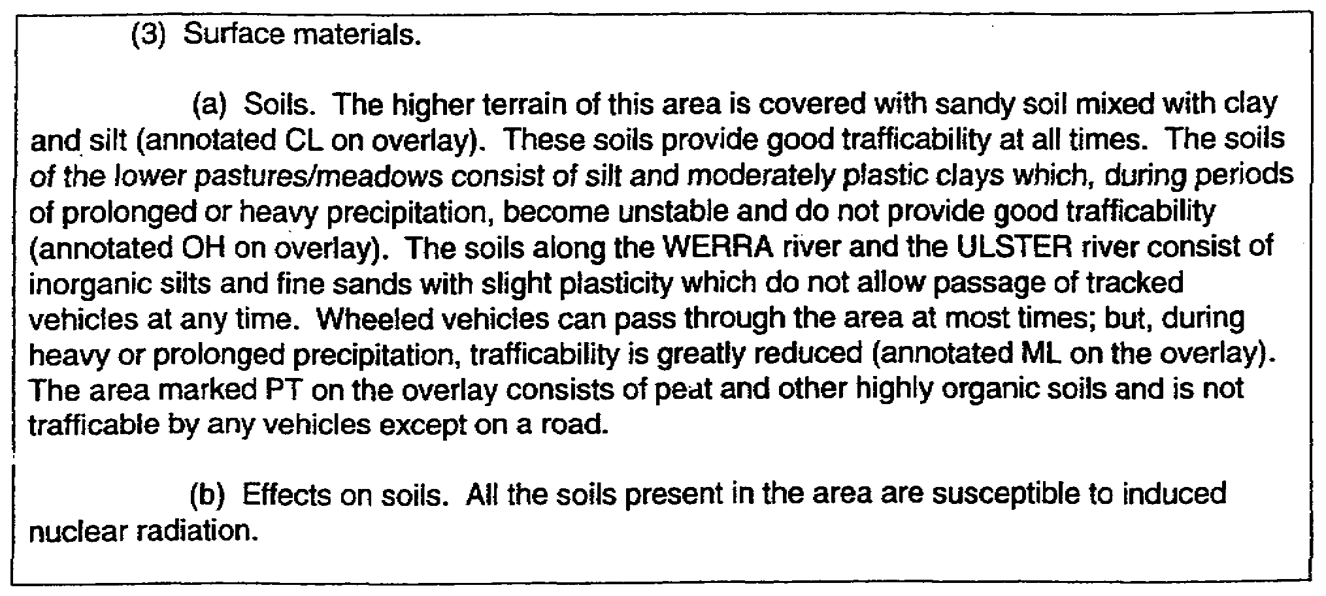

Figure 2-10. Example of paragraph 2b(2) vegetation.

d. Paragraph 2b(4) shows artificial or manmade features. The military importance of manmade features includes the street-by-street warfare in strongly defended cities, the critical communication of roads and railroads, bridges, and all other elements of manmade landscape which provide obstacles, cover, concealment, or "key terrain."

NOTE: The most important of these features in relation to military operations are settlements and buildings, transportation routes, bridges, airports, tunnels, fortifications, and other features of military significance; includes types of construction.

IT0566 2-16
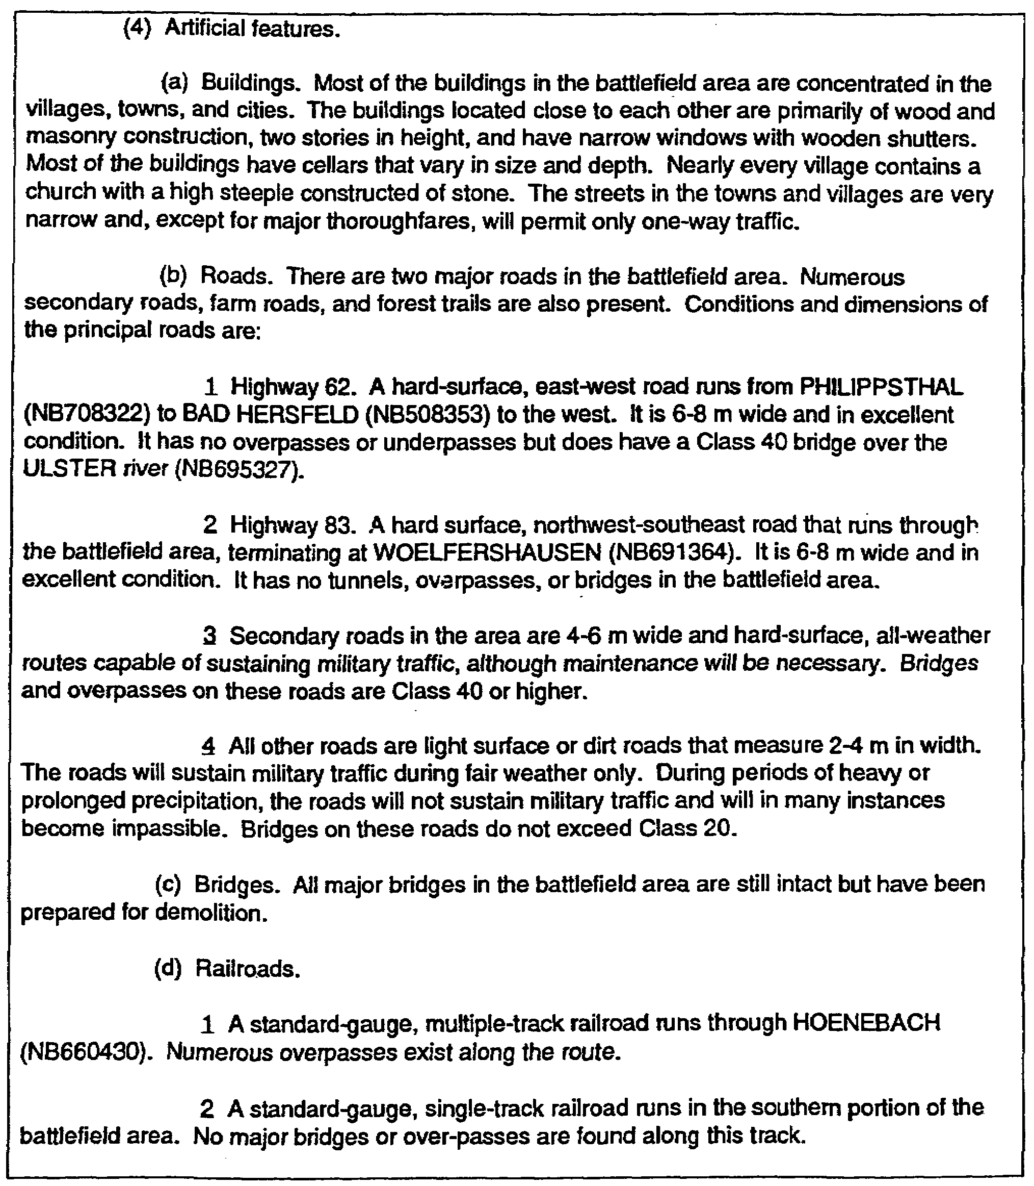

Figure 2-11. Example of paragraph 2b(4) -artificial features.

2-17 IT0566
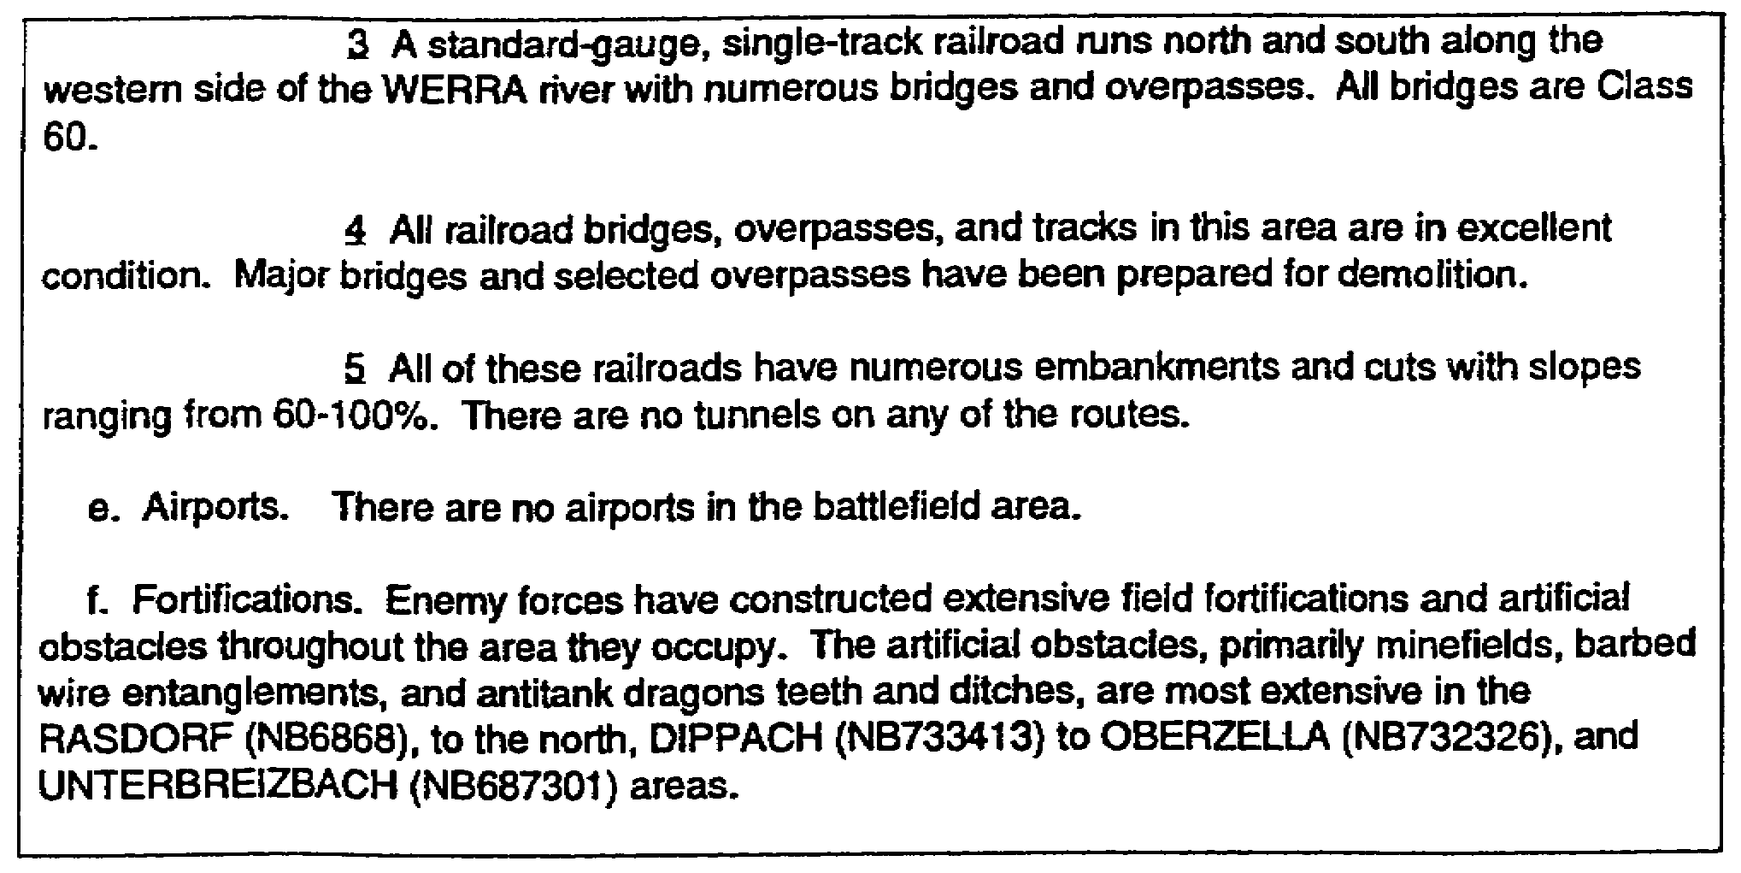

Figure 2-12. Example of paragraph 2b(4) -artificial features (concluded).

NOTE: The preceding examples of ovelays, plus additional types, are an important input to the intelligence preparation of the battlefield (IPB). IPB is an analytic process which allows maximum integration of effort among the all-source intelligence section (ASIS), engineer section, and air weather service.

4. Paragraph 2c is entitled "Other Characteristics" and the following elements are considered in separate categories. Elements lacking information are not addressed.

- Sociology.

- Economics.

- Psychology.

- Government.

- Religion.

- Science and technology.

- Transportation.

- Manpower.

- Hydrography.

IT0566 2-18
NOTE: Under each of these separate characteristics, you list all available FACTS that pertain to the area under demographic study which may influence friendly and enemy courses of action. These characteristics are particularly important to combat service support (CSS) units. They also influence, to some extent, the decisions of all commanders and become increasingly important as the area of interest of a command increases. The information listed under this paragraph will normally be provided to you by the G5, civil-military officer (Figure 2-13).

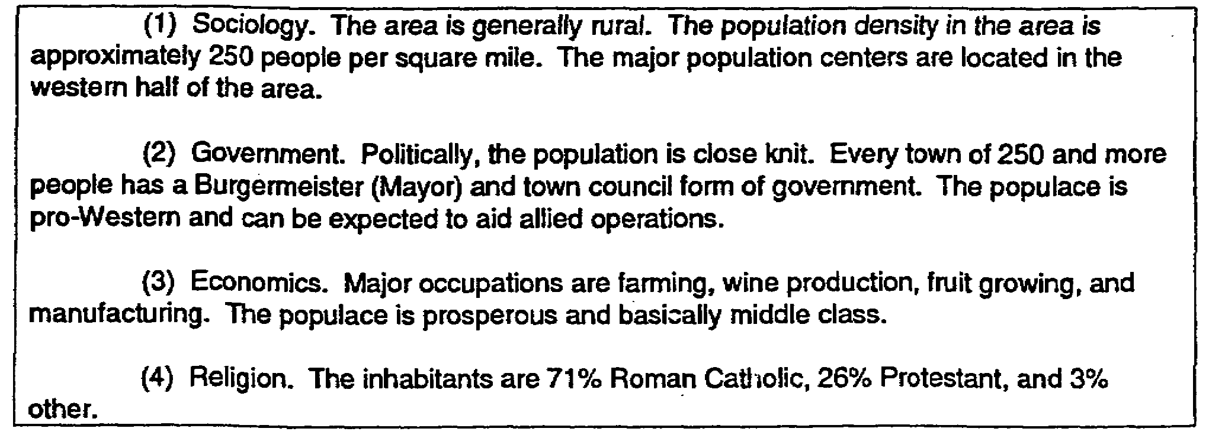

Figure 2-13. Demographic study.

NOTE: Once you have received or developed this information, you should list those characteristics that impact upon the course of action for either force.

2-19 IT0566
LESSON 2

PRACTICE EXERCISE

The following items will test your grasp of the material covered in this lesson. There is only one correct answer for each item. When you have completed the exercise, check your answers with the answer key that follows. If you answer any item incorrectly, study again that part of the lesson which contains the portion involved.

1. What is the last item of the heading in the analysis of the battlefield area?

A. DTG.

B. Title line.

C. Time suffix designator.

D. Classification.

2. What is the title of paragraph lb and what information does it contain?

A. Purpose. It contains a statement on the purpose of the analysis of the battlefield area and a description of the area to be analyzed.

B. Mission. It contains a statement on the mission of the unit/command and lists any consideration that limit the application of the study.

The following instructions pertain to questions 3-9.

Under each of the following statements, categorize by paragraph and characteristics of a paragraph, where you would place the individual items in the analysis of the battlefield area. For example:

"Bridges on all secondary roads are Class 40 or higher."

ANSWER: Terrain is covered in paragraph 2b and artificial (manmade) features (such as bridges) are characteristics (pages 2-19/2-20, para d (note) /fig 2-12.

3. The mission is to delay in zone and, on order, move to the west bank of the FULDA river and assume defensive positions.

ANSWER:

IT0566 2-20
4. The preponderance of the battlefield area is higher terrain which rises from the WERRA river valley to the west to heights of 500-600 m.

ANSWER:

5. All soils in the battlefield area are susceptible to induced nuclear radiation.

ANSWER:

6. Highway 83 is a hard-surface, northeast-southwest road that runs through the battlefield area ending at WOELFERSHAUSEN (NB691364).

ANSWER:

7. Major occupations are farming and fruit growing. Populace is considered middle-class.

ANSWER:

8. Light rain beginning at 0230 hours; visibility .5-1 mile; 100% cloud cover; max temp 65°F, min 50°F, humidity 90-100%; atmospheric pressure 30.00 inches (990 millibars).

ANSWER:

2-21 IT0566
LESSON 2

PRACTICE EXERCISE

ANSWER KEY AND FEEDBACK

Item Correct Answer and Feedback

1. C. The last item of the heading is time suffix designator line (page 2-4, para 10).

2. B. Paragraph 1 b is entitled "Mission." It contains a statement on the mission of the unit/command and lists any consideration that may limit the application of the study (page 2-5, para 3).

3. Mission is covered in paragraph lb (pages 2-5, para 3/fig 2-2).

4. Terrain is covered in paragraph 2b and relief and drainage are the characteristics of the battlefield area (pages 2-9/2-10, para 3/fig 2-5).

5. Terrain is covered in paragraph 2b and surface materials are the characteristics (pages 2-9/2-16, paras 3/3c, fig 2-10).

6. Terrain is covered in paragraph 2b and manmade features are the characteristics (pages 2-16/2-17, paras 3/3d, fig 2-12).

7. Other characteristics are shown in paragraph 2c (pages 2-18/2-19, para 4/fig 2-13).

8. Climate and weather conditions shown in paragraph 2a (pages 2-6/2-8, para 2/fig 2-4).

IT0566 2-22
LESSON 3

MILITARY ASPECTS OF THE AREA

CRITICAL TASKS: 301-336-1100
301-372-2050
301-372-3050

OVERVIEW

LESSON DESCRIPTION:

In this lesson you will learn to prepare paragraph 3 (military aspects of the area) of the analysis of the battlefield area.

TERMINAL LEARNING OBJECTIVE:

TASK: Prepare paragraph 3 of the analysis of the battlefield area.

CONDITION: You will be given access to extracts from FM 34-3, FM 34-130, and FM 101-5.

STANDARD: Paragraph 3 of the analysis of the battlefield area will be in accordance with FM 34-3, FM 34-130, FM 101-5.

REFERENCES: The material contained in this lesson was derived from the following publications:

FM 34-3.
FM 34-130.
FM 101-5.

INTRODUCTION

After completing the heading and paragraphs 1 and 2, you should prepare paragraph 3, military aspects of the area in the analysis of the battlefield area.

PART A: DEFINITIONS AND DESCRIPTION OF PARAGRAPH 3

1. Paragraph 3 of the analysis of the battlefield area is entitled "Military Aspects of the Area." Paragraph 3 is where an analysis of the information contained in paragraph 2 is made. Through the analysis of the facts listed in paragraph 2, you can determine the influence they have on the tactical and combat service support (CSS) factors considered in the selection of a course of action by either force. In the analysis of these factors, the effects of and on nuclear fires, chemical and biological agents, and important devices and equipment used are integrated.

2. Paragraph 3a is entitled "Tactical Aspects." It considers the effect that the area will have on
five tactical aspects; observation, and FofFs, concealment and cover, obstacles, key terrain,
and avenues of approach, which are the OCOKA factors.

3-1 IT0566
NOTE: Before you begin to develop the necessary information for this paragraph, you should review these OCOKA factors.

a. Paragraph 3a(1) describes observation and FofFs. Observation relates to the influence of terrain on the ability of a force to exercise surveillance over a given area either visually or through the use of surveillance devices, both optical and electronic. Effects of and on nuclear fires, chemical agents, and so forth are included as are any marked effects on surveillance equipment based on LOS and fire delivery means. The total effect of visibility and observation is unmistakable in the ability of a force to see or its vulnerability to be seen. These conditions are analyzed separately because visibility varies with weather, which changes, whereas observation varies with terrain, which is relatively stable. For example, a high hill may provide excellent observation even though visibility is restricted by fog surrounding the hill at a given time.

(1) As used in the analysis of the battlefield area, fire relates to the influence of terrain on the effectiveness of direct-and indirect-fire weapons. The fires on indirect-fire weapons, such as mortars and artillery guns and howitzers, are affected primarily by terrain-conditions within the target area which may influence the effects of the fire delivery means. Observation and fire are of concern to CSS units as they influence rear area security.

(2) FofFs for direct-fire weapons such as machine guns and automatic rifles may be affected by the terrain conditions between the weapon and the target.

(3) The analyst identifies those terrain features within and adjacent to the battlefield area which afford the friendly or enemy forces favorable observation and fire.

REMEMBER: Effects on fire include effects on delivery means, FofFs, and effectiveness on fires.

b. Paragraph 3a (2) shows concealment and cover. It is oriented on protection of friendly and enemy forces and indicates or describes the influence of weather, relief, vegetation, and artificial features. Effects of and on nuclear fires, surveillance devices, chemical and enemy biological agents, and so forth, are included as appropriate. The discussion is oriented not only on protection of our own and enemy forces, but also on other operations to include use of guerrillas, infiltration and counter infiltration, deception, counterintelligence (CD), armor, and artillery. It is also oriented on site requirement for CSS and tactical installations. Include only marked effects that help in selection of friendly and enemy courses of action.

(1) Concealment is protection from observation and may be provided by woods, undergrowth, snowdrifts, tall grass, cultivated vegetation, smoke, fog, ground haze, rain, dust, or any other feature which denies observation.

(2) Cover is defined as protection from the effects of fires and is provided by rocks, ditches, quarrie, caves, riverbanks, folds in the ground, shell holes, firing positions, buildings, walls, railroad embankments and cuts, and so on. Areas that provide cover from direct fire weapons may or may not provide cover from indirect-fire weapons. When you evaluate the effects of nuclear weapons, what provides cover from direct- and indirect-fire conventional weapons does not necessarily afford the same protection. For example, unless the forward slopes of a terrain mass are extremely steep, blast will affect personnel and equipment on the

IT0566 3-2
reverse slope because the blast wave will follow the contour of the ground. Additionally, when a nuclear weapon is detonated over a valley or the axis of the valley is pointed toward ground zero, the blast will be canalized and intensify the damage. Irregular terrain does offer some protection from thermal radiation, but few buildings are sufficiently strong to withstand the effects of blast and heat.

(3) Concealment and cover are extremely important in both the attack and the defense. If attacking units can move under the concealment of woods, fog, or a moonless night, the chances of the success of their mission are enhanced. In a defensive situation, forces seek to defend in an area which offers both good concealment and cover, but does not provide covered approaches for the enemy. In the attack, any element of the weather or terrain which offers concealment and cover assists in the mission and may ensure the attack will be more effective.

NOTE: The important point to remember is that cover is solid; therefore, it provides limited protection from weapons fire. Concealment simply keeps the enemy from seeing you.

c. Paragraph 3a(3) on obstacles indicates graphically or describes all natural and artificial obstacles and the influence of relief, weather, vegetation, surface materials, and artificial features. Effects, as appropriate, of and on nuclear fires, chemical and enemy biological agents, and effects on trafficability and accessibility are included. If of significant influence, the effect of each obstacle on possible friendly and enemy courses of action is indicated. Obstacles and trafficability influence site locations for CSS units.

(1) An obstacle is any natural or manmade feature which stops, impedes, or diverts military movement. Show all natural and artificial obstacles. Natural obstacles include:

- Rivers.

- Streams.

- Canals.

- Lakes.

- Swamps.

- Cliffs.

- Steep slopes.

- Dense woods.

- Mountains.

- Deserts.

- Jungles.

3-3 IT0566
(2) Manmade obstacles are works of construction or destruction. They include minefields, craters, antitank ditches, trenches, roadblocks, NBC contaminated areas, extensive rubble, and tree blowdown.

NOTE: To be fully effective, obstacles must be covered by observation and FofFs. In the defense, you must identify those features that stop or impede movement within the battlefield area; in the attack, you consider the obstacles within the units zone of action.

(3) Advantages and disadvantages. An obstacle may be considered an advantage or a disadvantage. An obstacle perpendicular to the direction of attack favors the defender by slowing or canalizing; obstacles parallel to the direction of attack may assist in protecting a flank of the attacking force. However, when the obstacle(s) run parallel to the direction of attack, lines-of-communication (LOCs) may be severely degraded.

d. Paragraph 3a(4) describes key terrain features based on the analysis of observations and fields of fire, concealment and cover, obstacles, and mission. Any locality or area the seizure, retention, or control of which affords a marked advantage of either force is considered. The influence of each key terrain feature listed is discussed briefly. The discussion is oriented toward subsequent development of friendly and enemy courses of action. Key terrain features selected are revised as required by the commander's decision and current situation. Key terrain features may be omitted when the enemy has no capability to secure or control terrain features that will materially affect the accomplishment of the mission.

(1) Key terrain is an important factor in the integration of fire and maneuver, in the generation of combat effectiveness, and in all military support operations. Terrain can usually be described in terms of its military aspects. A key terrain feature is any area whose seizure, retention, or control affords a marked advantage to either controlling forces.

(2) Selection. Key terrain features must be considered when formulating courses of action; their selection is based on the mission of the unit, the command level, and the type of unit. Terrain which stops, impedes, or denies military movement may be a key terrain feature. Tactical use of terrain often is directed at increasing the capability for applying combat effectiveness and at the same time forcing the enemy into areas which reduce his capability. Terrain which permits this may also be key terrain. The effect of terrain on fire and maneuver, application of combat effectiveness, and preservation of force integrity are considerations in selecting key terrain. A terrain feature may afford a marked advantage in one case, but little or no advantage under other conditions.

(3) Command level selection. As an example of command level selection of key terrain, a commander at EAC may consider the seizure and control of a given city would afford control of a vital link in the LOC, so the city might be rightly called key terrain. On the other hand, an infantry brigade commander within the EACs area of operations would probably consider the high ground which dominates the city to be of greater importance and the city itself to be an obstacle; therefore, the city is not key terrain.

(4) Tactical units. The structure of friendly and enemy units also influences the selection of key terrain. The types of terrain features usually selected as key terrain for tactical units include:

IT0566 3-4
- High ground which affords favorable observation and FofFs.

- Bridges over unfordable rivers.

- Assigned or assumed objectives.

- Dominant terrain within a defensive sector.

(5) Key terrain or obstacles. Although obstacles are rarely selected as key terrain, the same terrain feature may properly be considered as key terrain at one command level and as an obstacle at another. An example might be in the classification of an unfordable river. At the tactical unit level, in normal terrain, the river is classified as an obstacle because of its primary effect of stopping or impeding military movement; the adjacent high ground is the key terrain because its seizure and control permits full use of the river as an obstacle, and this condition constitutes the tactical advantage. At the EAC level, however, the commander might consider the river as key terrain because of its importance to the supply system. Thus an important fact emerges-the same commander does not consider the river as both key terrain and an obstacle. An exception occurs when an obstacle is assigned as an objective to a force; the obstacle then becomes key terrain to the force ordered to capture it. Lets look briefly at how the mission of a unit affects the selection of key terrain.

(a) In the attack. In the friendly attack, key terrain features usually are forward of friendly positions and frequently assigned as objectives. However, terrain features in adjacent areas may be key terrain if their control facilitates the conduct of the attack or the accomplishment of the mission. Terrain in an adjacent area which enables effective observation and fire of the enemy along an avenue of approach for friendly forces may be key terrain. Key terrain may be within friendly territory when its control is essential to the success of an operation. For example, if the enemy can control a terrain feature which prevents or hinders the attack, the seizure of that feature is essential because it affords us a marked advantage and thus is key terrain.

(b) In the defense. In the friendly defense, key terrain is usually located within the assigned sector and within or behind the selected defensive area. Some examples of key terrain are—

- Terrain which gives good observation over avenues of approach into the defensive position.

- Terrain which permits the defender to cover an obstacle by fire.

- Important communication centers which affect command communications and the use of reserves.

NOTE: Key terrain may also be forward of the defensive area or in adjacent areas. For example, a terrain feature in the forward edge of the battle area (FEBA) or in an adjacent sector, which gives the enemy good observation over defended localities, communication routes, or avenues of approach, is key terrain when active measures must be taken to reduce the enemy advantage. The defender may move his position

3-5 IT0566
forward to include the feature or take actions to minimize the enemy's advantage by the use of fire, chemical, smoke, and concealment and cover.

e. Paragraph 3a(5) describes the avenues of approach (AAs) and mobility corriders (MCs) that are developed from all the previous analysis of the tactical aspects. Such development does not consider the disposition of the enemy forces. An AA must afford some facility of movement and room for adequate dispersion for a force large enough to have significant effect on the outcome of the operation. When either opposing force has available an adequate number of aircraft that can be used to deploy troops and equipment forward to the battle area and significantly affect the accomplishment of the mission, air avenues of approach (AAAs) are listed. If terrain and weather conditions do not significantly influence choice of flight paths, then AAAs are not listed. Enemy AAs are listed first, followed by a list of AAs into the enemy battle area. When the opposing forces are not in contact, or when security forces are in contact, AAs to the battle area for both forces are listed. Each listing of an AA is accomplished by a brief discussion to provide a basis for subsequent development of possible courses of action by either force. For CSS units, the discussion of AAs is based on rear area security requirements.

(1) AAs and MCs are routes by which a force may reach key terrain or an objective. AAs and MCs address maneuver support potential, degree of canalization, concealment and cover, observation and FofFs, obstacles, and the access to key terrain and adjacent avenues or corridors. To be considered an AA, a route must provide some ease of movement and sufficient width for the deployment of the size force for which it is being considered.

REMEMBER: When determining AAs and MCs the analyst uses the one-up, two-down formula. (See page 1-3, para 3).

(2) The analysis of an AA is based on all previous analysis of tactical aspects to include:

(a) Observation and FofFs. This consideration should be favorable for the force moving on the AA.

(b) Concealment and cover. This consideration is often in conflict with observation and FofFs.

(c) Obstacles. Avoiding those perpendicular to the direction of advance and, whenever practical, taking advantage of those parallel to the direction of advance.

(d) Utilization of key terrain.

(e) Adequate maneuver space. This is based, in part, on evaluation of deployment patterns, mobility means, and sufficient space to avoid presenting advantageous targets for nuclear fires.

(f) Ease of movement. This includes relative length of the AA, directness of approach to the objective, soil trafficability, steepness of slopes, obstacles, direction of terrain compartments with respect to direction of movement, and other aspects of the terrain which enhance or restrict command and control.

IT0566 3-6
REMEMBER: The analysis of an AA is primarily based on terrain considerations. Do not consider the disposition of enemy forces. When either force has an adequate number of aircraft available to deploy troops and equipment, air AA may be listed.

(3) In the attack, AAs leading from the line of departure (LD) to key terrain within the objective area are selected for analysis. The most favorable to the friendly forces is identified.

(4) In the defense, AAs starting forward of the defensive position and leading to key terrain within the battle area are selected for analysis and the most favorable to the enemy forces is identified. AAs available to the enemy are described as ending within that key terrain in the battle area which, if seized by the attacker, could result in a marked disadvantage to the defender. Such an AA begins a reasonable distance in front of the friendly forces for whom the analysis is being made. This distance is usually equal to the forward extent of the defense sector.

(5) There are three types of AAs: ground, air, and rear area AAs (Figure 3-1).

(a) Ground avenues of-approach. A ground AA is broad enough and contains sufficient MCs to support rapid movement and maneuver of forces along its entire course. It should be free of obstacles. If obstacles are present they should be few in number and require reasonable engineer support to remove them. The avenue also affords good to excellent concealment and cover.

(b) Air avenues of approach (AAA). An AAA is much the same as a ground AA. They are routes that provide a suitable flight path for a specified number of aircraft to reach a drop or landing zone. They should be free of obstacles or obstructions and the flight path must afford some ease of movement for a force of sufficient size to produce a significant effect on the operation. It is important to consider AAAs or MCs in layers as to reflect different altitudes of approach, depending on the level and size of the operation. Furthermore there must be adequate air space for rapid movement of the aircraft to landing or drop zones, the desirability of having multiple flight routes available, and easily recognized terrain features since navigation at low altitudes is extremely difficult.

NOTE: To minimize the exposure of aircraft en route to the objective area, the shortest flight paths that afford sufficient air space, concealment from ground observation, and easily recognized terrain are preferred.

(c) Rear area avenues of approach. These are avenues that provide the rapid movement of rear threat elements and the additional service support elements to the front lines.

NOTE: It is extremely important to indicate the width of the avenues and corridors and what size element can pass through. Note any major choke points that canalize movement along the AA into designated MCs as key terrain.

NOTE: When you prepare the AAs for inclusion in paragraph 3 of the analysis, you should list the enemy's AAs first, followed by a list of the friendly avenues into the enemy's positions, if necessary. This list of friendly AAs may be included, even if the mission is to defend, because friendly forces may take limited objective action during the defense.

3-7 IT0566
interfere with enemy preparations for an attack, or attacks may be launched to relieve and extricate heavily engaged security forces.

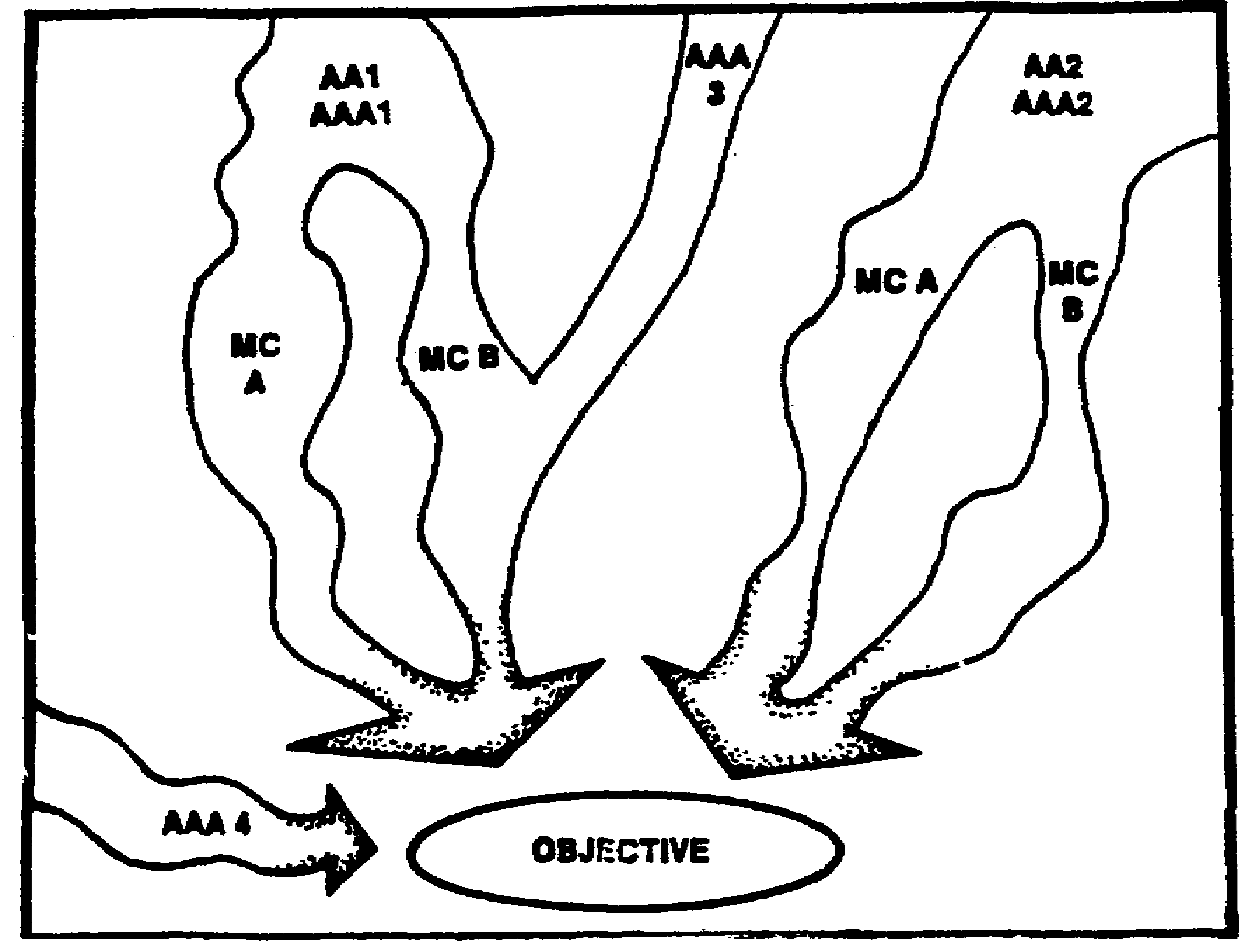

Figure 3-1. Avenues of approach.

f. Other tactical aspects considerations.

(1) MCs. An MC is an area bounded on two opposite sides by terrain features which limit ground observation and direct-fire into the area. These limiting features are usually ridges or high ground, but may also be woods, cities, towns, or wide bodies of water. An MC can take several forms: It may be a street lined with buildings, a meadow bordered by forests, a plain with a mountain range along one side and a body of water opposite, a valley bordered by ridges, or a similar combination of terrain features.

(2) Limiting features. The terrain features which bound an MC are termed "limiting features." An MC includes not only the enclosed area, but also the limiting features. As illustrated in Figure 3-2, you see two MCs formed by three types of limiting features: wooded areas to the north and east, built-up areas throughout, and ridges to the northwest and west. The distance within these features will depend upon the density of the woods and built-up areas.

NOTE: To facilitate analyzing an area, the terrain may be divided into separate areas called compartments which are formed by relief and drainage, vegetation, manmade features, or a combination of all three (Figure 3-2).

IT0566 3-8
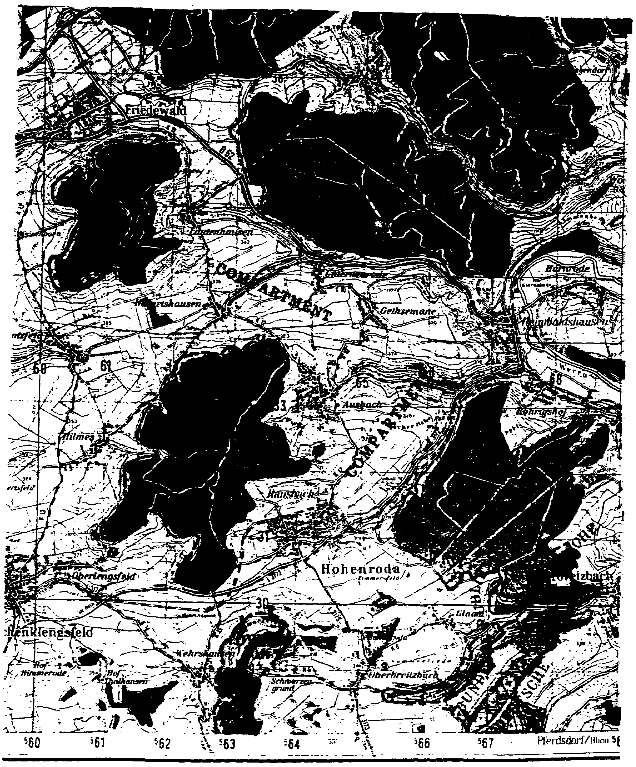

Figure 3-2. Compartments.

3-9 IT0566
(3) Classification. MCs are classified as corridors or cross-compartments. A corridor or cross-compartment is determined by the direction of advance of a military force. A compartment whose long axis is perpendicular or oblique to the direction of advance of a military force is called a "cross-compartment." A compartment whose long axis is parallel to the direction of advance of a military force is called a "corridor."

NOTE: Figure 3-3 is an illustration that portrays these two types of compartments. Arrow AA1 represents a military force advancing from the east. The compartment, in this instance, is considered to be a cross-compartment. Arrow AA2 represents a military force advancing to the southwest and the compartment is considered to be a corridor.

(a) Cross-compartments. In considering the significant tactical aspects in classifying MCs, you will find that cross-compartments in general favor the defense and are not considered as favorable MCs. Cross-compartments offer the most favorable terrain characteristics for defending units to obtain maximum observation and fields of fire from their positions. This is because they increase their ability to gain mutual support between units, laterally and in-depth, and enhance their ability to mass all their fires on the point most threatened by the attacker.

(b) Corridors. Corridors present more variable avenues of approach for the attacker. In this case the defender's lateral organization of observation and fields of fire of flat-trajectory weapons are usually obstructed by the limiting features of the compartment. This decreases the ability of the defender to obtain mutual support between units along the main line of resistance and the units organized to the rear.

NOTE: The terrain considerations just described are not the only one which merit attention. Although corridors and ridges may provide favorable routes of advance for a military force, their effect may be nullified by a lack of trafficability or other terrain considerations.

g. Techniques. Some of the basic techniques which aid in the analysis of terrain deal with methods of marking maps, overlays, and photographs to emphasize terrain characteristics. When properly used, any of the following methods or a combination of these methods can better enable you to "read" terrain:

(1) Hill topping─ a method used to accentuate the high ground of an area. It is accomplished by selecting a critical elevation and then coloring or shading all areas higher than that elevation. This method shows the height, general configuration, and location of the high ground.

(2) Layer-tinting─ the coloring or shading of successive elevations of the ground, from lowest to highest. By selecting a series of colors and following the contour lines of the map, a realistic three-dimensional effect is created.

(3) Contour emphasizing─ identifies the primary contour lines most suitable for illustration of the configuration of the terrain. This vividly shows the general shape of the ground and the relationships between successive elevations on a map.

IT0566 3-10
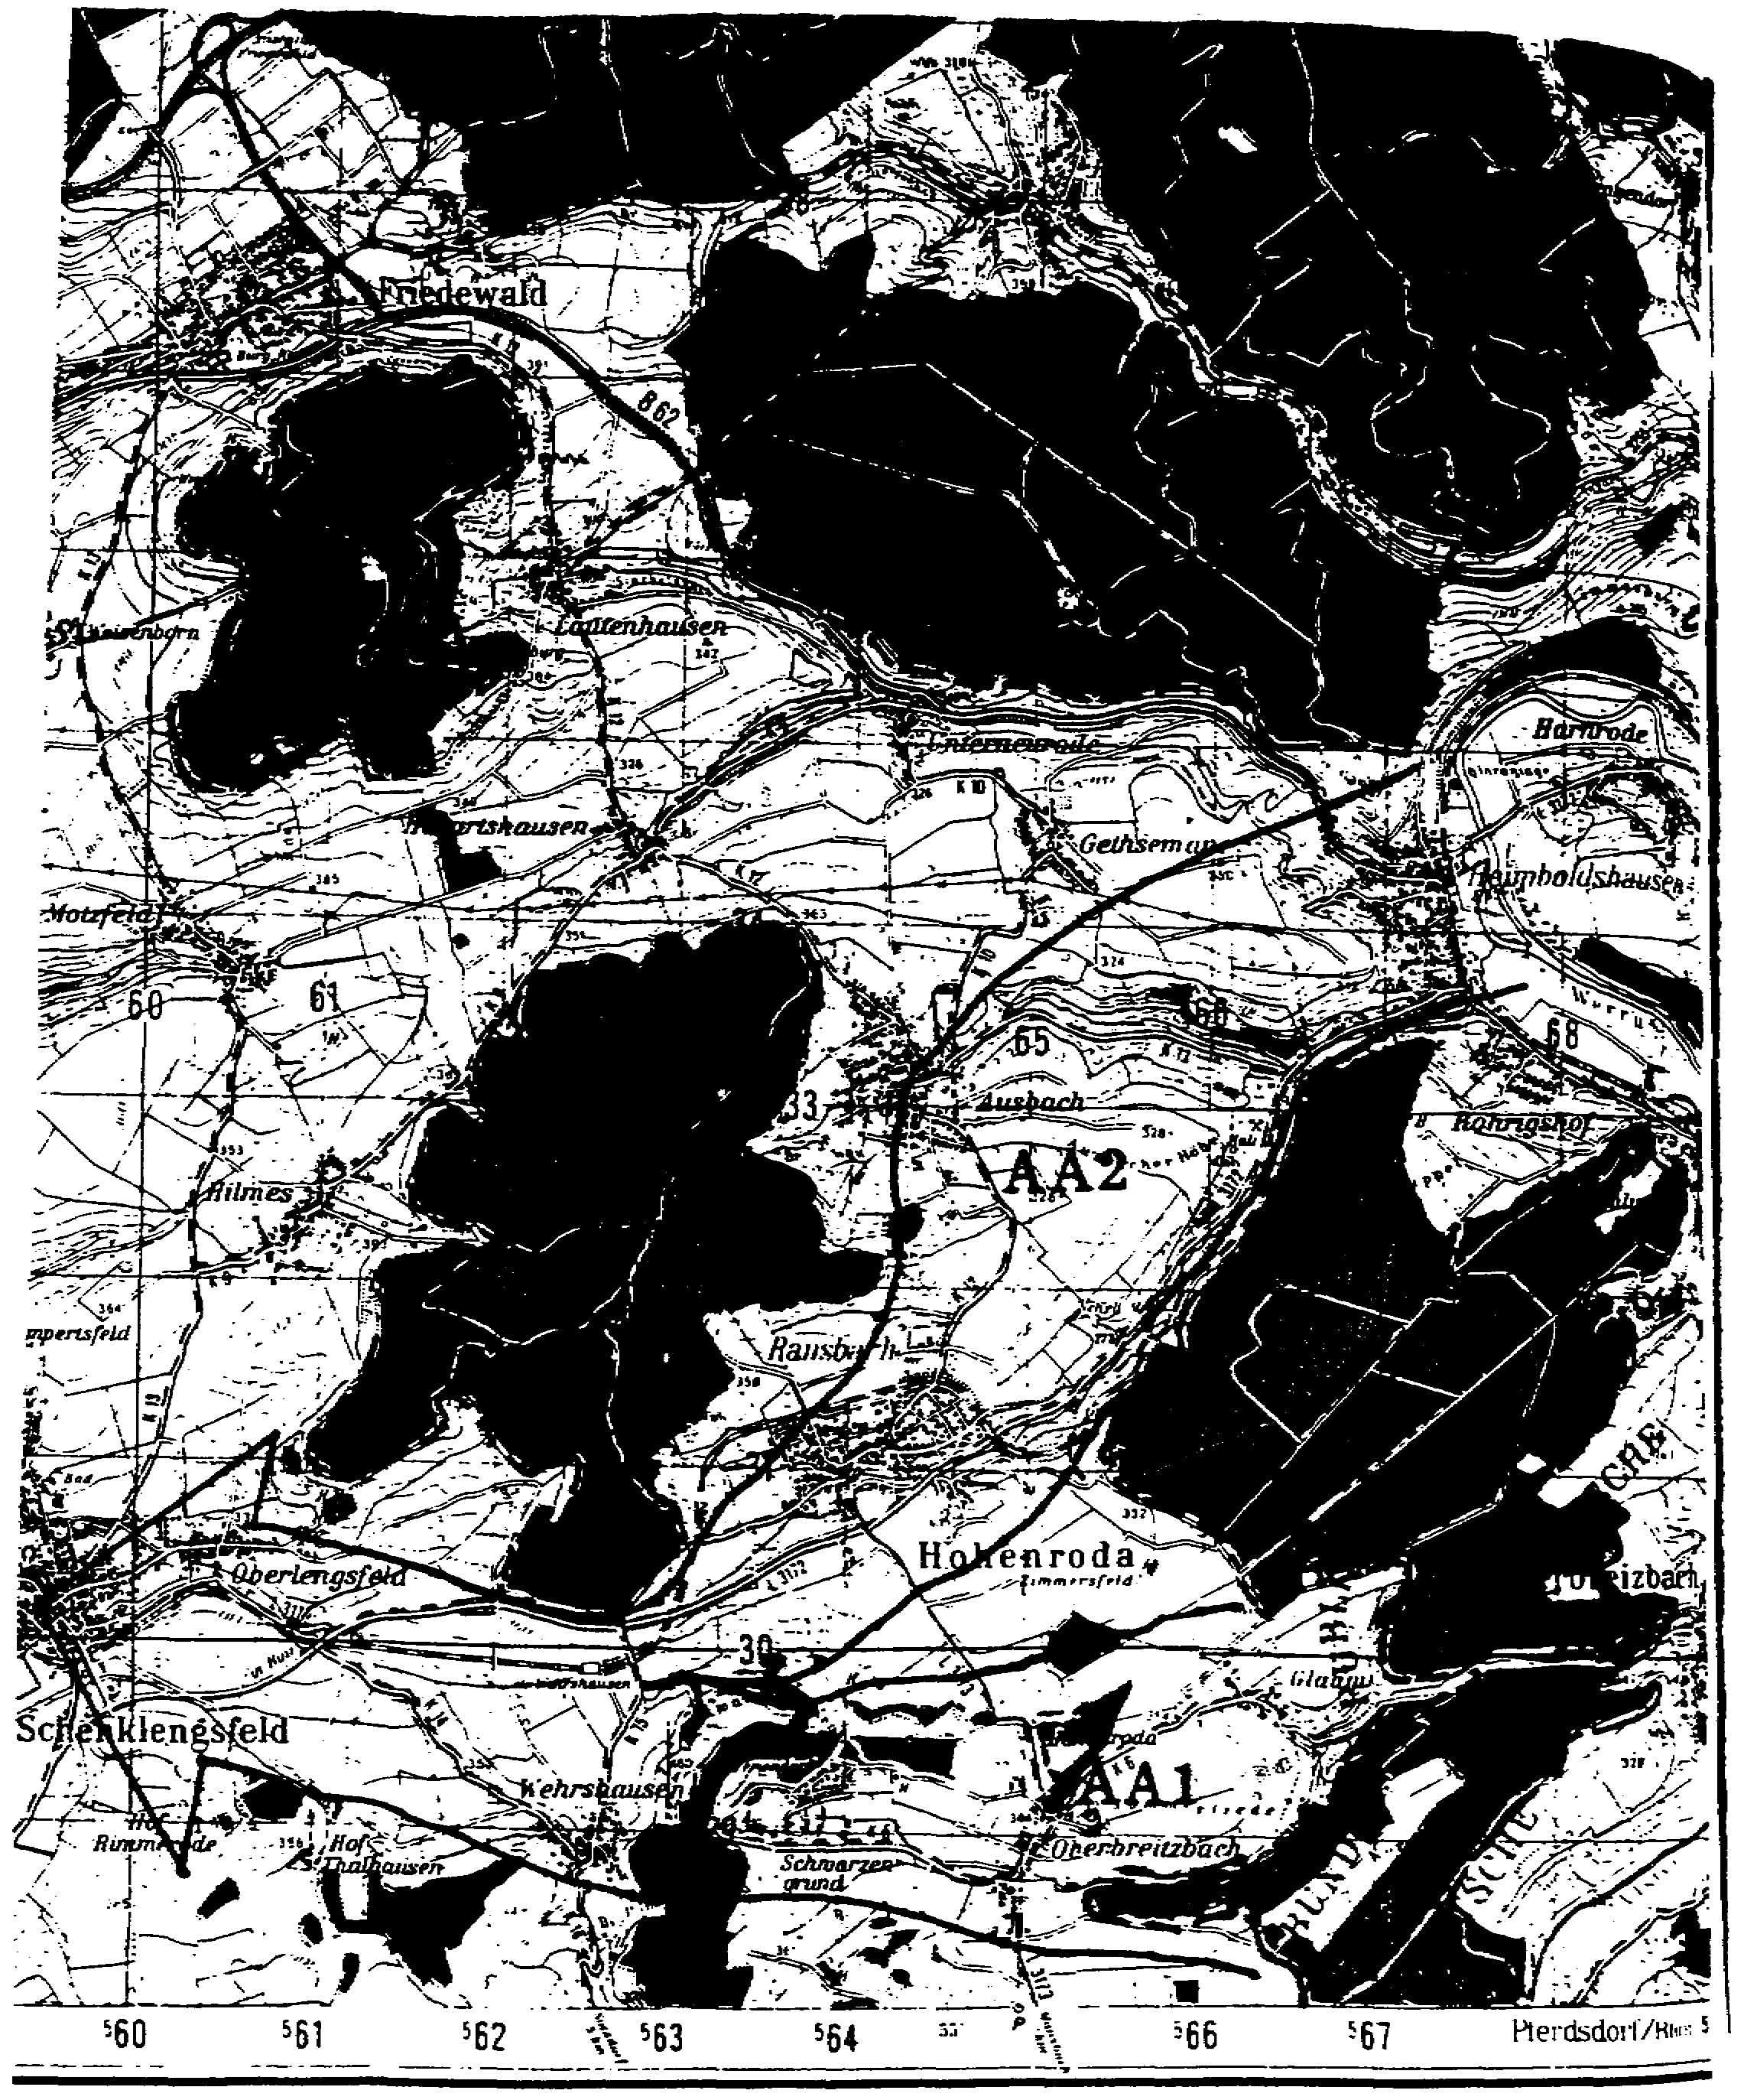

Figure 3-3. Cross-compartments and corridors.

3-11 IT0566
(4) Ridge and stream lining─ emphasizes the relief and drainage of an area by drawing over the ridge lines and then emphasizes the drainage system by tracing the course it takes. This method shows you the compartmentation of the area but does not indicate relative elevations or slope. Ridge lining can be used by itself to emphasize the ground compartmentation of an area.

(5) Profiling─ the determination of observation and flat-trajectory fields of fire that exist between two points. Terrain features may mask the line-of-sight between these points. By using this method, you can determine if clearance is or is not present.

3. Paragraph 3b is entitled "Combat Service Support (CSS) Aspects" and where you analyze the facts listed in paragraph 2 and the subconclusions developed under the tactical aspects just presented. The analysis of the facts and subconclusions are used as a basis for further studies of the effects of CSS activities on friendly and enemy units. Indicate the impacts of the military aspects of the area on CSS that influence the selection of a course of action by either force in this paragraph. Omit any activity that is not significantly influenced. Considering the major activities listed below, isolate those facts and subconclusions that significantly influence choices of possible courses of action by either friendly or enemy forces or that require special activities to ensure combat effectiveness and adequate support.

a. Paragraph 3b(1) is of particular importance when, weather and terrain conditions are severe; when the battlefield area has a significant population, to include potential labor forces; or when political and economic conditions are unsettled.

b. Paragraph 3b(2) addresses logistics. It is of particular importance when weather and terrain conditions are severe, when the battlefield area imposes additional logistic requirements or has significant resources of military value, or when political and economic conditions are unstable. Detailed coverage is required for those commands whose mission is the logistical support of other units.

c. Paragraph 3b(3) discusses civil-military operations (CMOs). CMO are of particular importance in cold war, limited war, occupation operations, and when extensive civil affairs responsibilities have been assigned to the command. It is particularly important to tactical units when the number of civilians in the area present control problems and restrict use of fire power. Coverage is detailed for those commands with extensive civil affairs responsibilities.

PART B: APPLICATION OF PARAGRAPH 3

1. Paragraph 3. Following is a description of paragraph 3a, Terrain Aspects. You will learn which and how each of the four topics discussed under Terrain of paragraph 2 are used to develop the analysis of OCOKA.

a. Observation and fire. Indicate graphically and/or describe the influence of weather, relief and drainage, vegetation, surface materials, manmade features given under "Terrain" of paragraph 2, and any other pertinent characteristics. Include any marked effects on surveillance devices, equipment based on line-of-sight, and direct delivery means. Effects on fire include the effects on delivery means, FofFs, and the effectiveness of fires. Observation and FofFs are of concern to CSS units because they influence rear area protection considerations.

IT0566 3-12
b. Concealment and cover. Indicate graphically and/or describe the influence of weather, relief and drainage, vegetation, and manmade features. Include effects, of and on, nuclear fires, surveillance devices, and chemical and biological agents. The analysis is oriented on protection of both friendly and enemy forces and on the effects on other operations to include use of guerrilla or irregular forces, tactical cover and deception, counterintelligence, armor, and artillery. This discussion is also oriented to on-site requirements for combat service support and tactical installations.

c. Obstacles. Indicate graphically and/or describe all natural and manmade obstacles and what influence weather, relief and drainage, vegetation, surface materials, and manmade features have on them. Include the effects, of and on, nuclear fires, chemical and biological agents, and trafficability and accessibility. If of significant importance, indicate the effect of each obstacle on possible friendly and enemy courses of action. Obstacles and trafficability influence site locations for combat service support units.

d. Key terrain. Based on the analysis of observation and FofFs, concealment and cover, obstacles, and the mission, select the key terrain features. You should consider any area or locality the seizure, retention, or control of which affords a marked advantage to either force. Discuss, in turn, the influence of each key terrain feature listed. The discussion is pointed toward subsequent development of friendly and enemy courses of action. You must revise this part of the subparagraph as required by the commander's decision and current situation. This discussion may be omitted when the enemy has no capability to secure or control terrain features that will seriously affect the accomplishment of the mission.

e. Avenues of approach. Based on all the previous analyses of the tactical aspects, you develop possible AAs. The development of AAs does not consider the dispositions of enemy forces. An AA must afford some ease of movement and sufficient width for adequate dispersion for a force large enough to have a significant impact or effect on the outcome of the operation. When either friendly or enemy forces have an adequate number of aircraft available which can be used to deploy troops and equipment forward of the battlefield area, and can significantly affect the accomplishment of the mission, AAAs should be listed. If weather and terrain conditions do not have a significant impact, choice of flight paths and AAAs are not listed. Enemy AAs are listed first followed by a list of friendly axes of advance into the enemy's battle area. When the friendly and enemy forces are in contact, AAs for both forces are listed. Every listing of an AA is accompanied by a brief discussion to provide a basis for further development of possible courses of action by either force. For CSS units, the discussion of AAs is based on rear area protection needs.

2. Paragraph 3b. In this paragraph you analyze the effects of weather, terrain, and other characteristics of the area given in paragraph 2, as well as the subconclusions you developed under the tactical aspects just described. You isolate those facts and subconclusions which significantly influence choices of possible courses of action by either the friendly or enemy force, or those that required special activities to ensure combat effectiveness and adequate support. You omit any activity not significantly influenced from the three topics listed below:

- Personnel.

- Logistics.

3-13 IT0566
- CMO requirements.

NOTE: Following is the format that illustrates paragraph 3 and the topics from paragraph 2 discussed under each one (Figure 3-3).

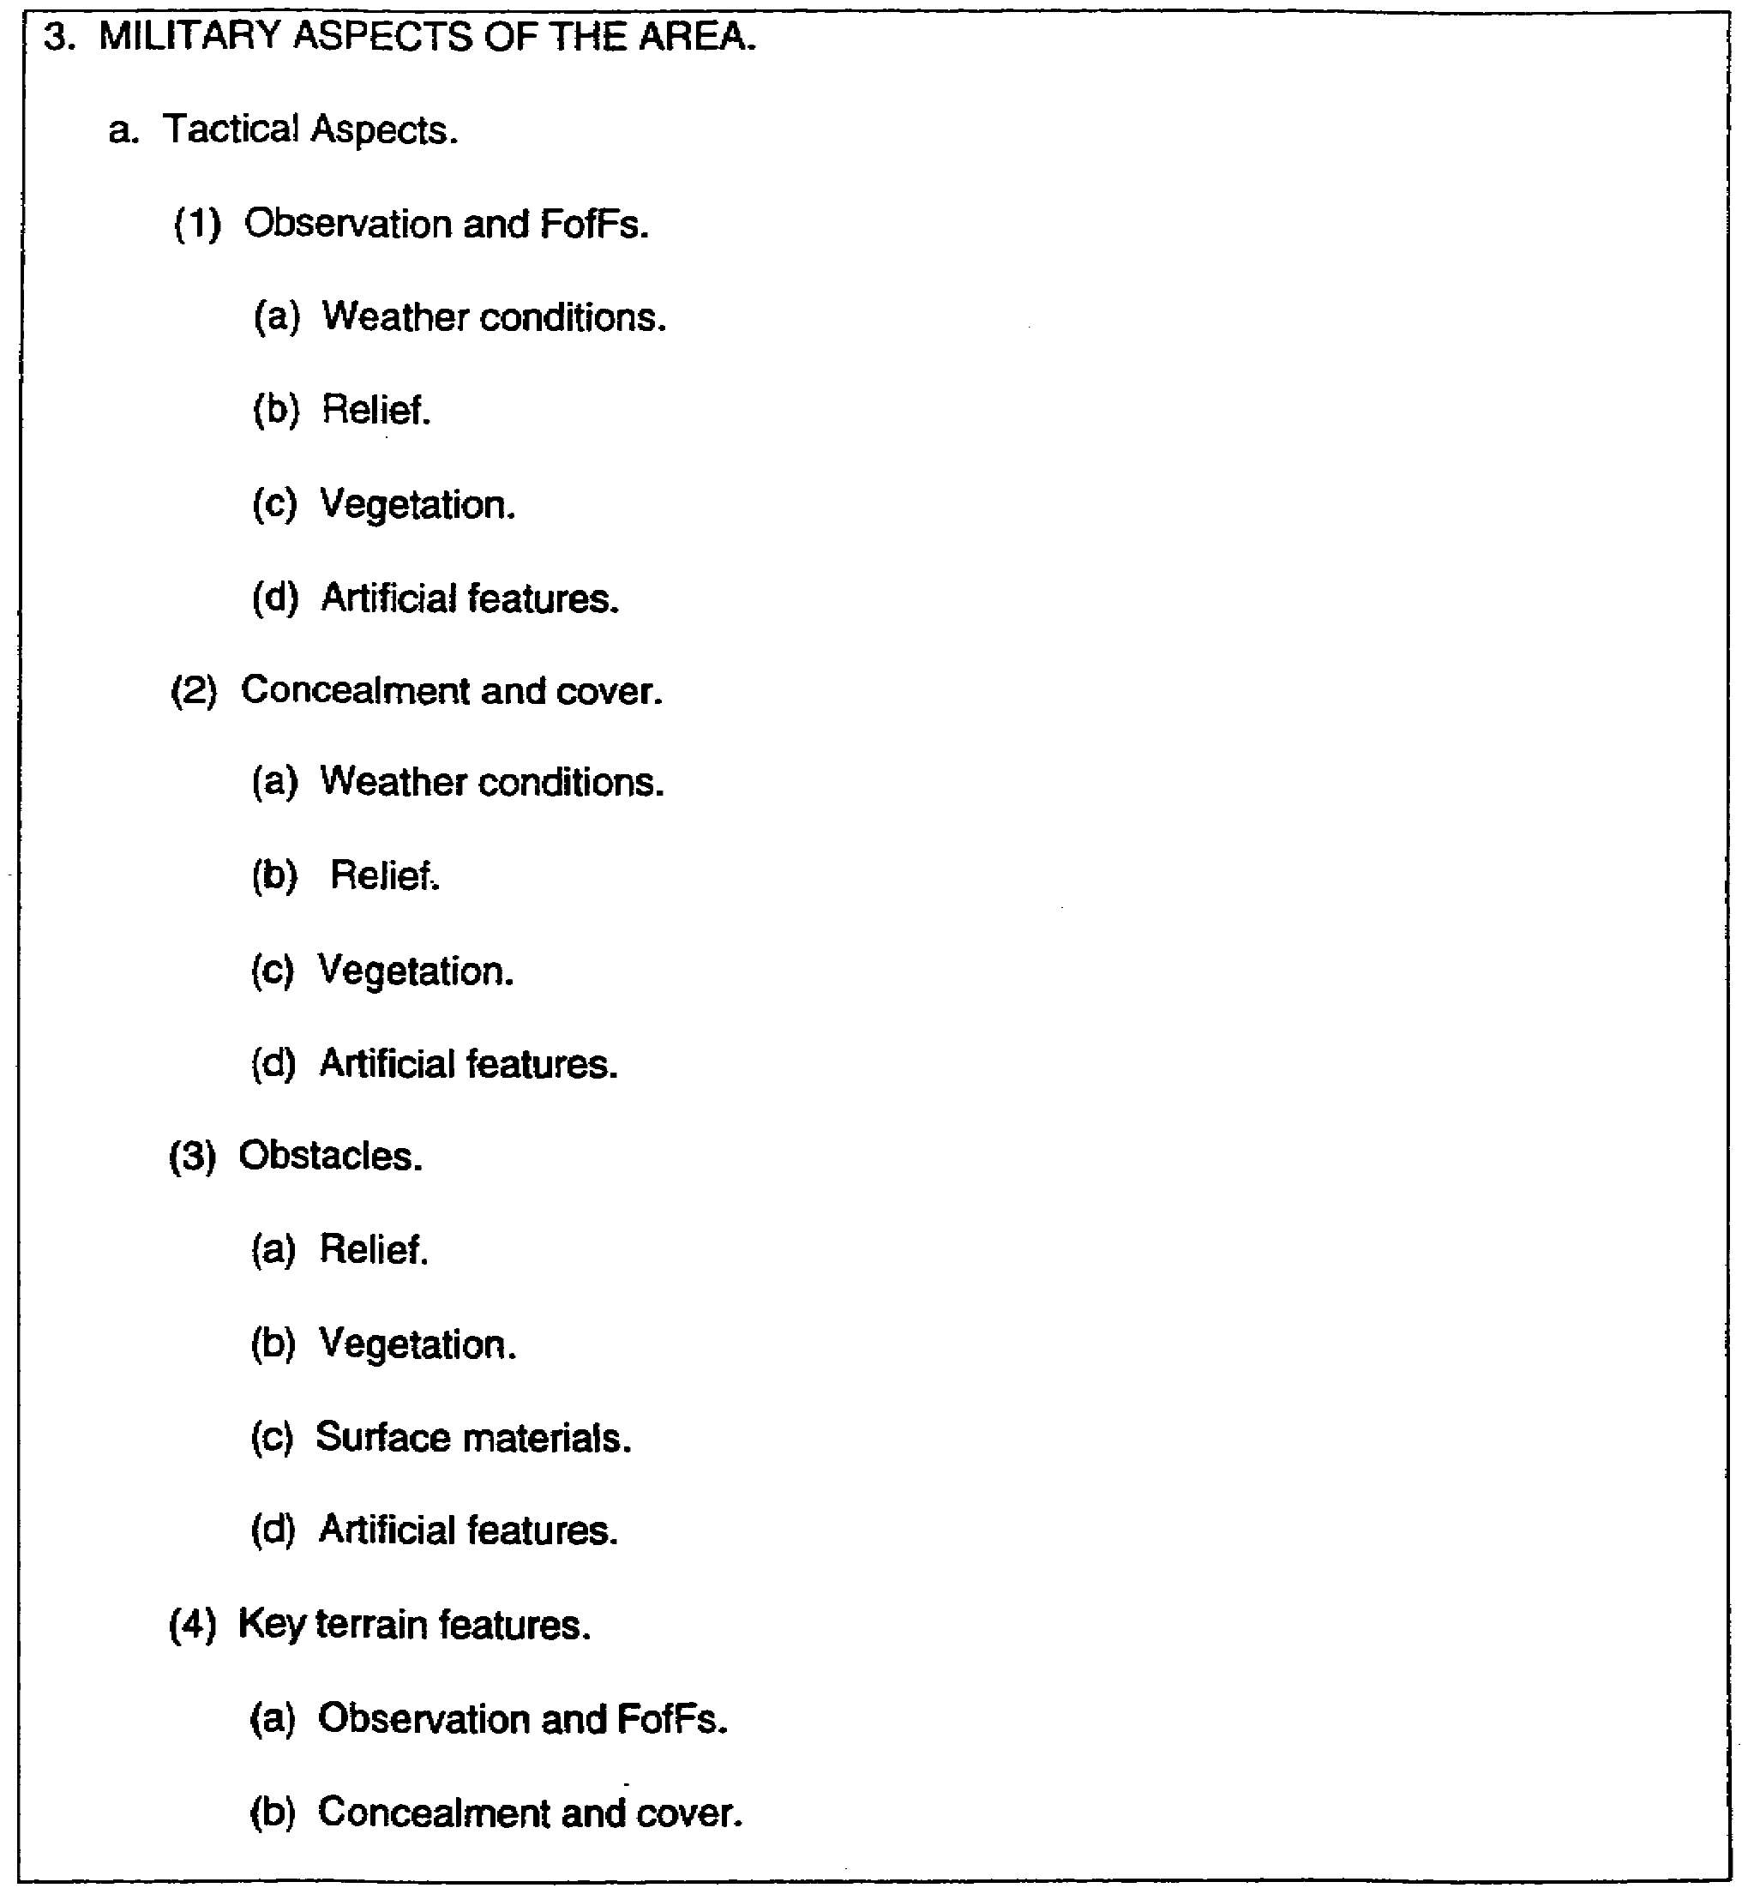

Figure 3-4. Example format-paragraph 3.

IT0566 3-14
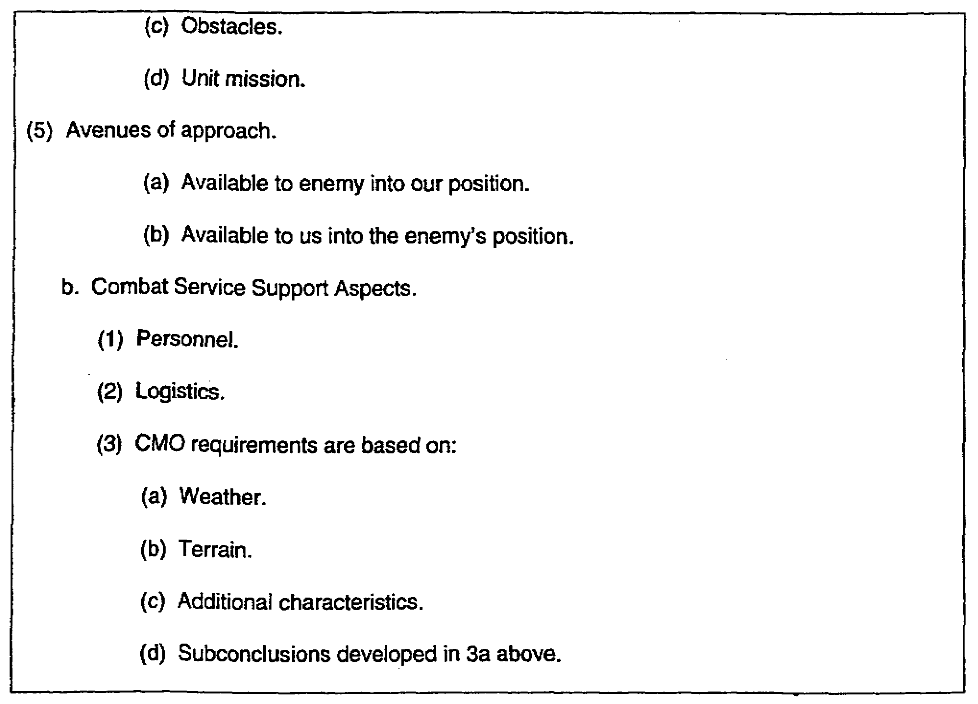

Figure 3-4. Example format-paragraph 3 (concluded).

3. Application. The following examples show how to prepare different topics of paragraph 3 using the data given in paragraph 2a(2):

a. Weather forecast. Following is a weather forecast for a battlefield area. .Using this data, let's prepare the necessary comments for observation and FofFs and concealment and cover (Figure 3-5).

3-15 IT0566
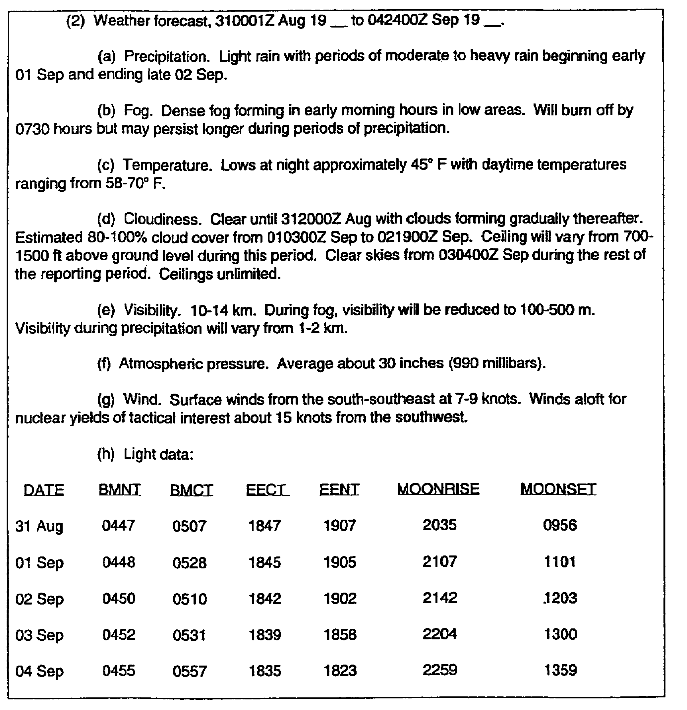

Figure 3-5. Weather forecast.

IT0566 3-16
b. The following example shows how the weather forecast is used in subparagraph 3a (Figure 3-6).

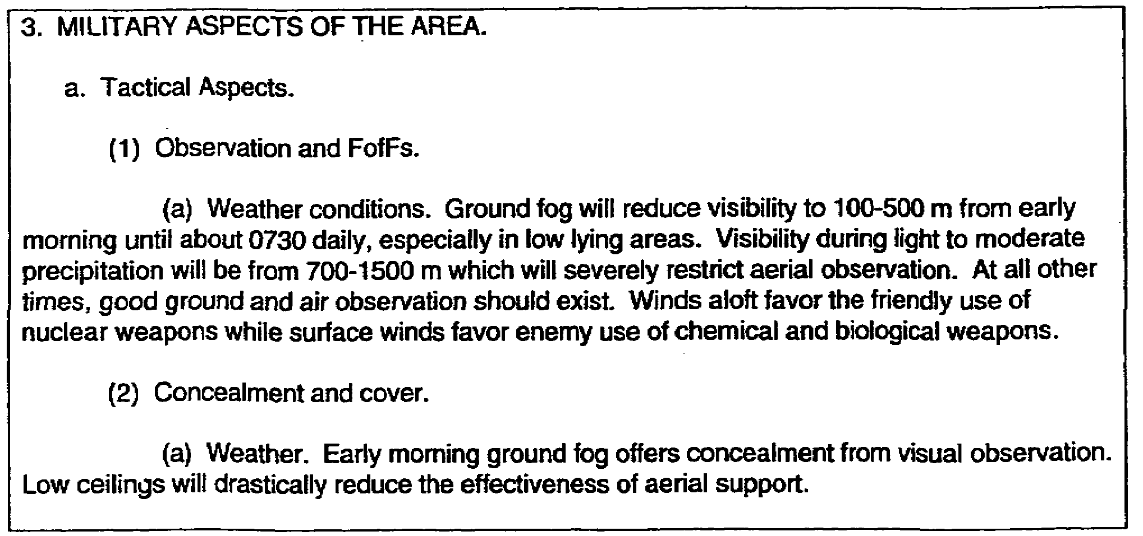

Figure 3-6. Use of weather report for paragraph 3a.

NOTE: Only those aspects that have an impact on observation and concealment and cover are presented. The ground fog and reduced visibility are critical factors in this area. The statements concerning nuclear weapons favoring friendly forces is due to the fact the upper winds from the southwest will cause the radioactive cloud to be blown over enemy areas while the surface winds are blowing toward friendly areas, which favor the enemy's use of chemical and/or biological agents.

c. On the following pages is an extract of a completed paragraph 2 of the analysis of the battlefield area. Note a mission statement from paragraph 1 is also provided. The weather information will be the same as just presented (Figure 3-7).

3-17 IT0566
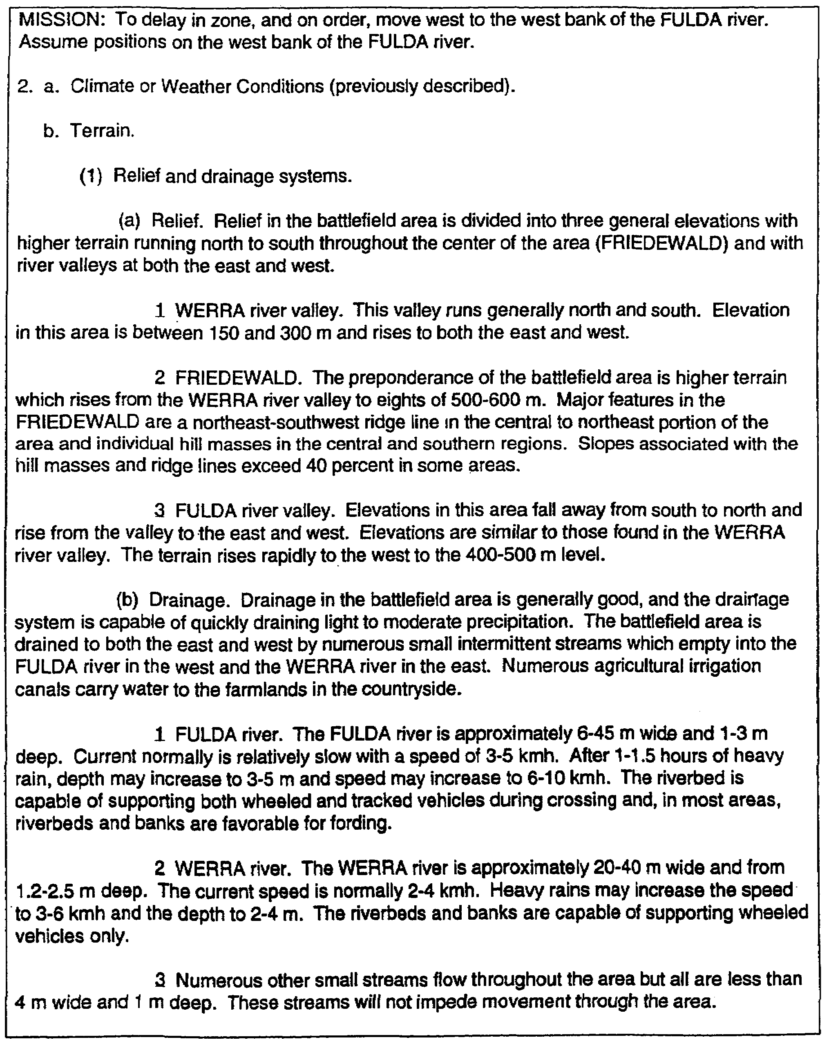

Figure 3-7. Paragraph 2.

IT0566 3-18
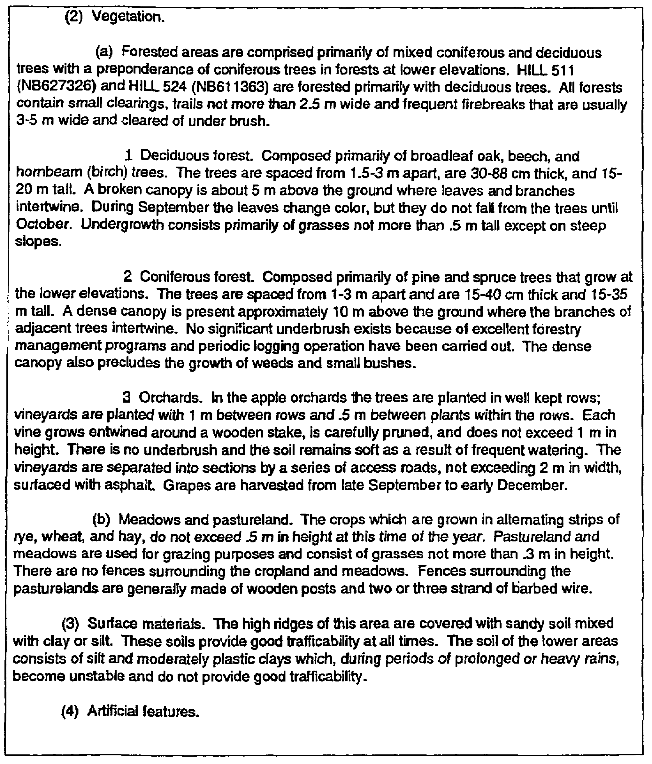

Figure 3-7. Paragraph 2 (continued).

3-19 IT0566
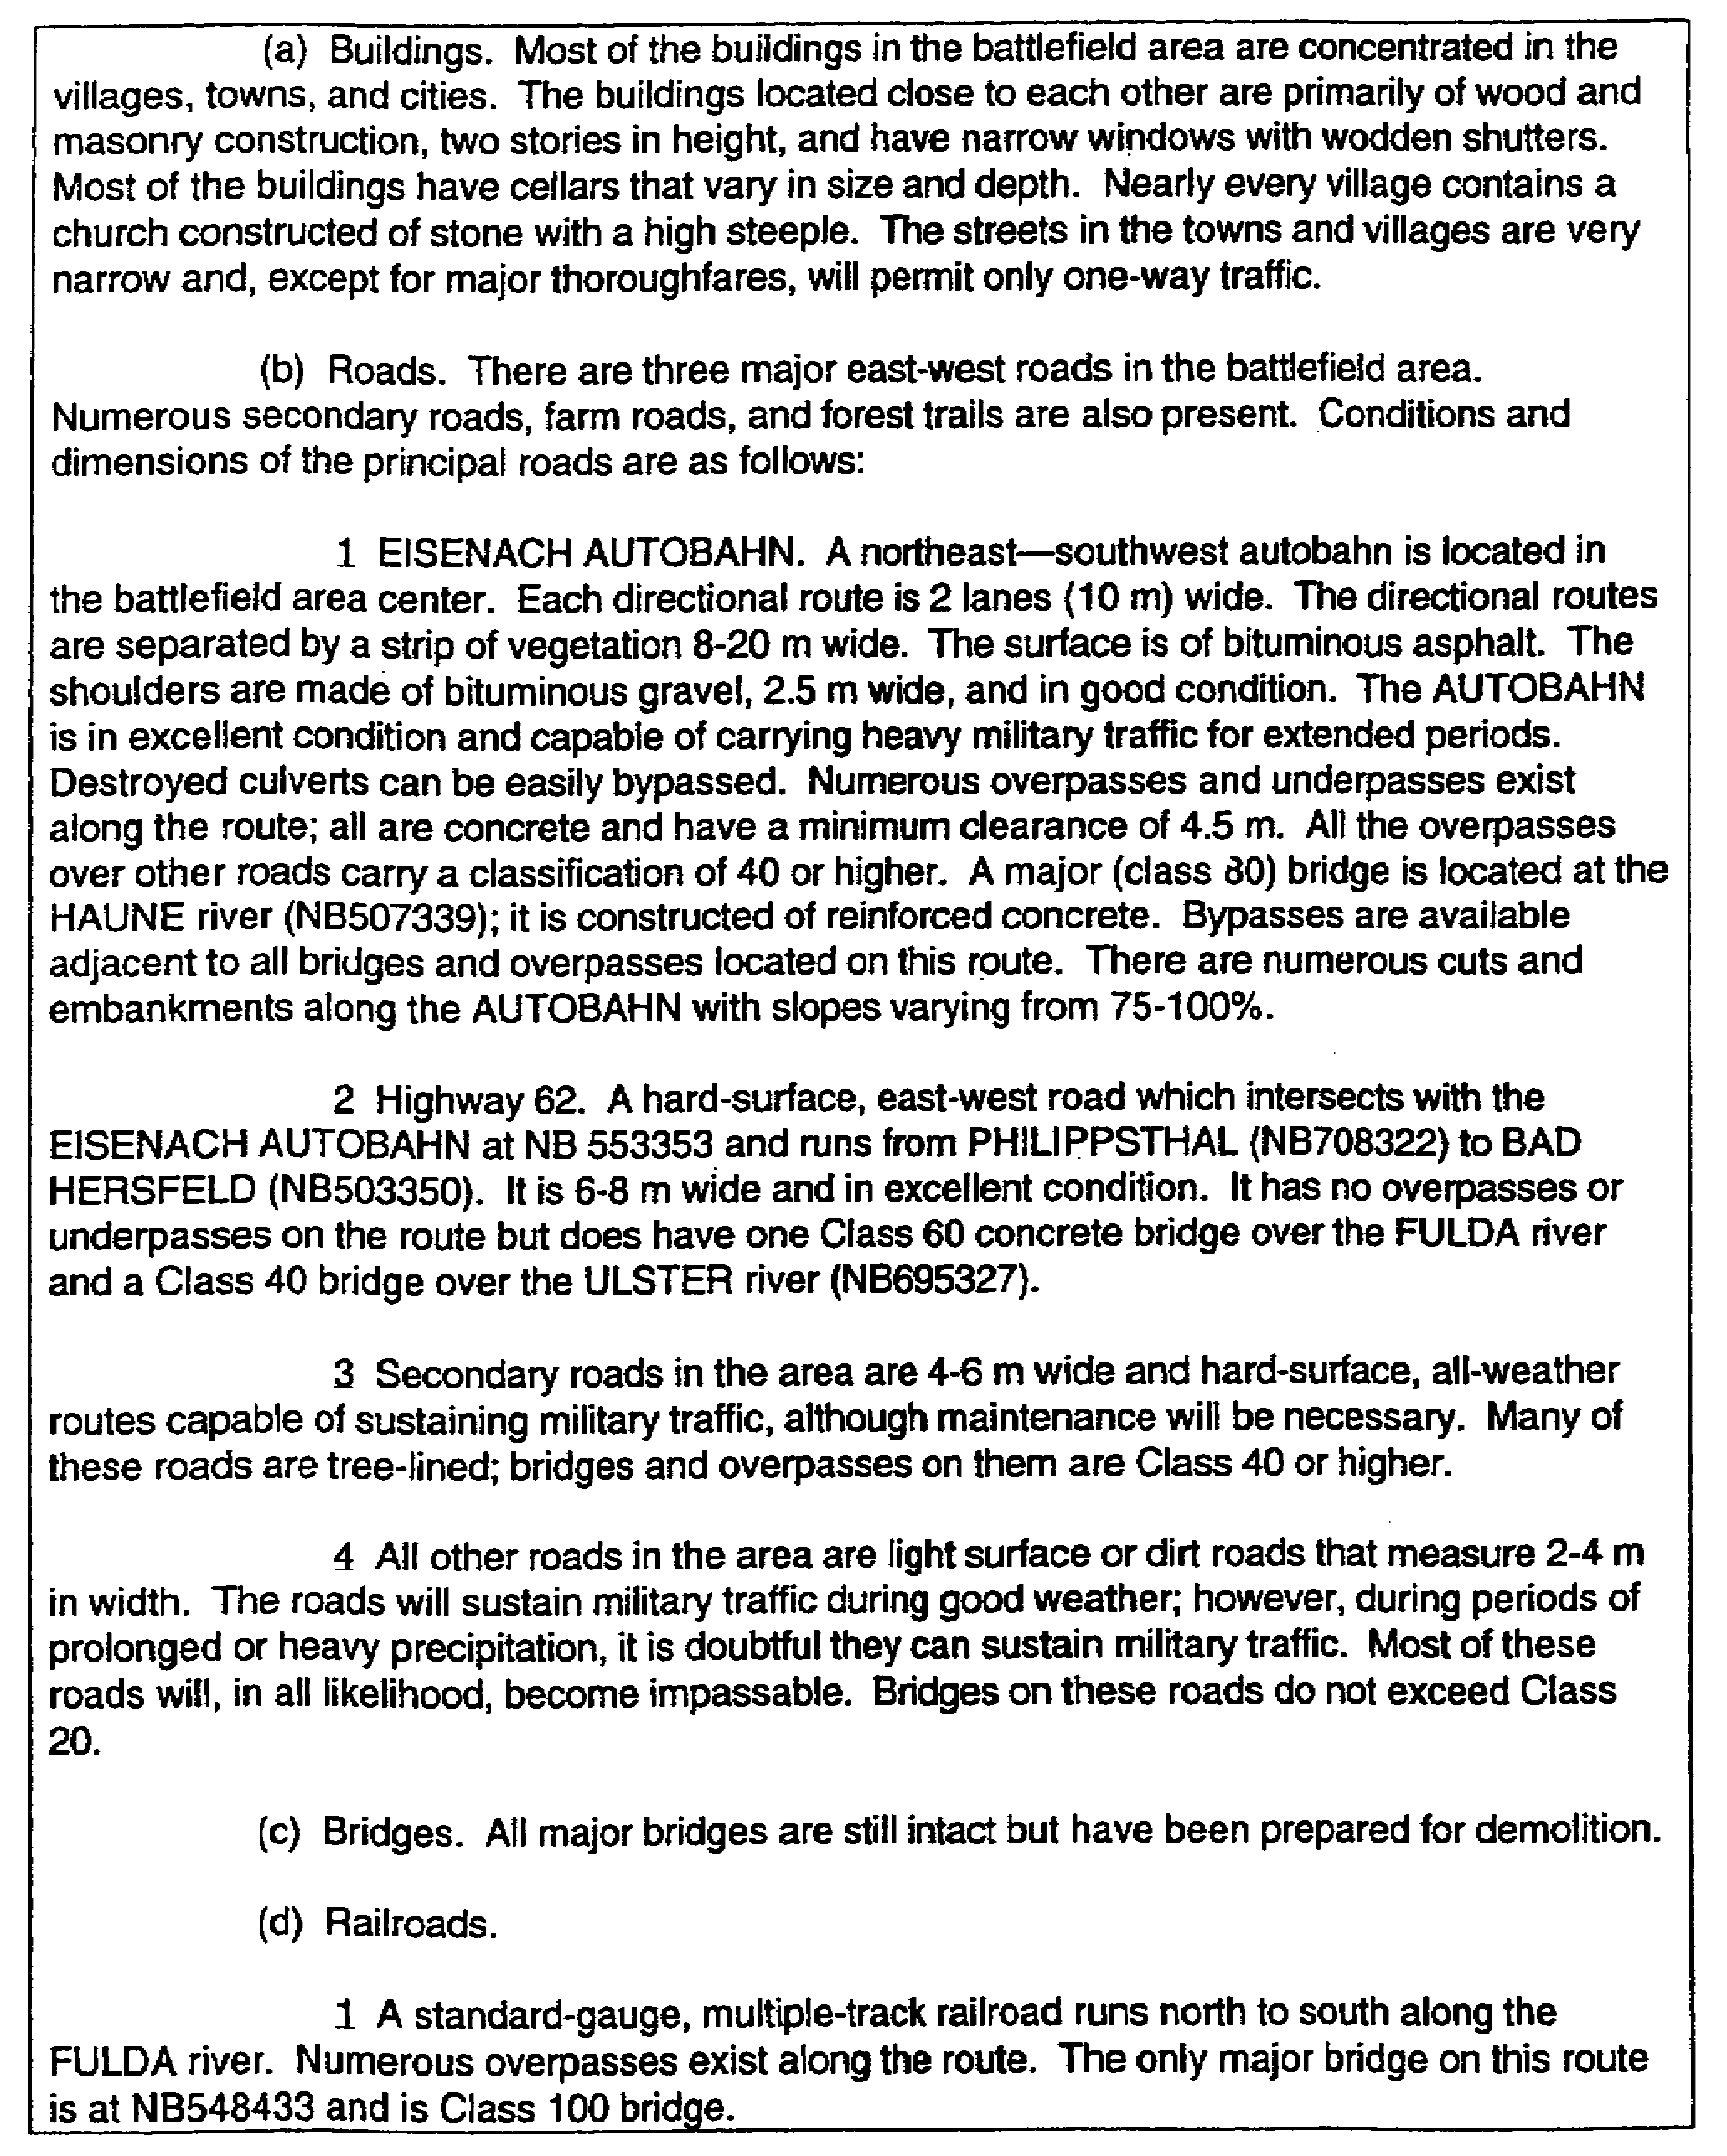

Figure 3-7. Paragraph 2 (continued).

IT0566 3-20
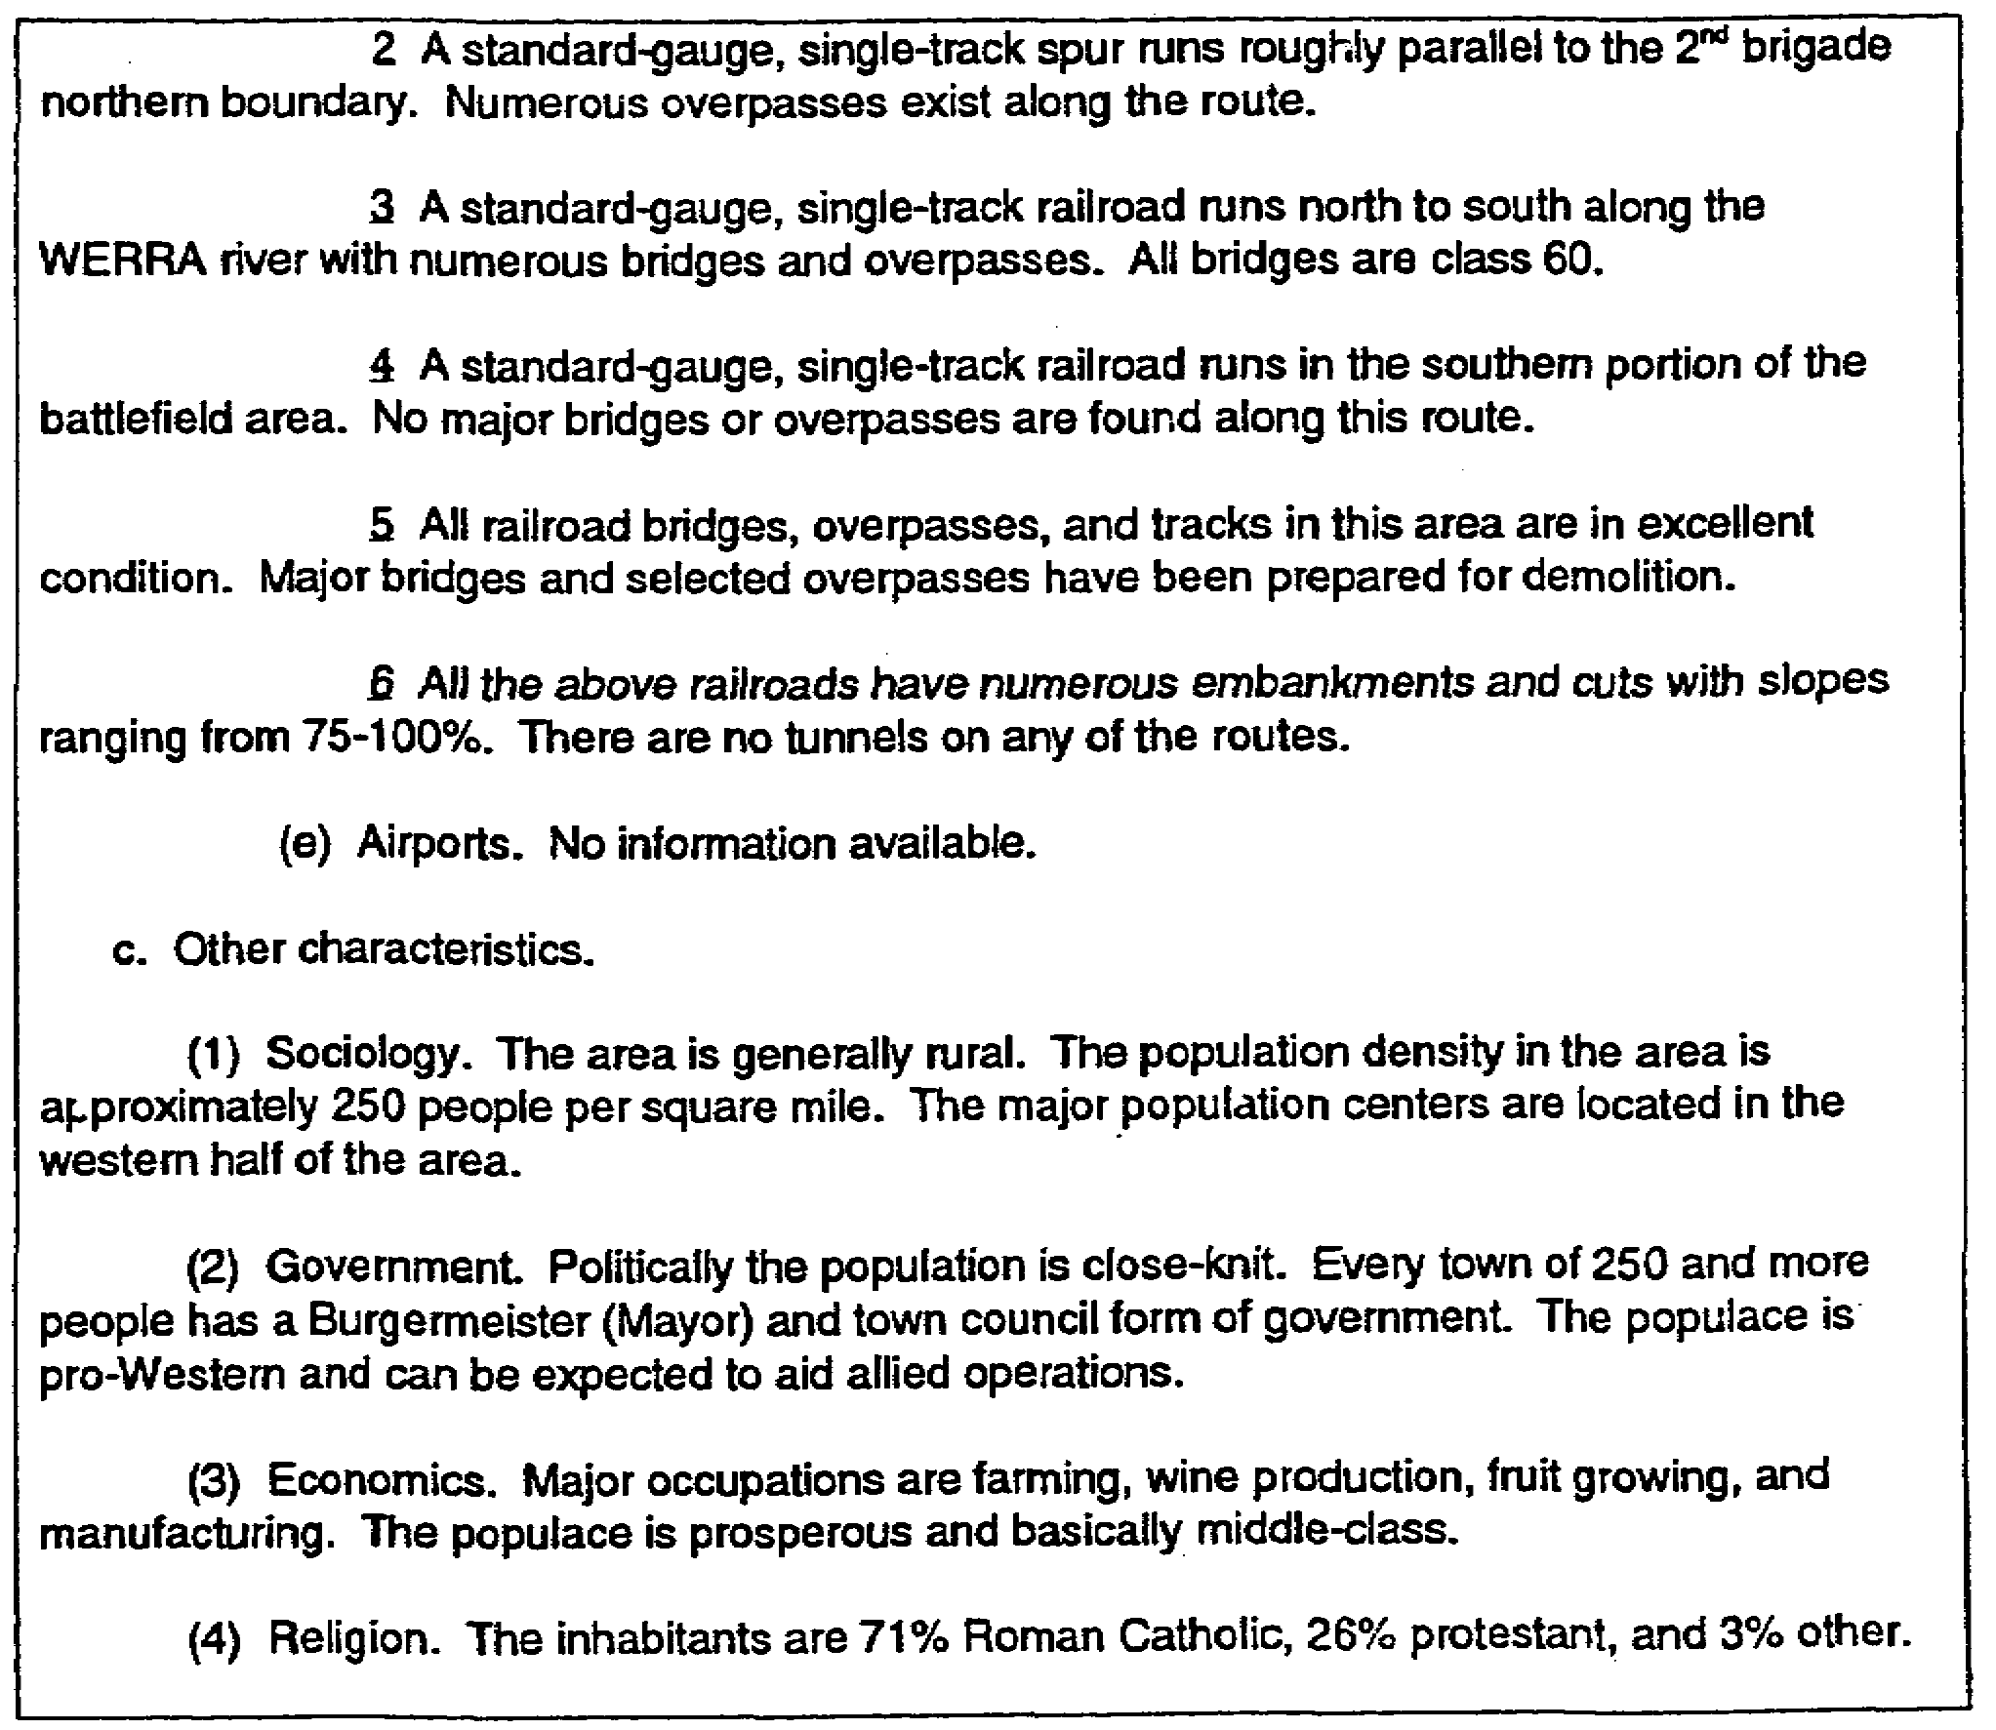

Figure 3-7. Paragraph 2 (continued).

4. Preparation of paragraph 3a. The following example (Figure 3-7) shows how to prepare paragraph 3a, 'Tactical Aspects" from information presented in paragraph 2 (Figure 3-8).

3-21 IT0566
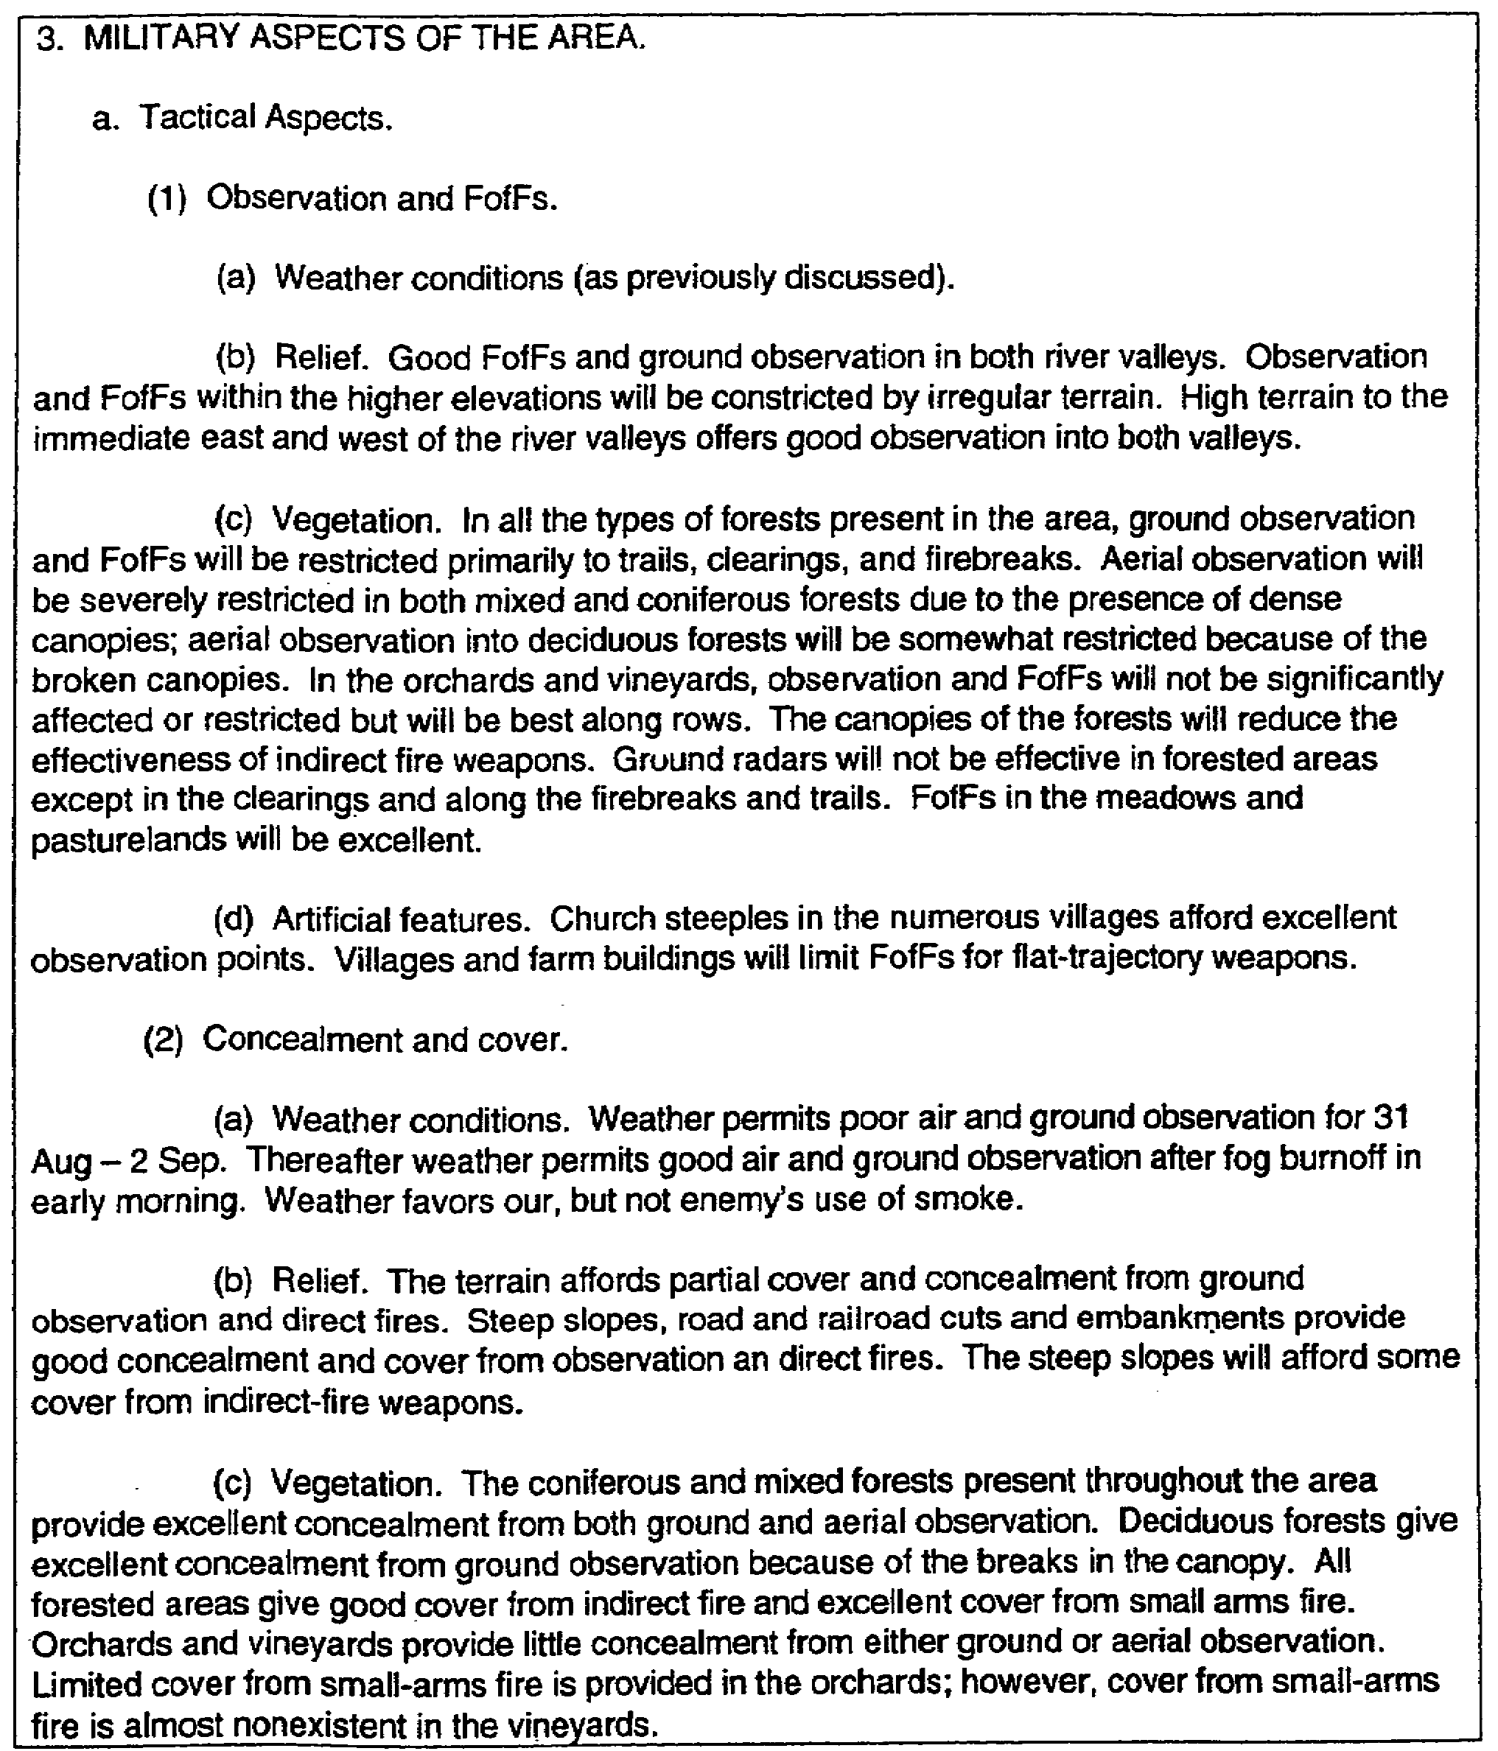

Figure 3-8. Preparation of paragraph 3a.

IT0566 3-22
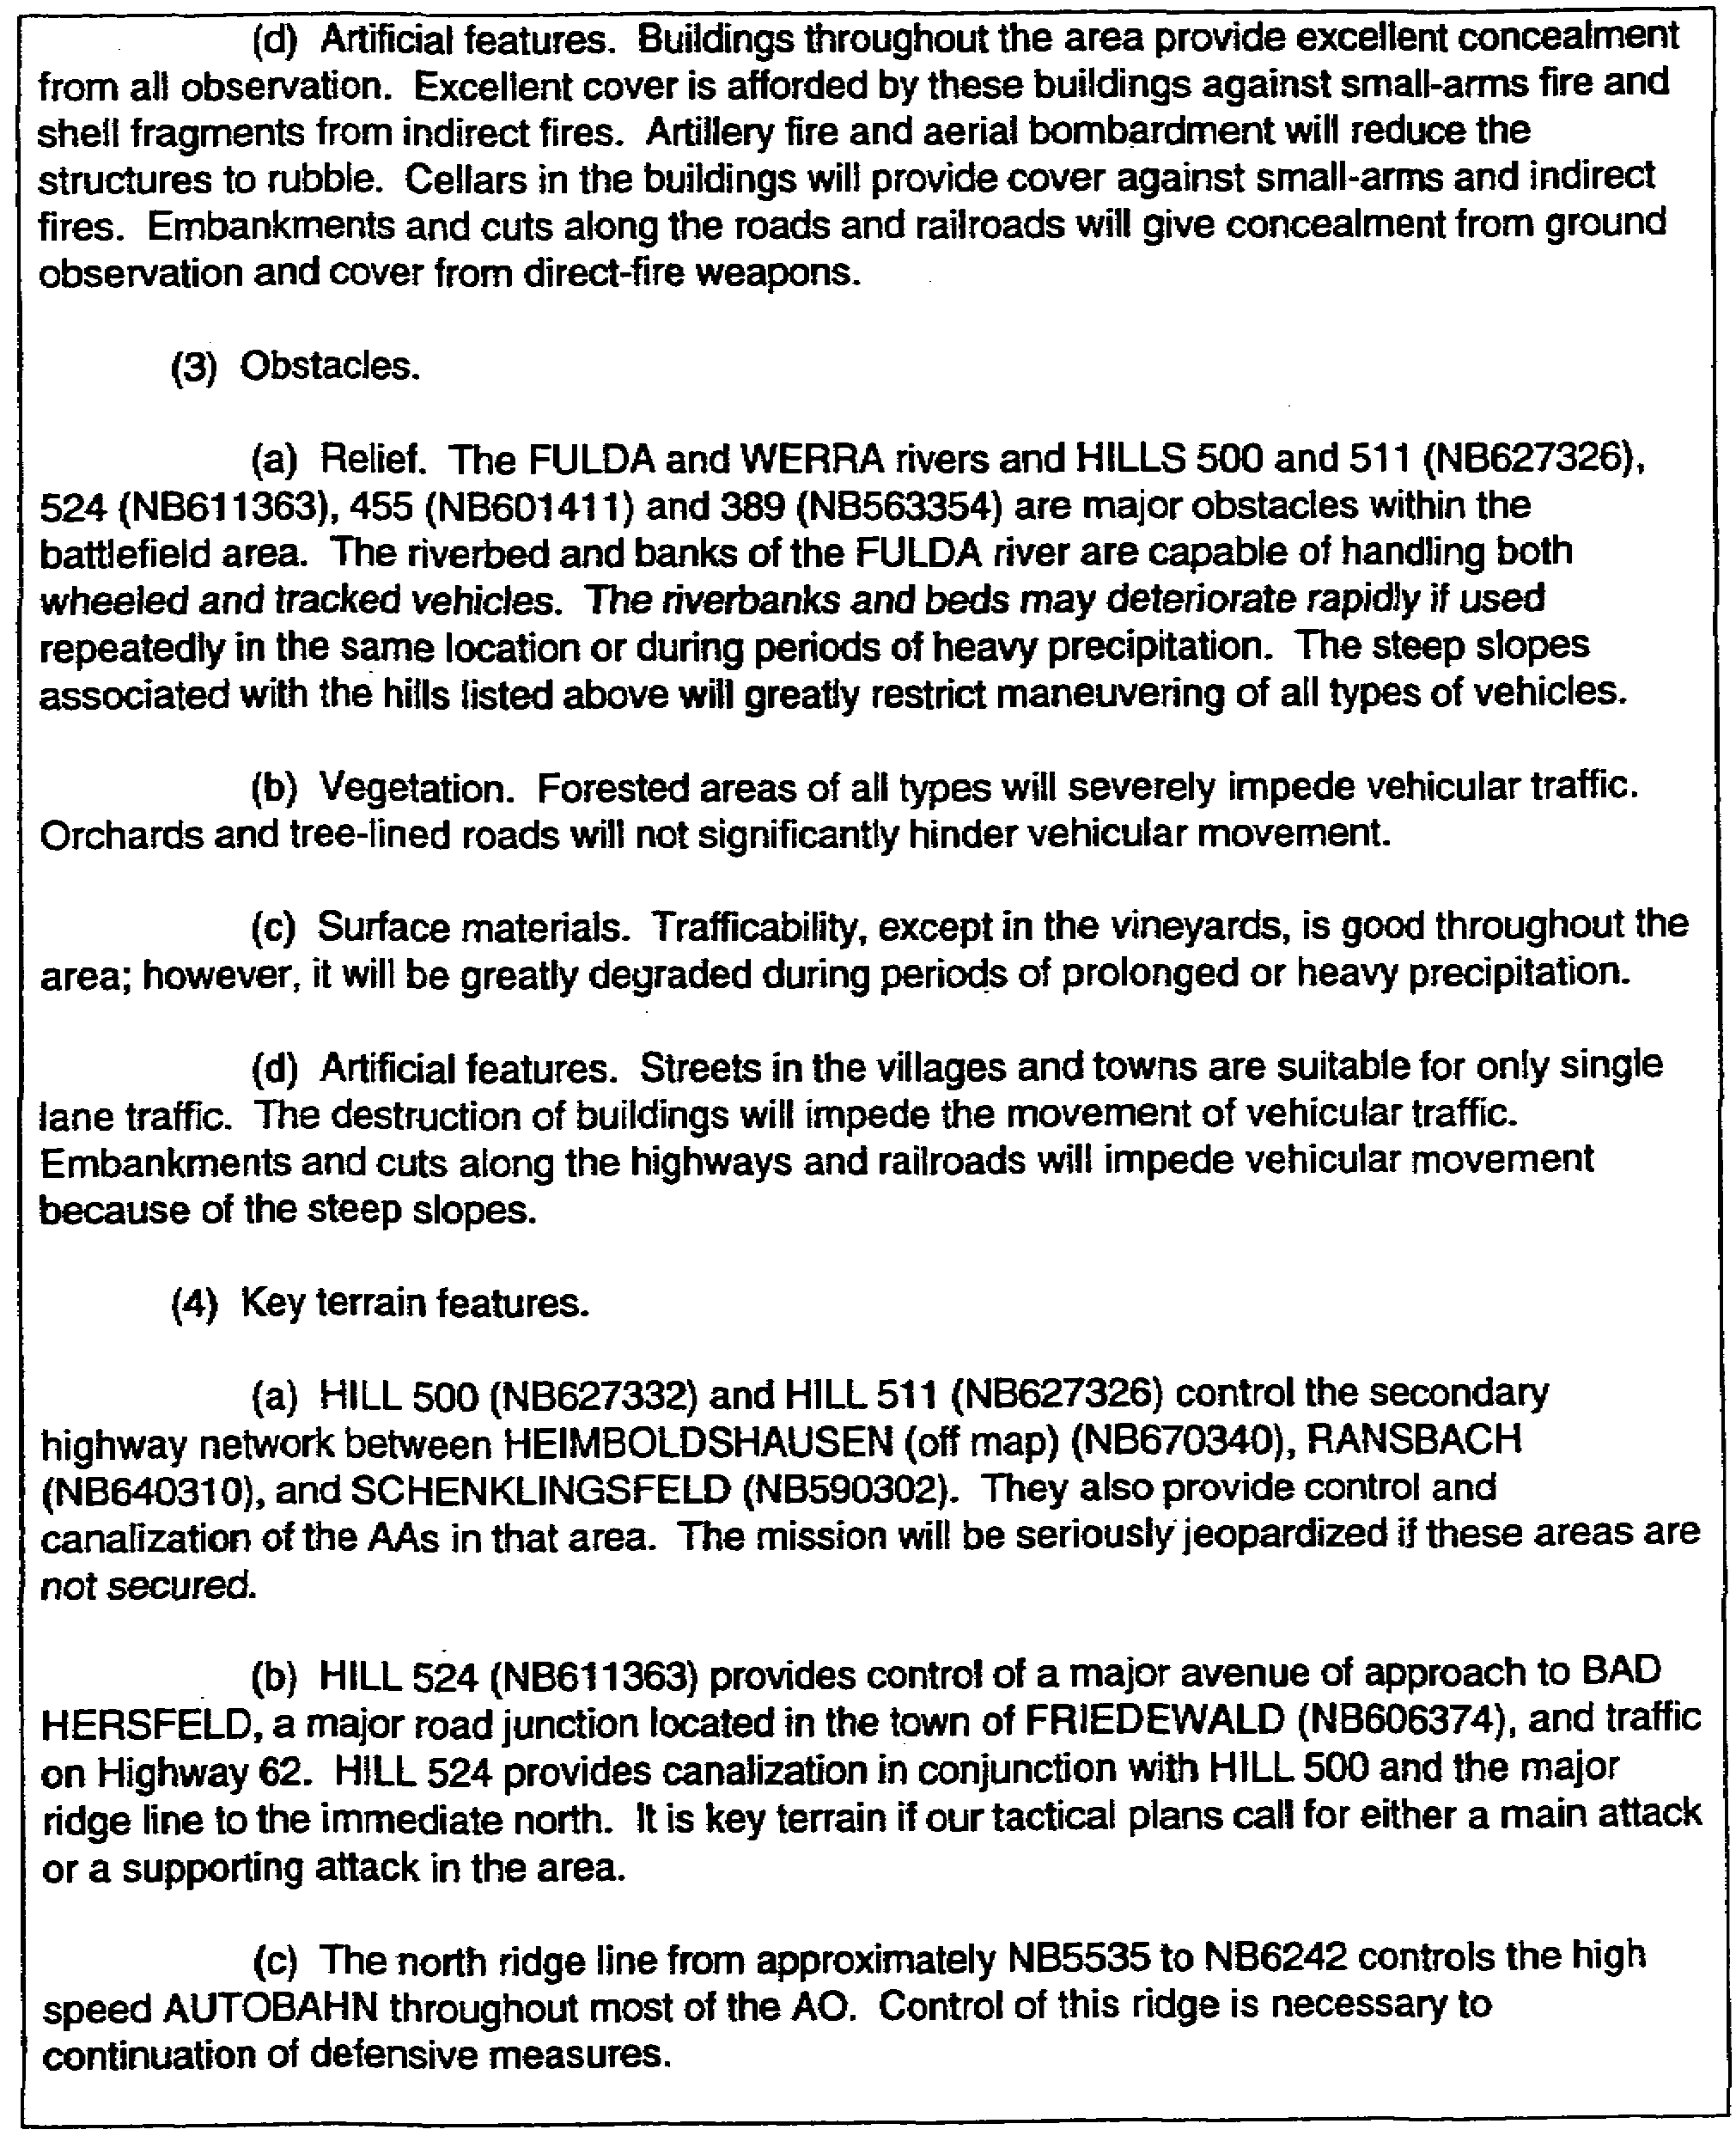

Figure 3-8. Preparation of paragraph 3a (continued).

3-23 IT0566
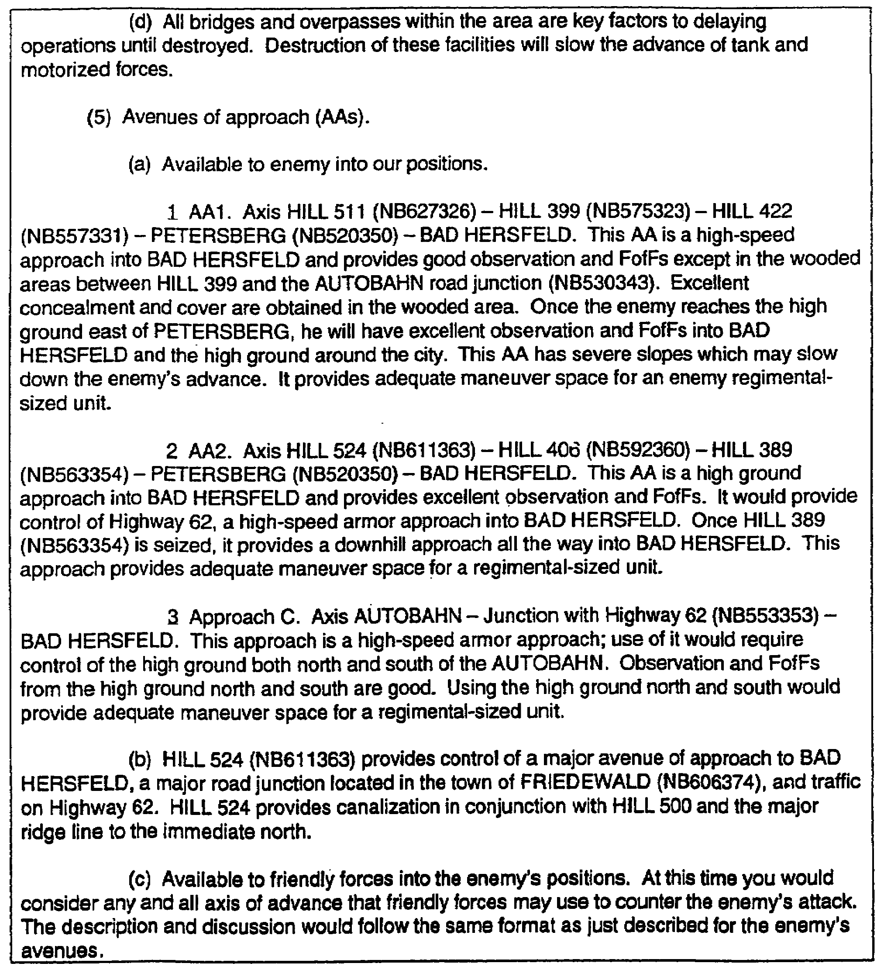

Figure 3-8. Preparation of paragraph 3a (concluded).

NOTE: At this time, it is important you realize the solutions presented here are not the only acceptable ones. What is critical, however, is if you understand that under each of the preceding topical headings, the necessary elements of weather and terrain are discussed. Under terrain the four major elements of relief, vegetation, surface materials, and artificial features are examined and presented in the analysis.

IT0566 3-24
5. Preparation of paragraph 3b. The following example (Figure 3-9) shows how to prepare subparagraph 3b, Combat Service Support Aspects.

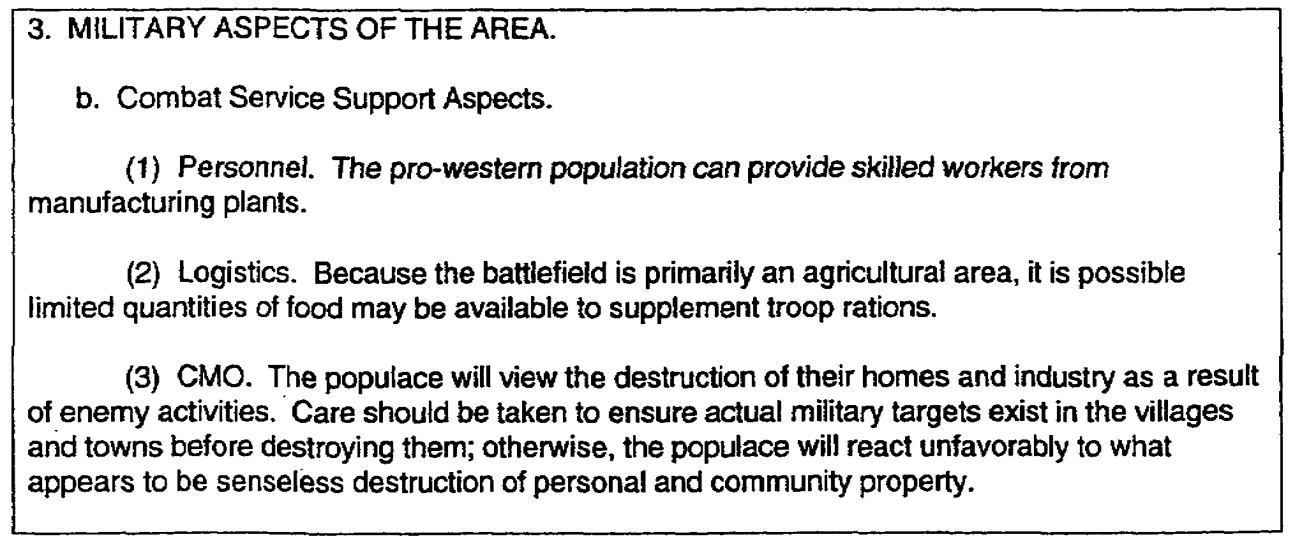

Figure 3-9. Preparation of subparagraph 3b.

NOTE: As you can see from the foregoing, a great and varying amount of data interpretation and thought processing are required to prepare paragraph 3 of the analysis. The purpose of this lesson is to acquaint you with the format and the types of information used to prepare this part of the analysis. While no two individuals will prepare the analysis using the same rationale, if you remember the required areas that are evaluated and how they are presented, you will be able to prepare the analysis of the battlefield in a competent manner.

3-25 IT0566
LESSON 3

PRACTICE EXERCISE

The following items will test your grasp of the material covered in this lesson. There is only one correct answer for each item. When you have completed the exercise, check your answers with the answer key that follows. If you answer any item incorrectly, study again that part of the lesson which contains the portion involved.

1. Which considerations should you primarily base the analysis of an AA on?

A. Climate.

B. Weather conditions.

C. Terrain.

D. Other characteristics.

2. What should you consider as protection from the effects of fire?

A. Concealment.

B. Cover.

C. Obstacles.

D. Key terrain features.

3. Which AAs should be free of obstacles or obstructions?

A. Ground.

B. Rear.

C. Defensive.

D. Air.

4. Given the following information from paragraph 2 of the analysis of the battlefield area (Figure 3-10), prepare subparagraph 3a(2), (tactical aspects for) concealment and cover.

3-27 IT0566
MISSION: Attack north 140600Z Sep to seize objective "X". Be prepared to continue attack
north on corps order.

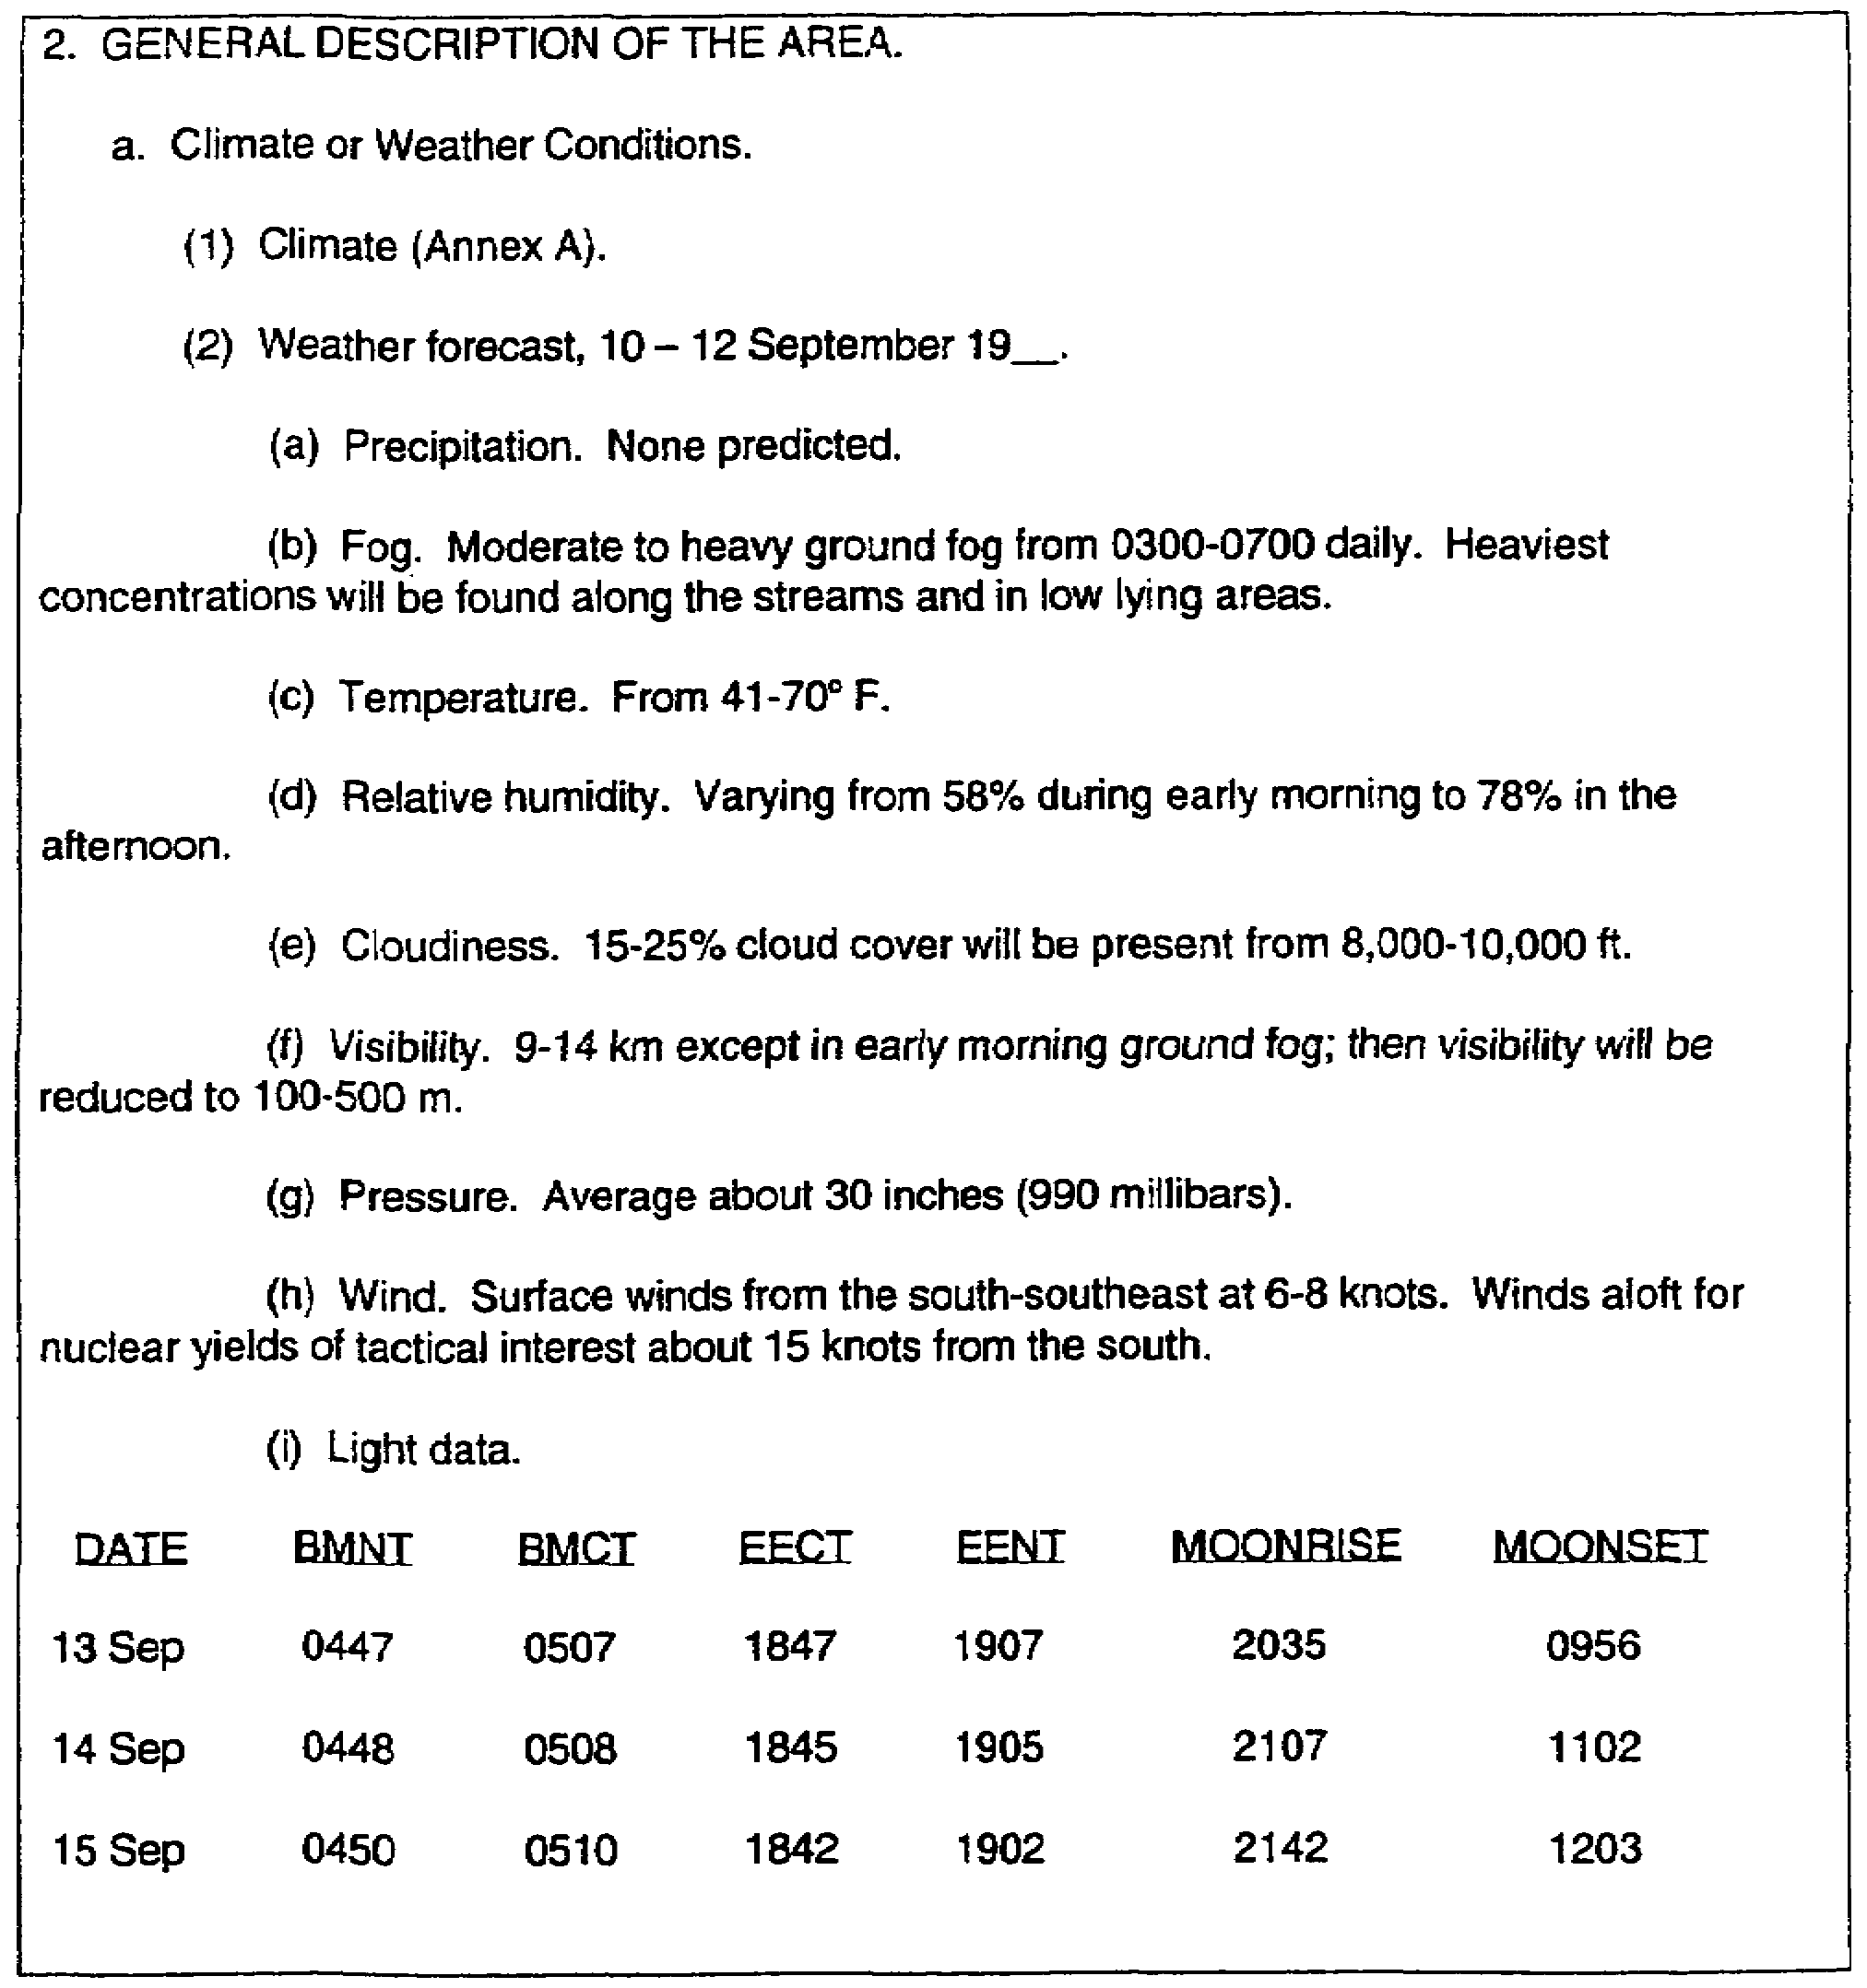

Figure 3-10. Paragraph 2 for Practice Exercise.

IT0566 3-26
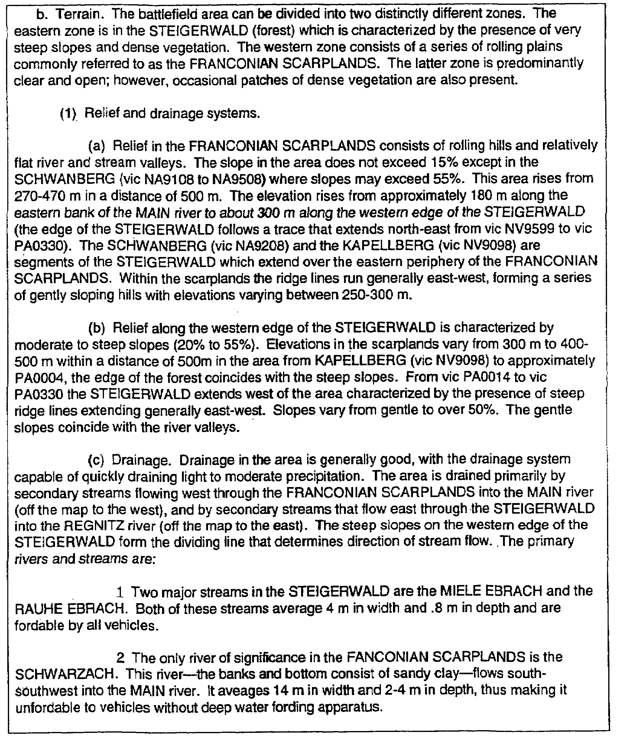

Figure 3-10. Paragraph 2 for practice exercise (continued).

3-29 IT0566
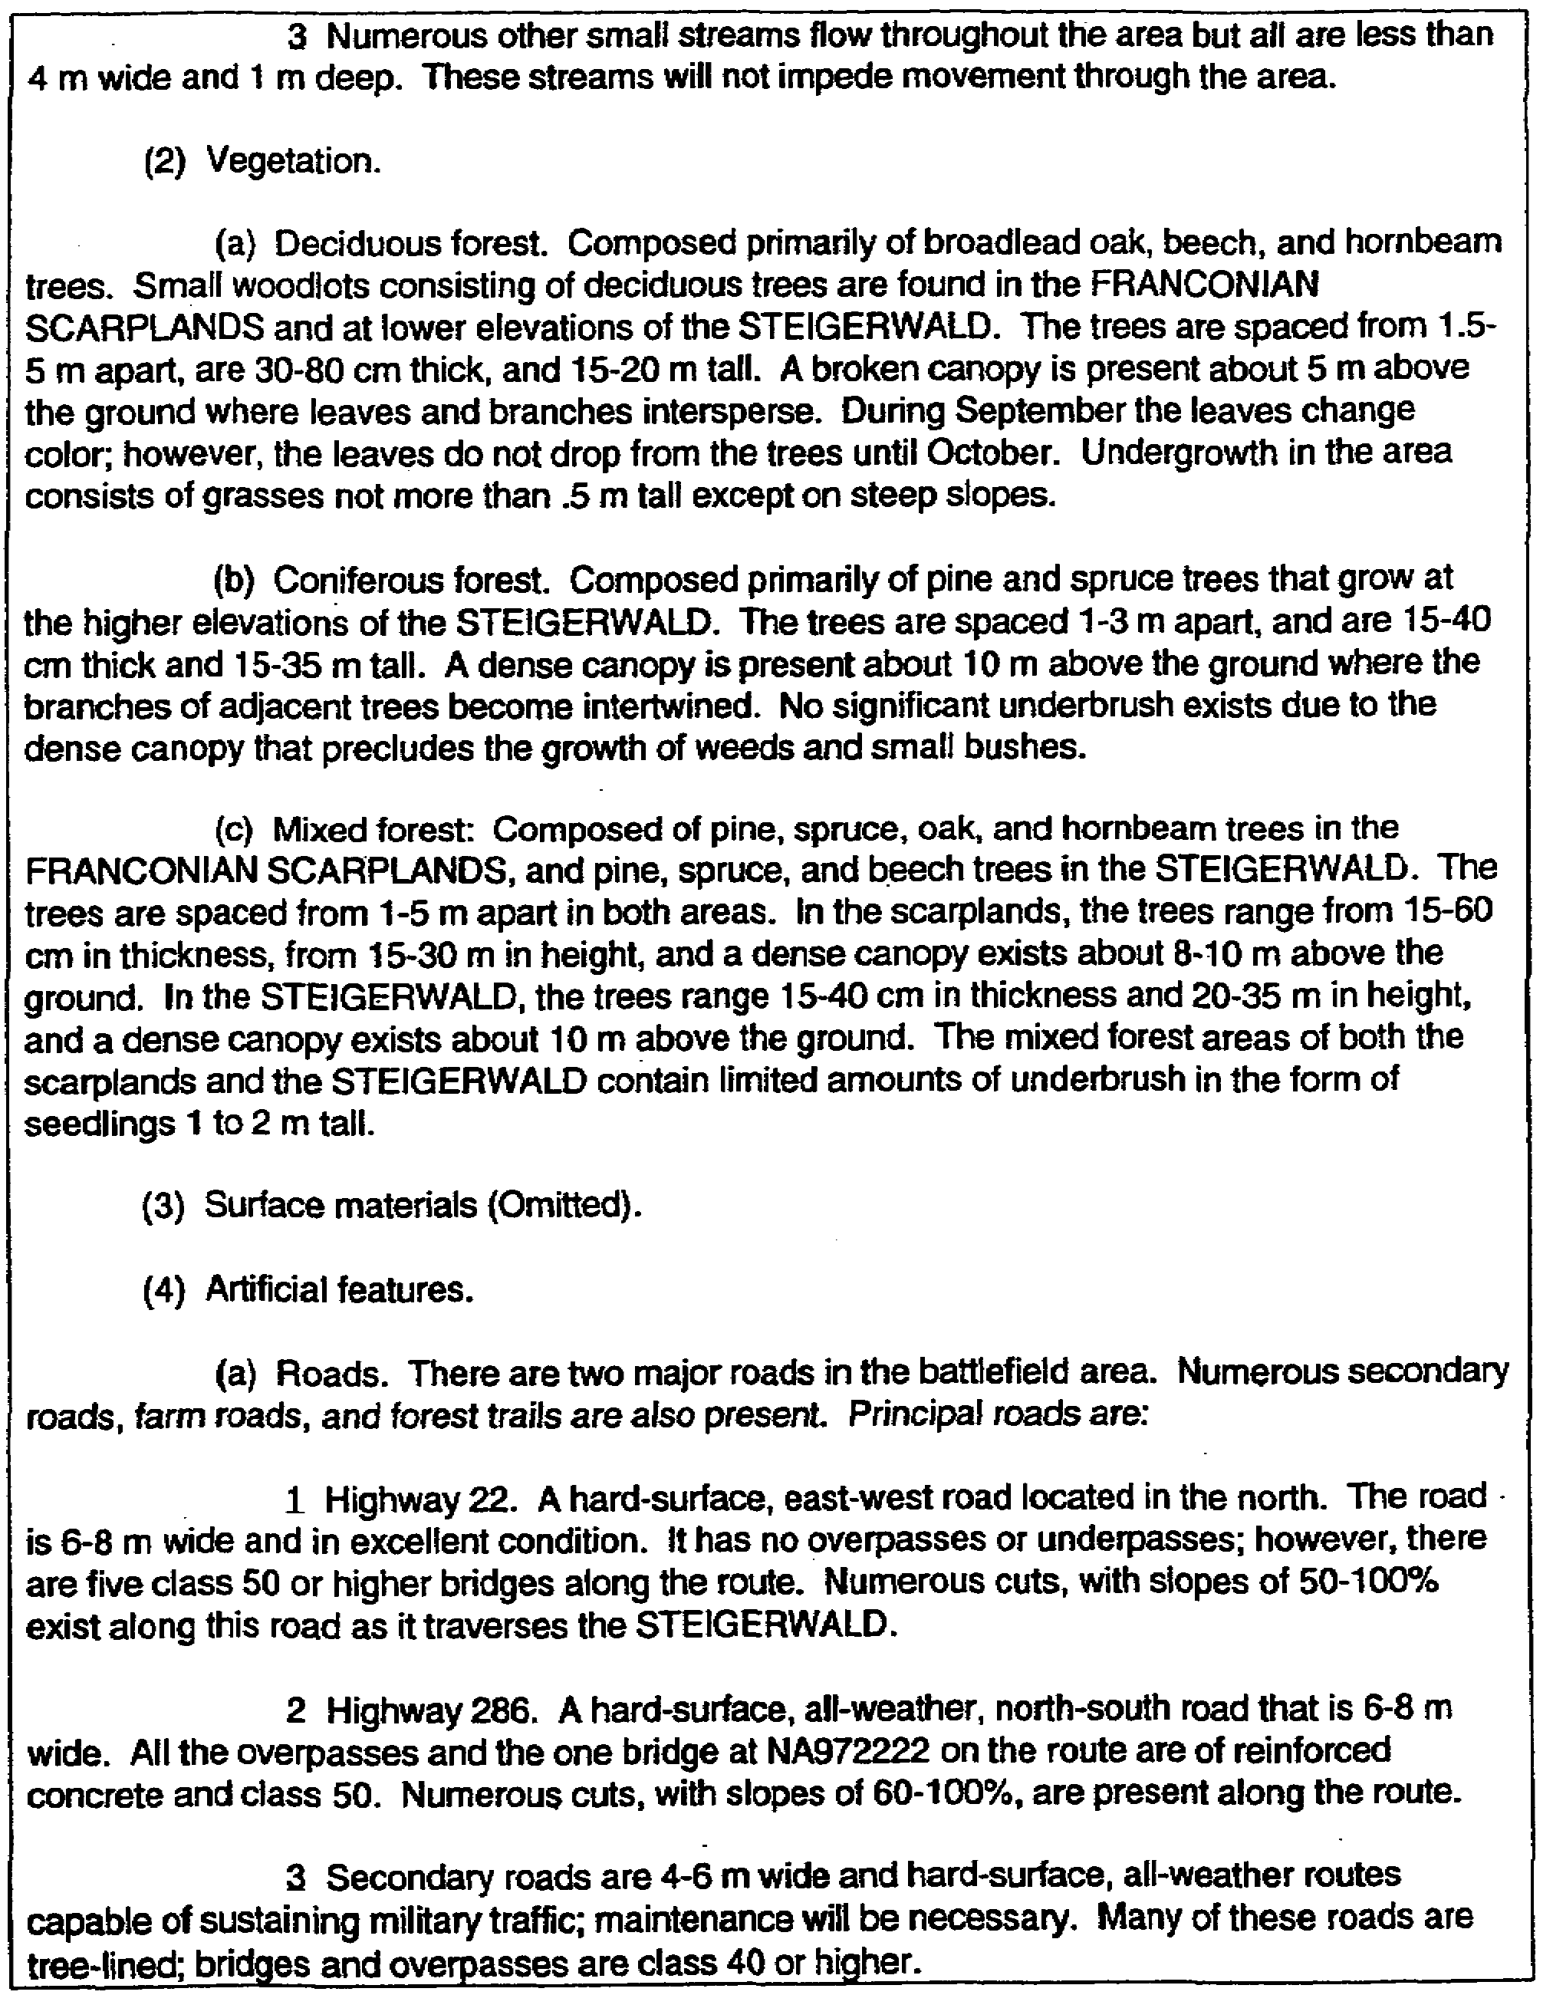

Figure 3-10. Paragraph 2 for practice exercise (continued).

IT0566 3-30
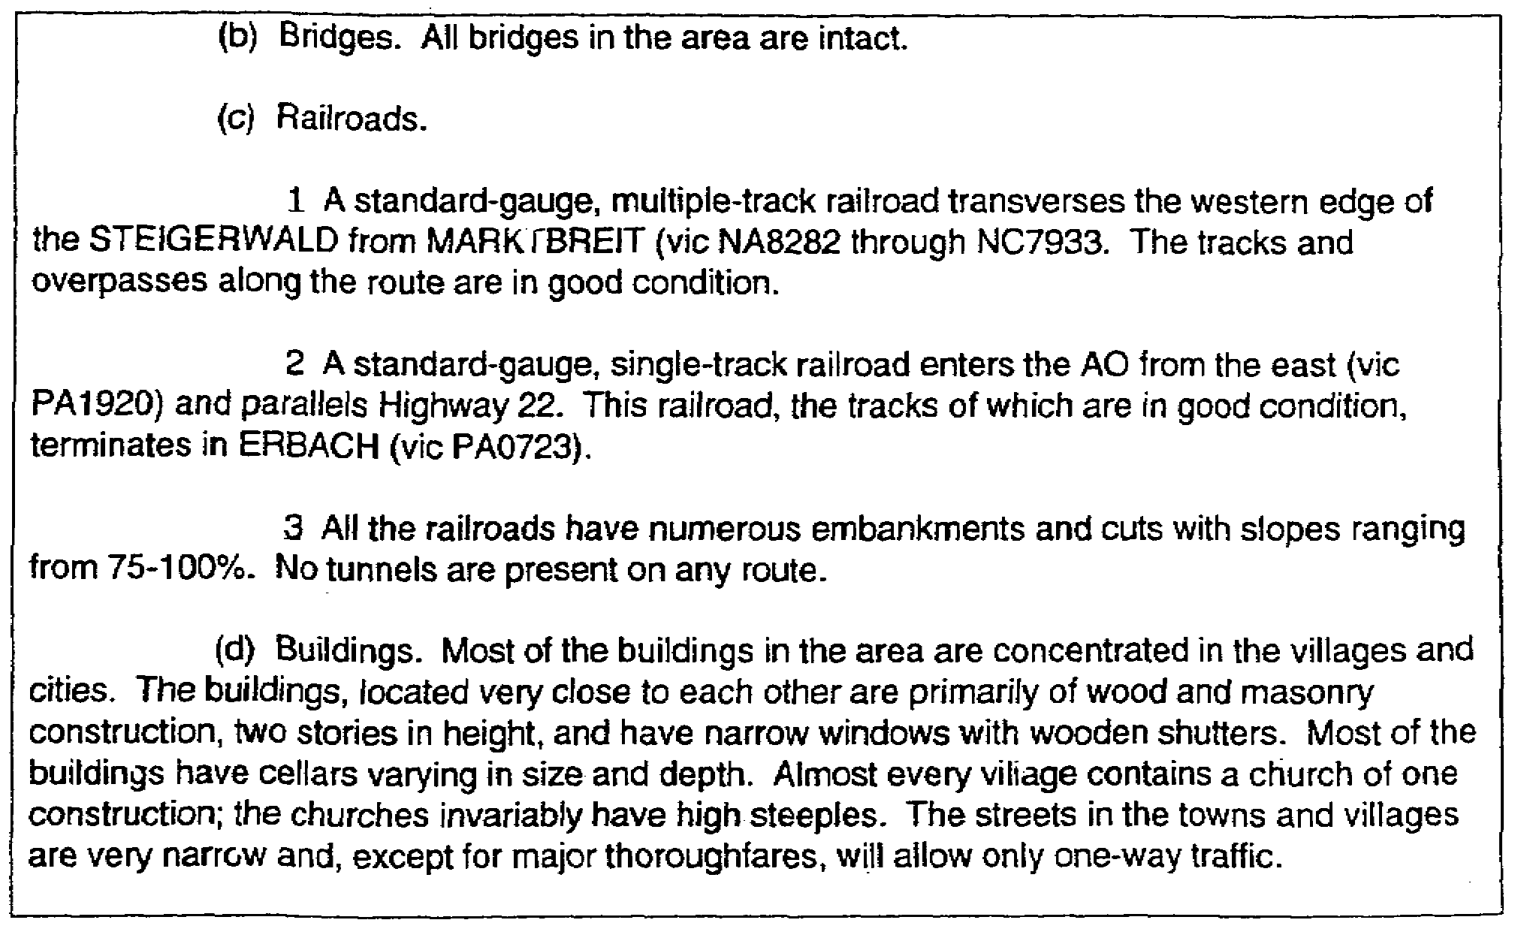

Figure 3-10. Paragraph 2 for practice exercise (concluded).

3-31 IT0566
LESSON 3

PRACTICE EXERCISE

ANSWER KEY AND FEEDBACK

Item Correct Answer and Feedback

1. C. You should base the analysis of an AA on terrain considerations (page 3-7, Remember).

2. B. You should consider cover as protection from the effects of fire (page 3-2, para 2b(2).

3. D. The air avenue of approach should be free of obstacles and obstructions (page 3-7, para 2e(5)(b).

4. Following is an example (Figure 3-11) how to complete paragraph 3a(2), concealment and cover, based on provided information (pages 3-2/3-22, para 2b/fig 3-8).

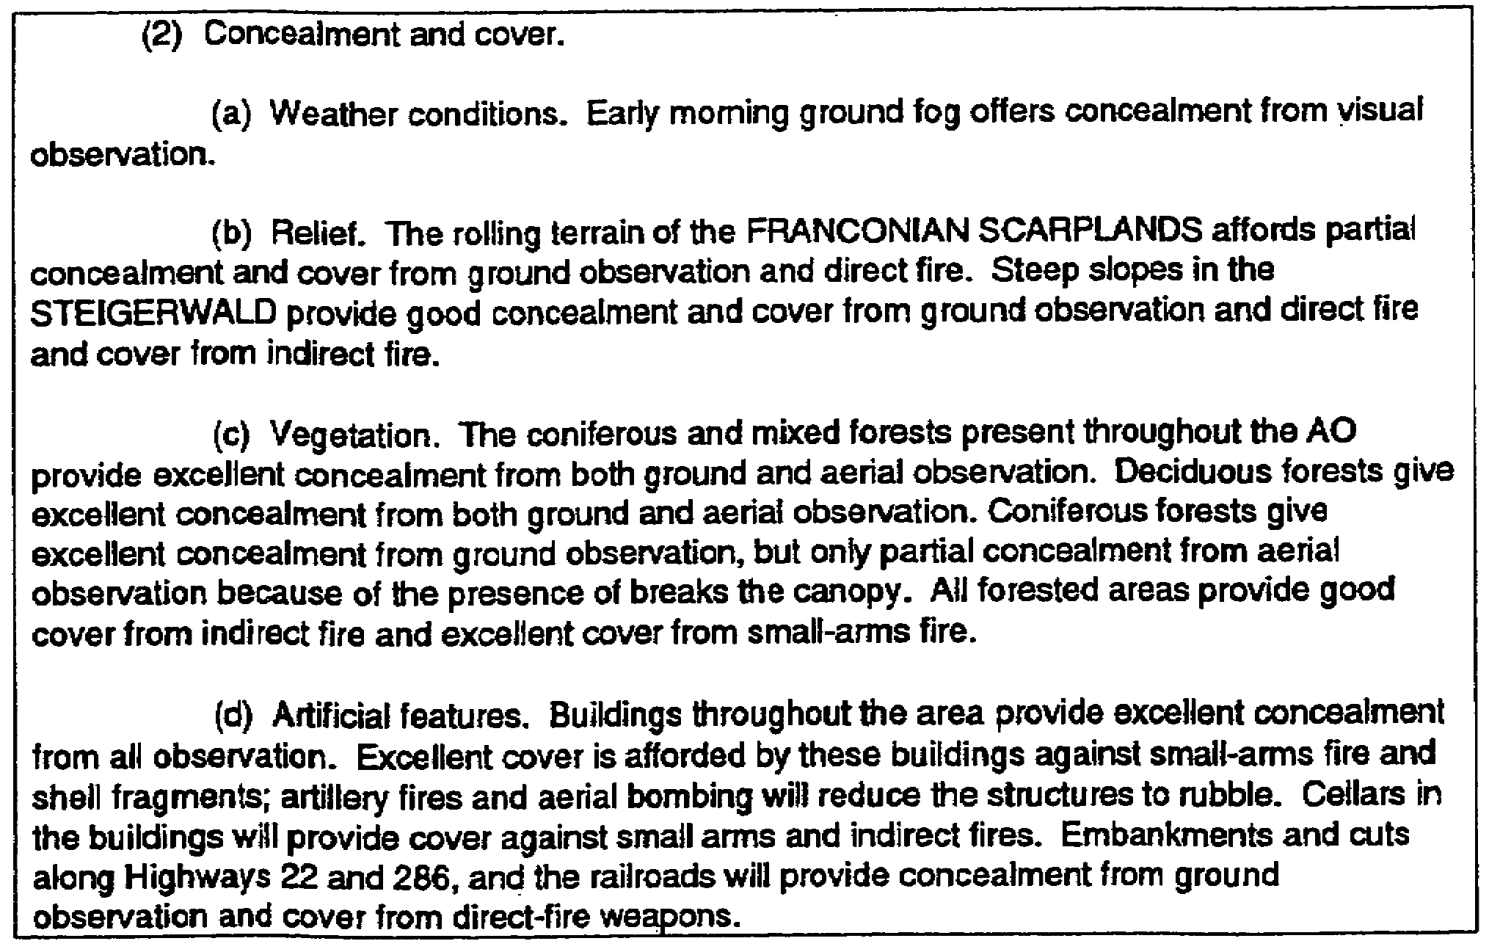

Figure 3-11. Example paragraph 3a(2).

IT0566 3-32
LESSON 4

EFFECTS OF CHARACTERISTICS OF THE AREA AND ANALYSIS ENDING DATA

CRITICAL TASKS: 301-336-1100
301-372-2050
301-372-3050

OVERVIEW

LESSON DESCRIPTION:

In this lesson you will learn to prepare paragraph 4 (effects of characteristics of the area) of the
analysis of the battlefield area and the analysis ending data.

TERMINAL LEARNING OBJECTIVE:

TASKS: Prepare paragraph 4 of the analysis of the battlefield area and analysis ending data

CONDITION: You will be given access to extracts from FM 34-3, FM 34-130, and FM 101-5.

STANDARD: Preparation of paragraph 4 of the analysis of the battlefield area and analysis ending data will be in accordance with FM 34-3, FM 34-130, and FM 101-5.

REFERENCES: The material contained in this lesson was derived from the following publications:

FM 34-3.
FM 34-130.
FM 101-5.

INTRODUCTION

After completing the heading and paragraphs 1, 2, and 3, you should prepare paragraph 4, effects of characteristics of the area, in the analysis of the battlefield area. Many important decisions made by the commander and his staff will depend on the reliability of the information contained in paragraph 4. Therefore, it is essential sound conclusions be drawn from factual data.

PART A: EFFECTS OF CHARACTERISTICS OF THE AREA

1. Paragraph 4 is entitled "Effects of Characteristics of the Area." It contains the conclusions developed from the analysis in the previous paragraphs. The conclusions are stated in terms of effects on the general courses of action available to both forces.

4-1 IT0566
2. Paragraph 4a is entitled "Effect on Enemy Courses of Action." List, in turn, each significant possible enemy course of action such as-

- Defense.

- Withdrawal.

- Attack.

- Use of enemy air, armor, nuclear fires, chemical and biological agents, and guerrillas.

NOTE: Accompany each listed course of action (using separate subparagraphs) with a discussion to indicate the characteristics of the area favoring the courses of action. For attack courses, show the best AA for the enemy. For defense courses of action, show the best defensible areas and the best AA leading to these areas (Figure 4-1).

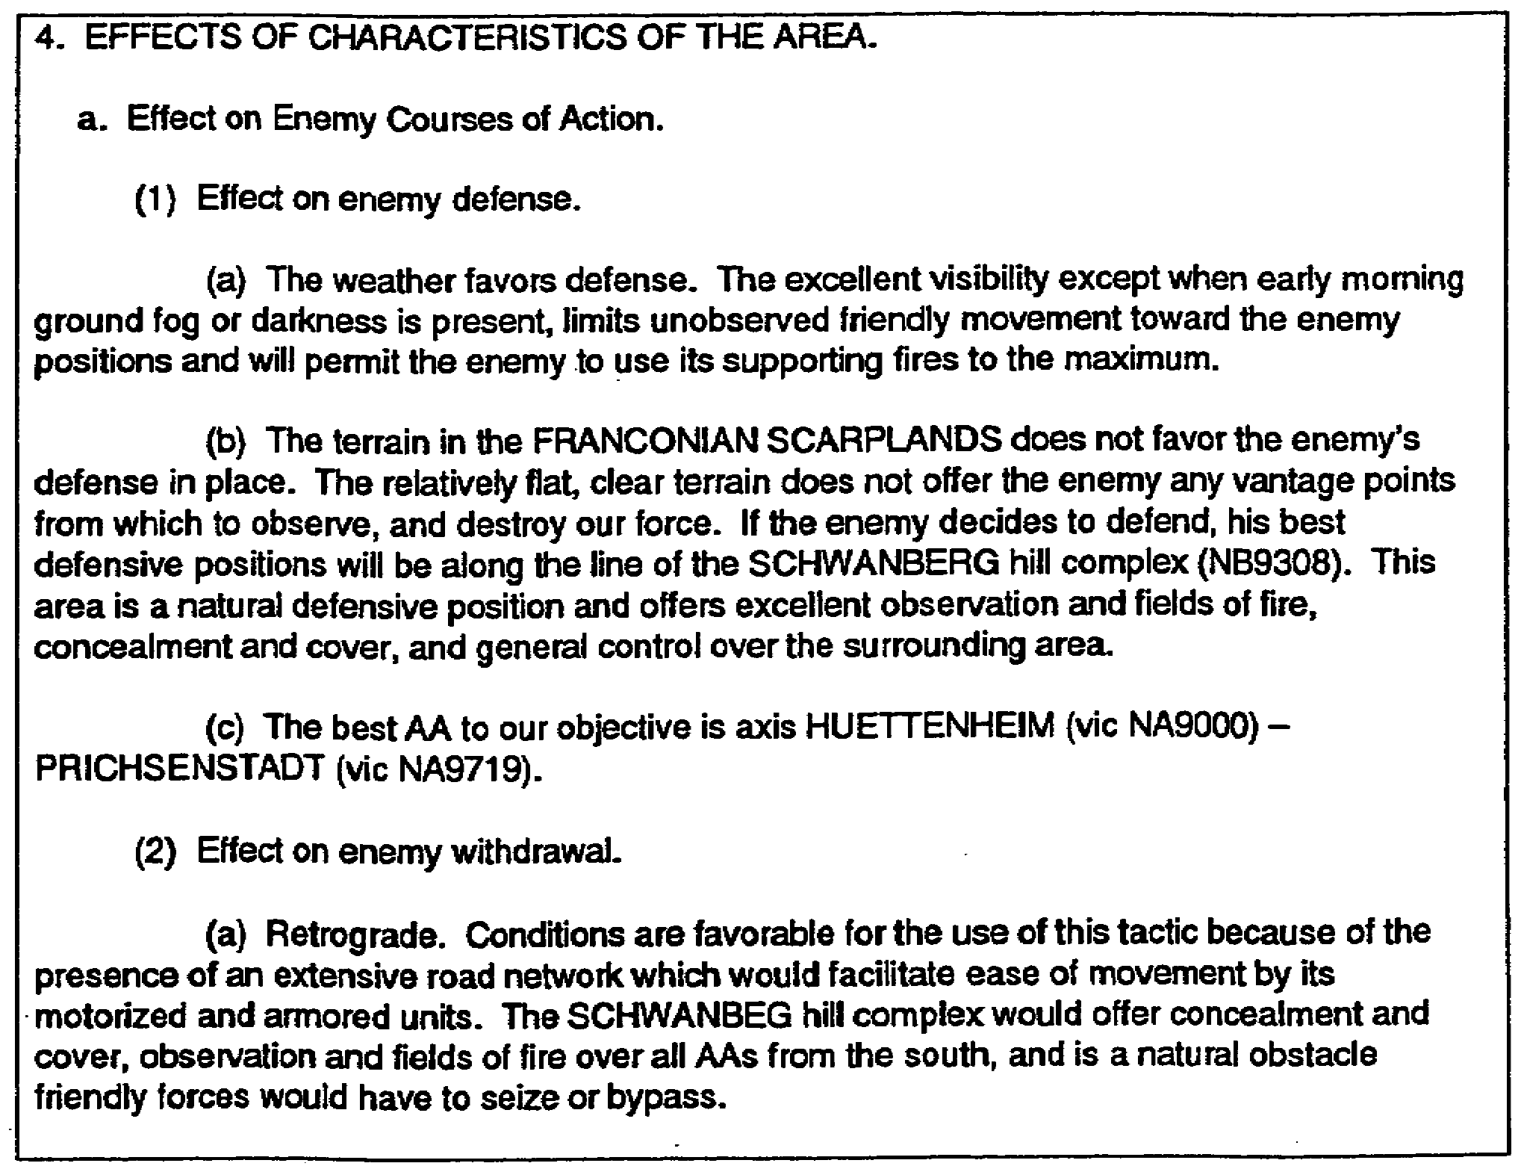

Figure 4-1. Example of paragraph 4a.

IT0566 4-2
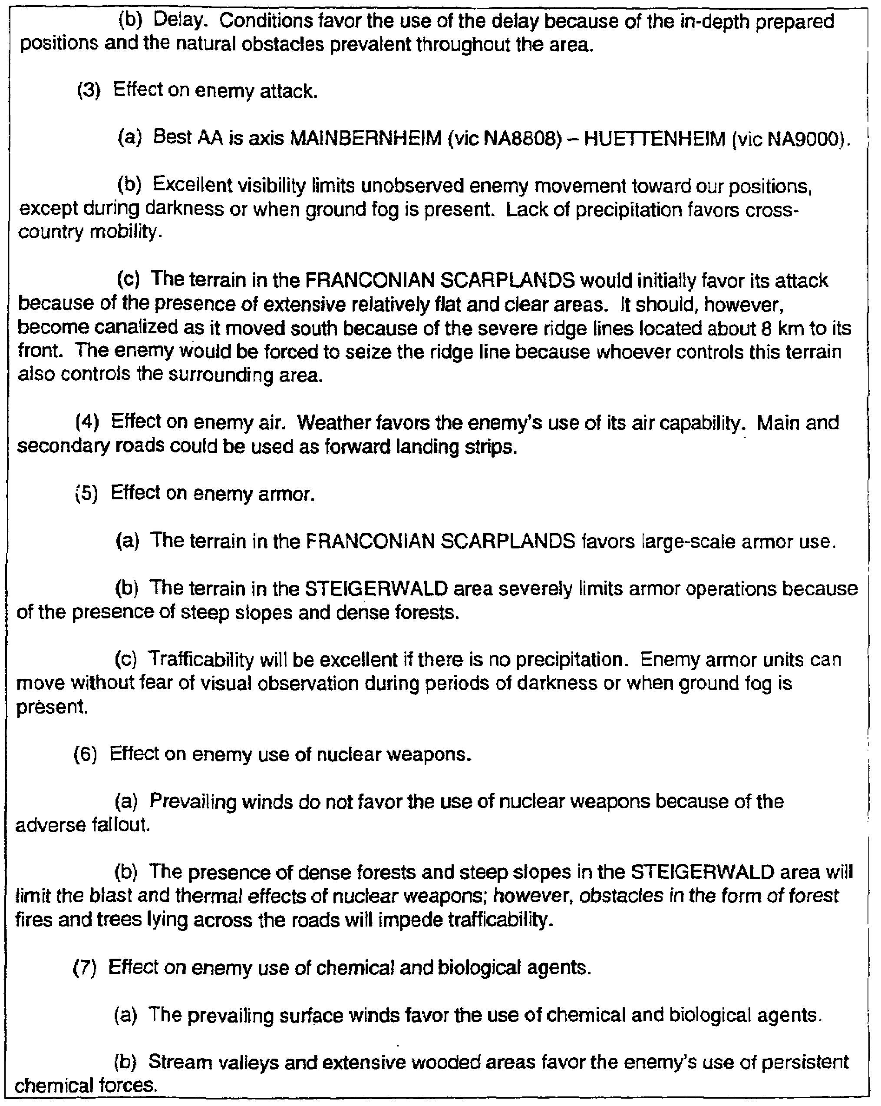

Figure 4-1. Example of paragraph 4a (continued).

4-3 IT0566
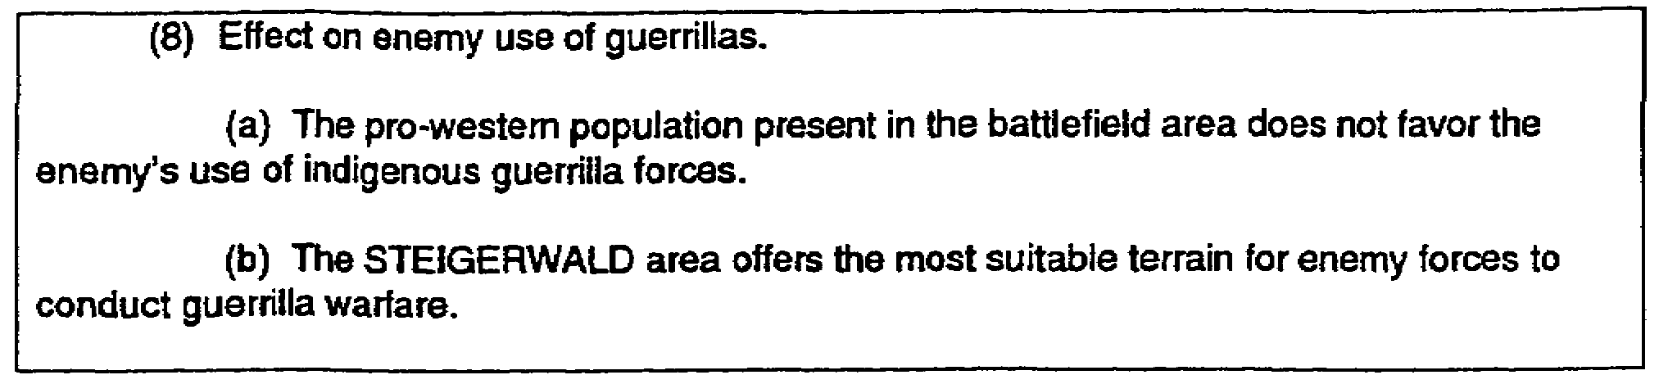

Figure 4-1. Example of paragraph 4a (concluded).

3. Paragraph 4b is entitled "Effect on Own Courses of Action." Discuss those broad courses of action that will accomplish or facilitate the accomplishment of the stated mission of your command or unit. The mission will be to attack, defend, or withdraw. You will also include in the discussion the use of friendly air, armor, nuclear fires, chemical and biological agents, and irregular forces.

NOTE: The most significant difference between the discussion of the enemy's courses of action and the friendly courses of action is you discuss all the courses of action available to the enemy while you only present the course of action dictated by the mission statement for friendly forces. You do, however, discuss the capabilities of air, armor, NBC, and irregular forces just as you did for the enemy (Figure 4-2).

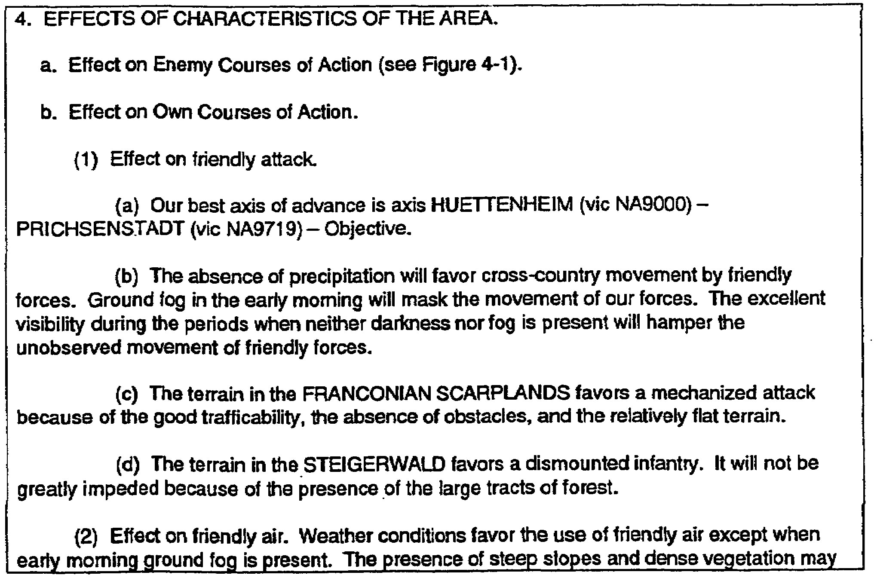

Figure 4-2. Example of paragraph 4b.

IT0566 4-4
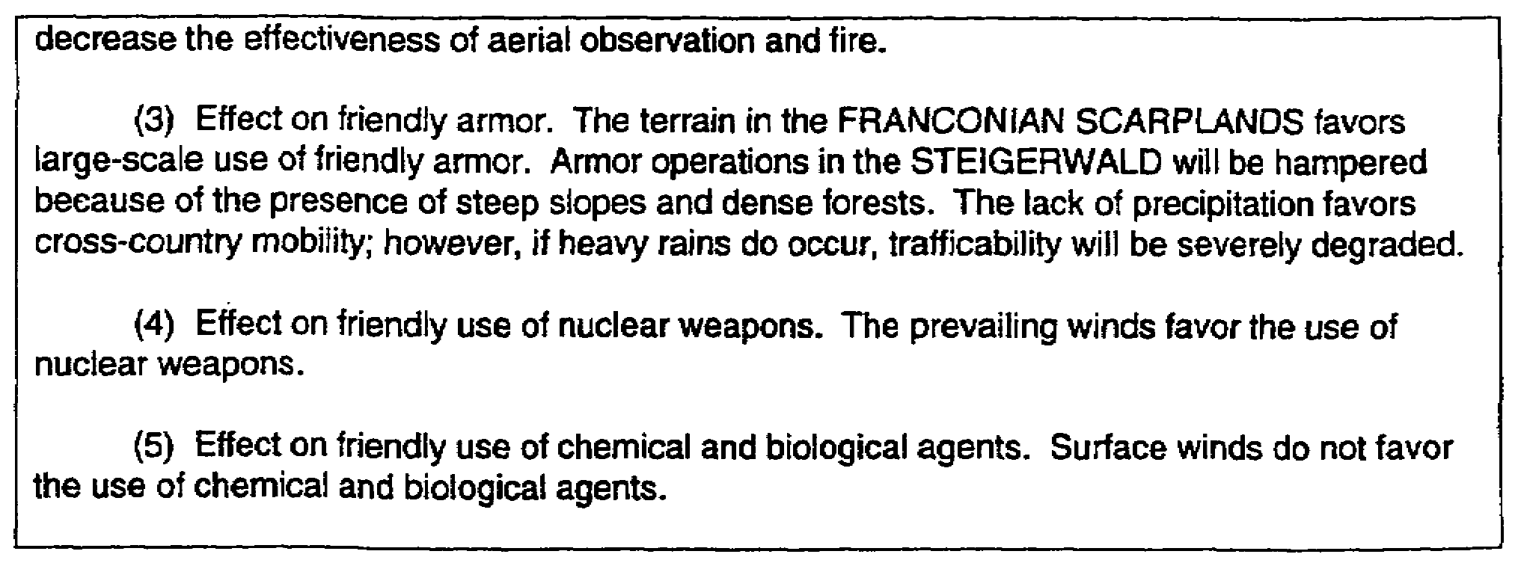

Figure 4-2. Example of paragraph 4b (concluded).

4. Preparation of paragraph 4. At this point, you have seen examples of how paragraphs 4a and 4b are prepared. On the following pages are extracts of paragraphs 2 (Figure 4-3) and 3 (Figure 4-4) developed earlier. Following these extracts, you will find paragraph 4 prepared using this information (Figure 4-5).

a. Extract -Paragraph 2 (Figure 4-3).

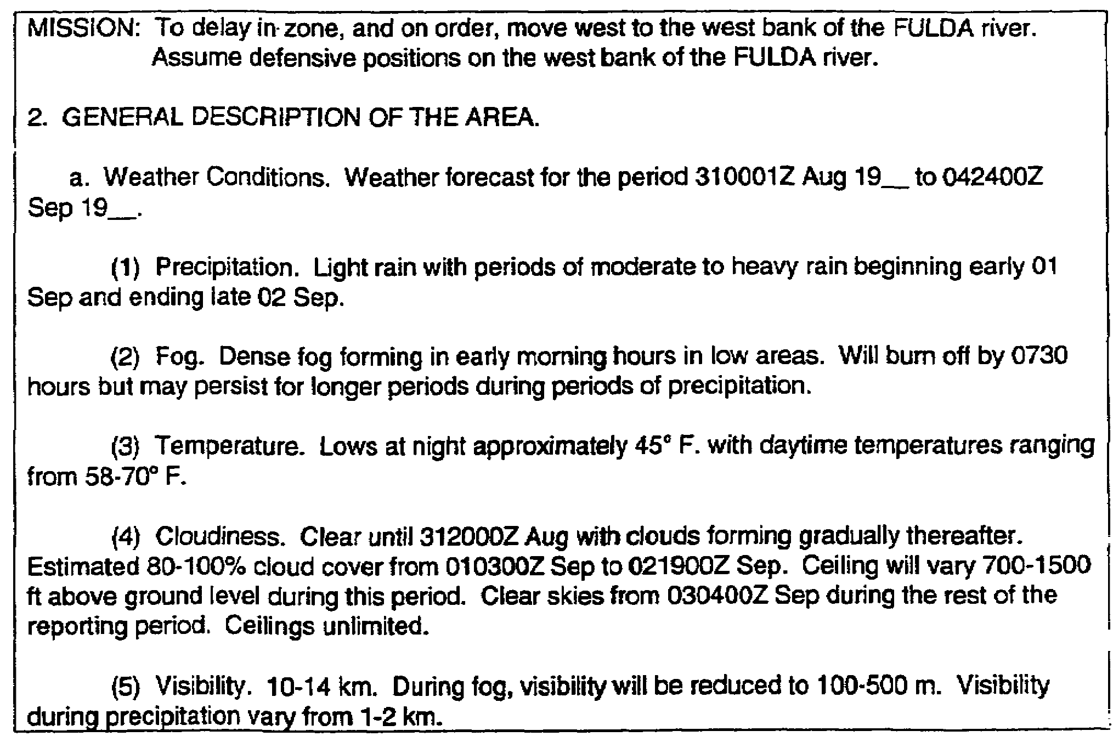

Figure 4-3. Extract -paragraph 2.

4-5 IT0566
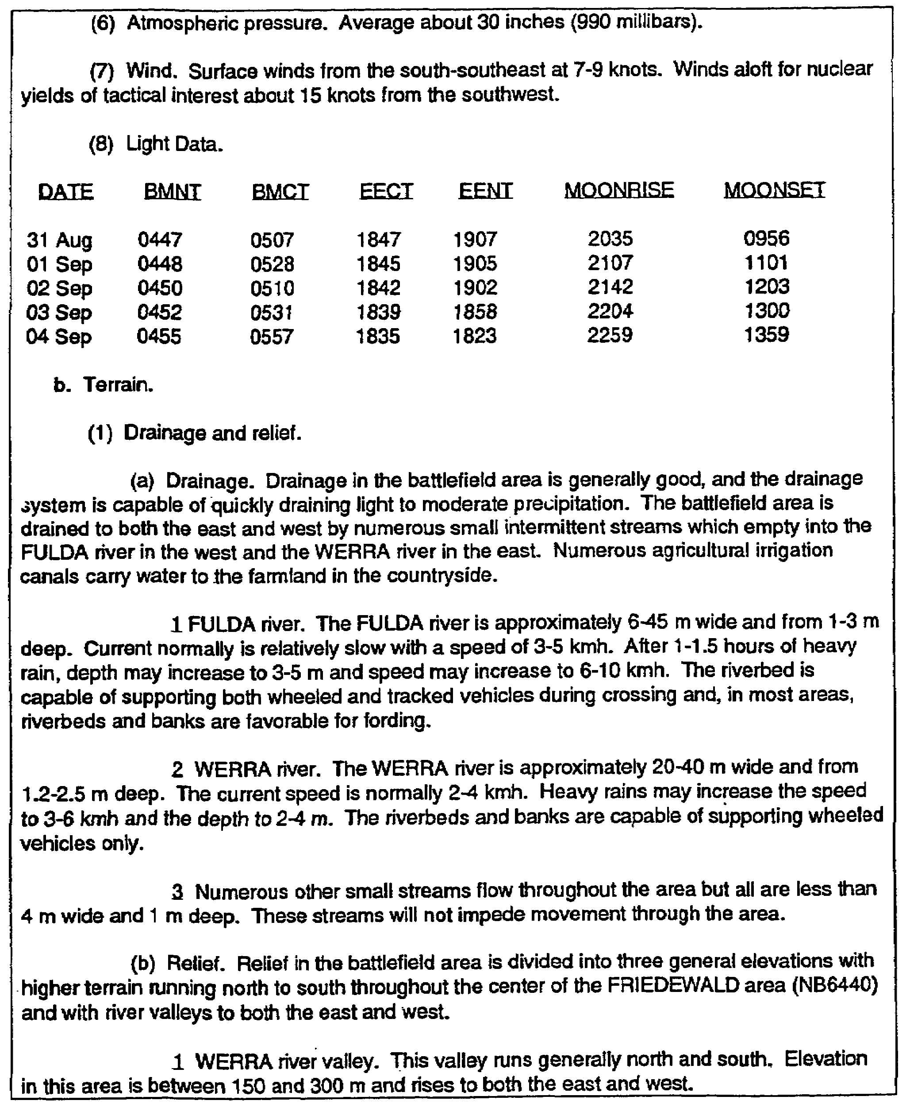

Figure 4-3. Extract ─ paragraph 2 (continued).

IT0566 4-6
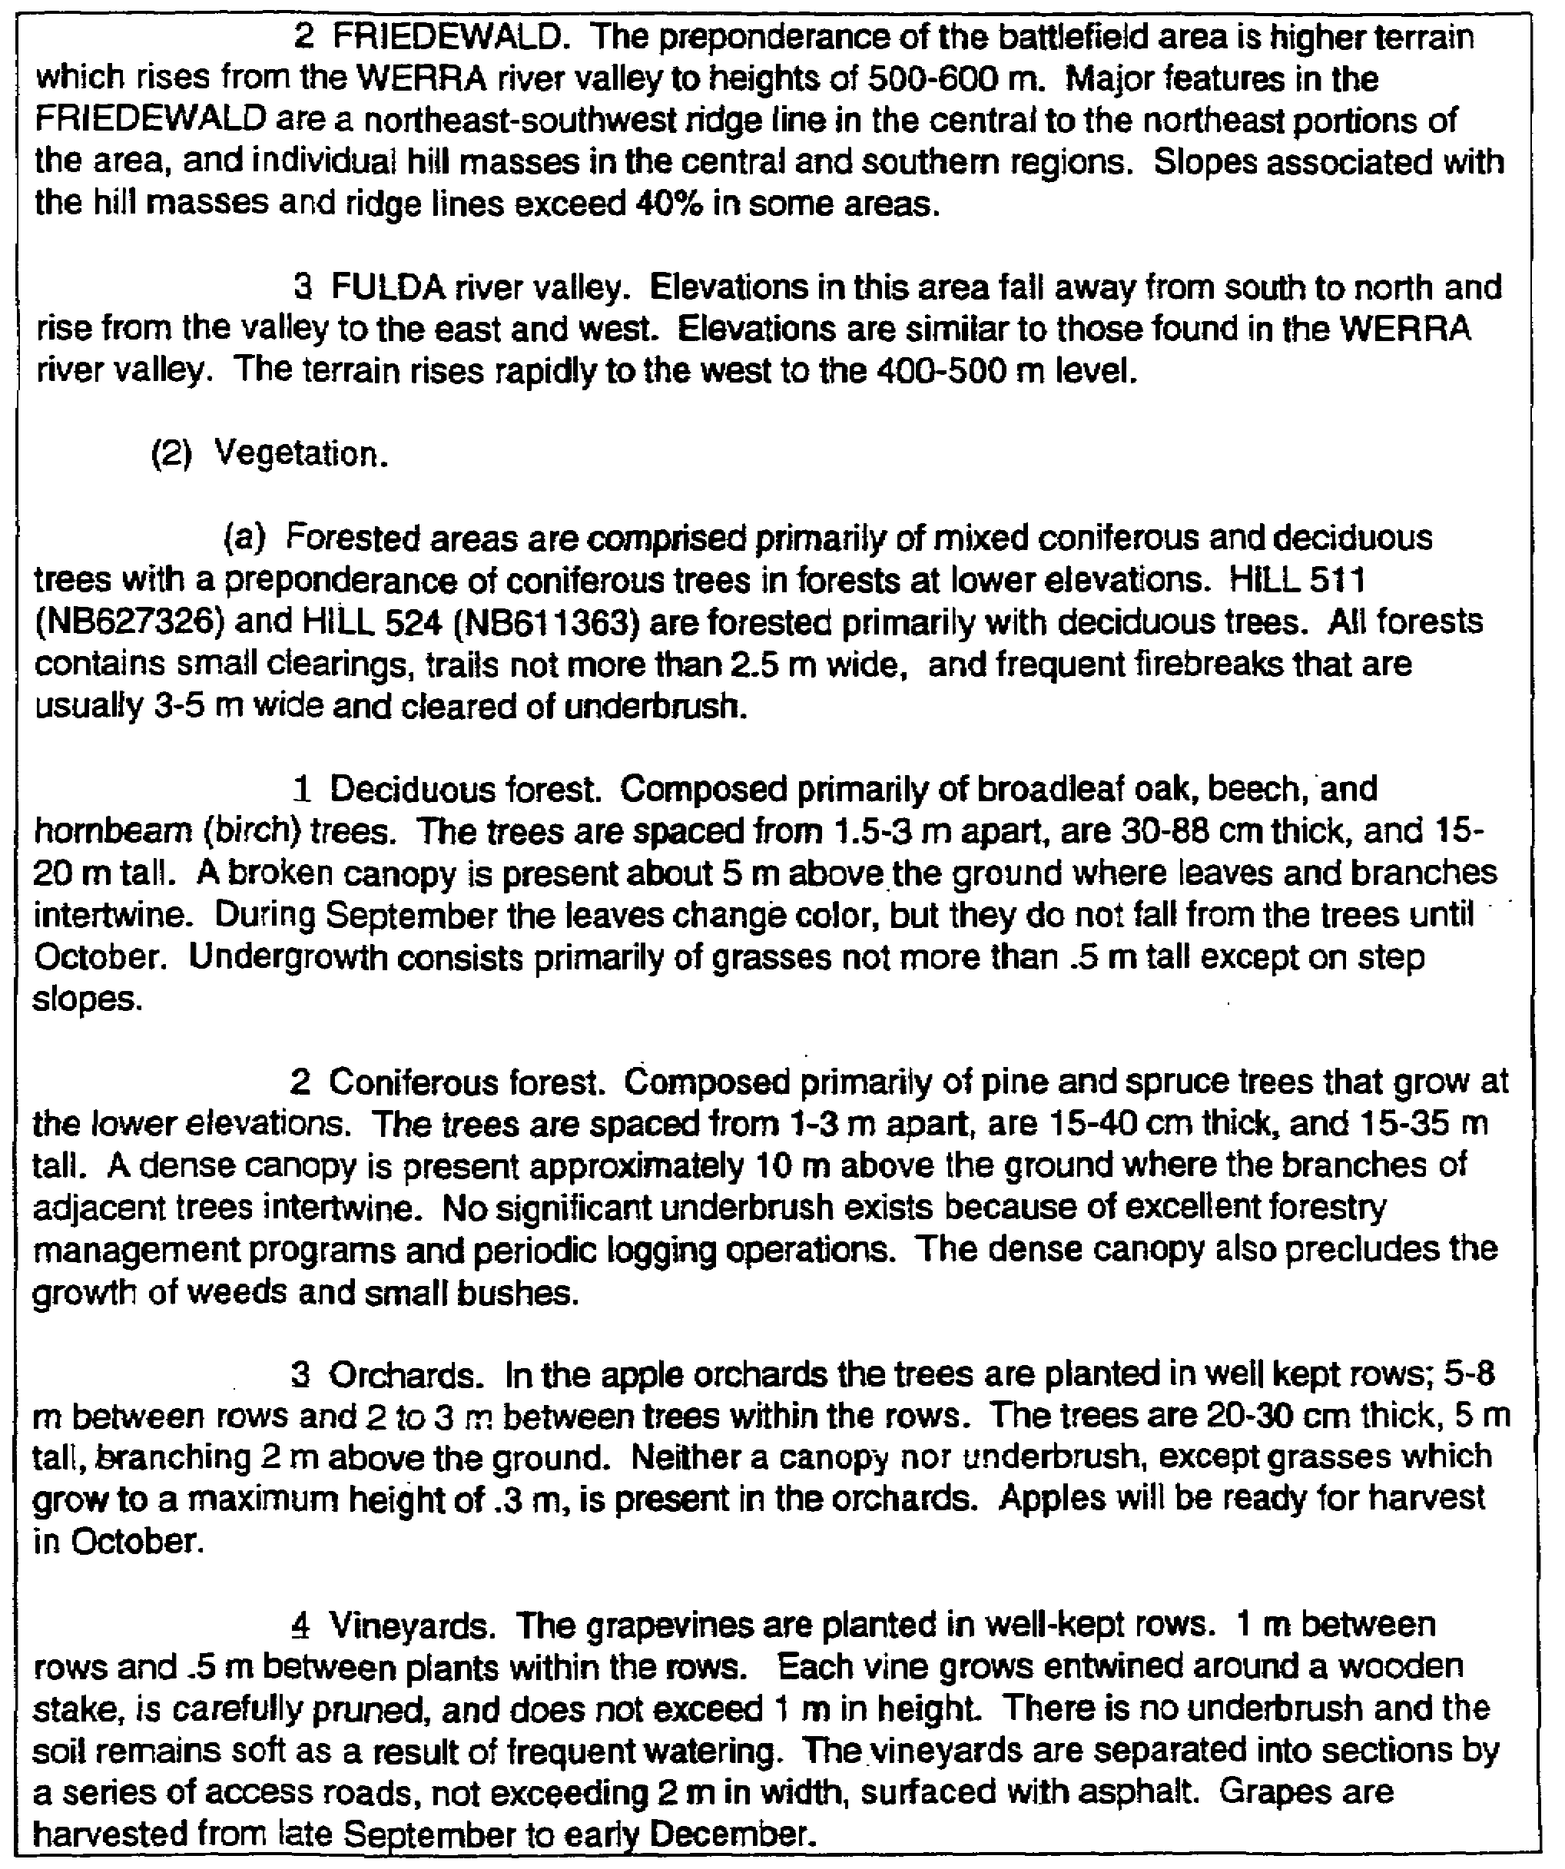

Figure 4-3. Extract ─ paragraph 2 (continued).

4-7 IT0566
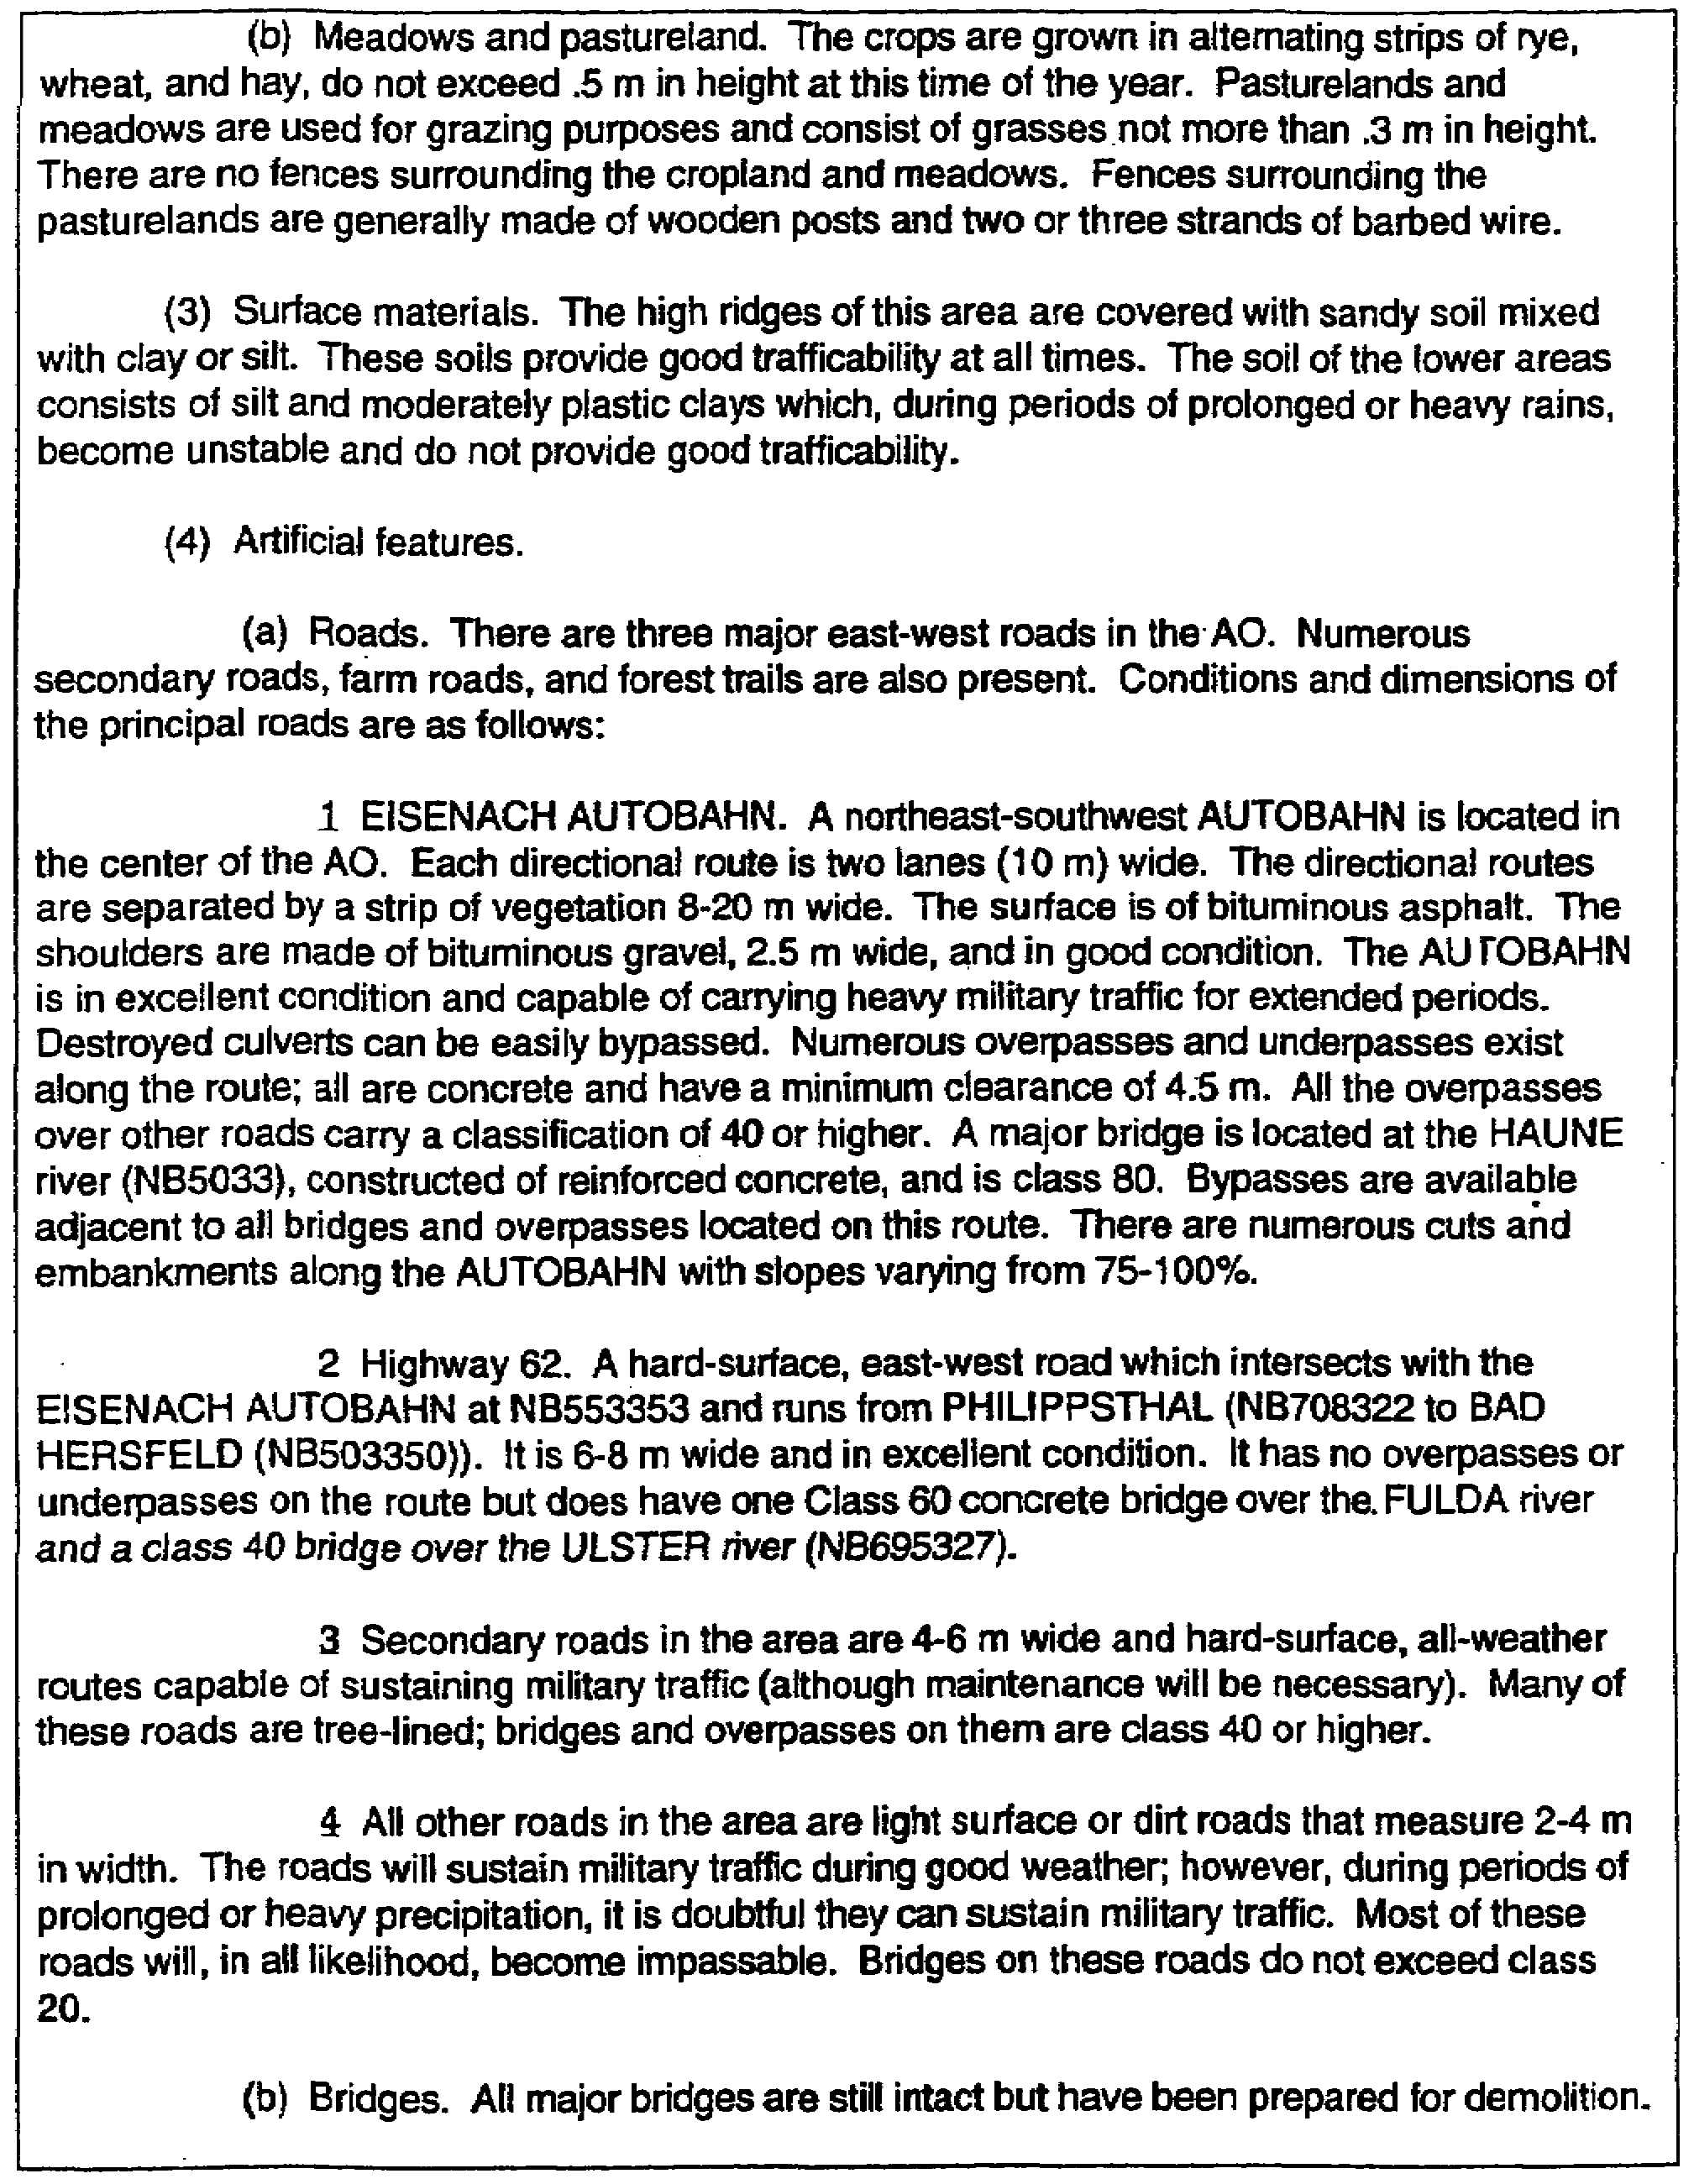

Figure 4-3. Extract ─ paragraph 2 (continued).

IT0566 4-8
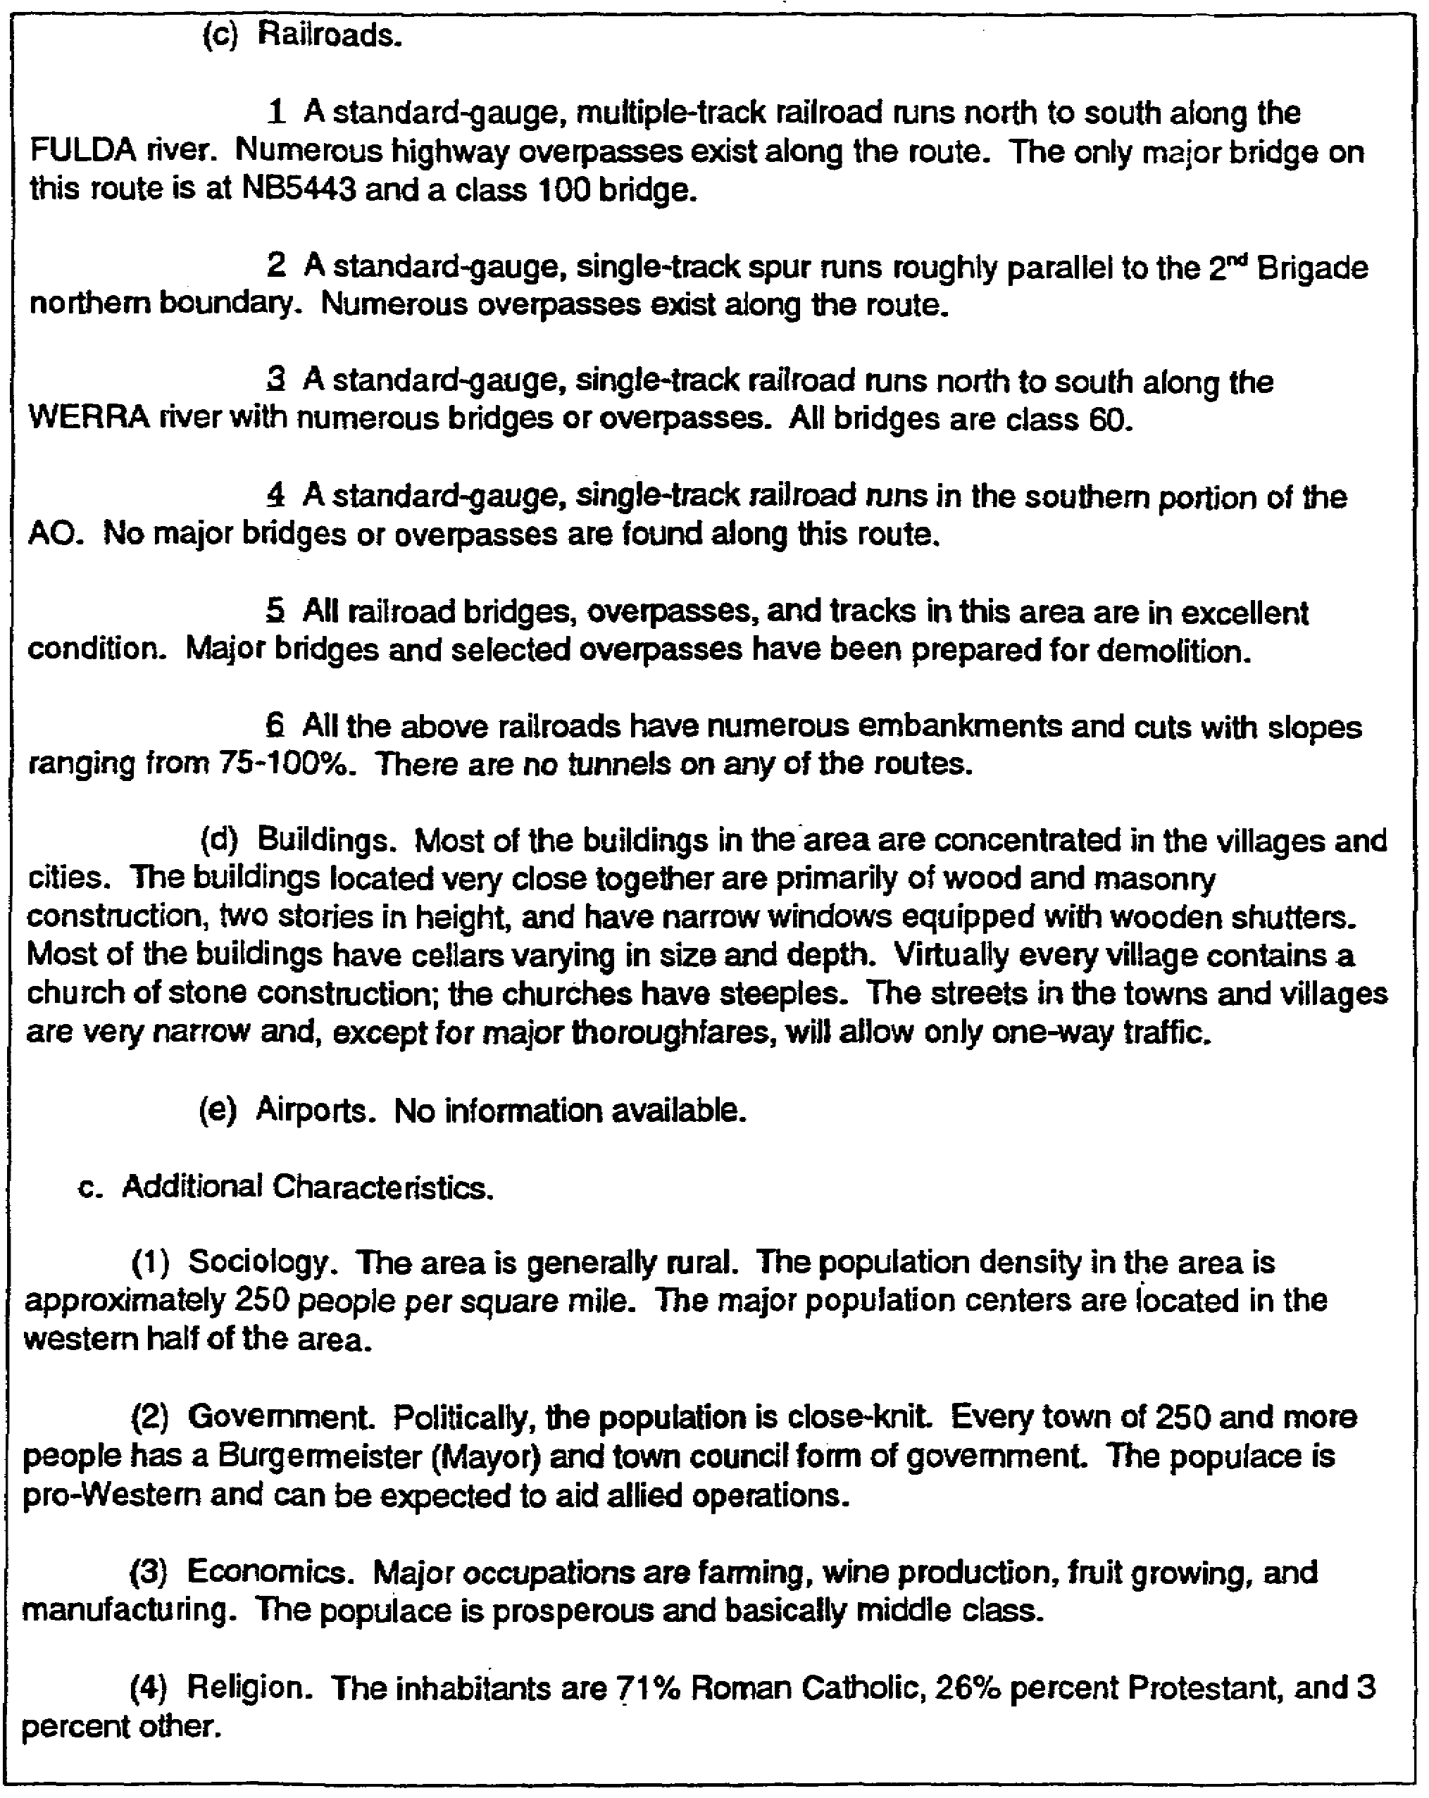

Figure 4-3. Extract ─ paragraph 2 (concluded).

4-9 IT0566
b. Extract ─ Paragraph 3 (Figure 4-4).

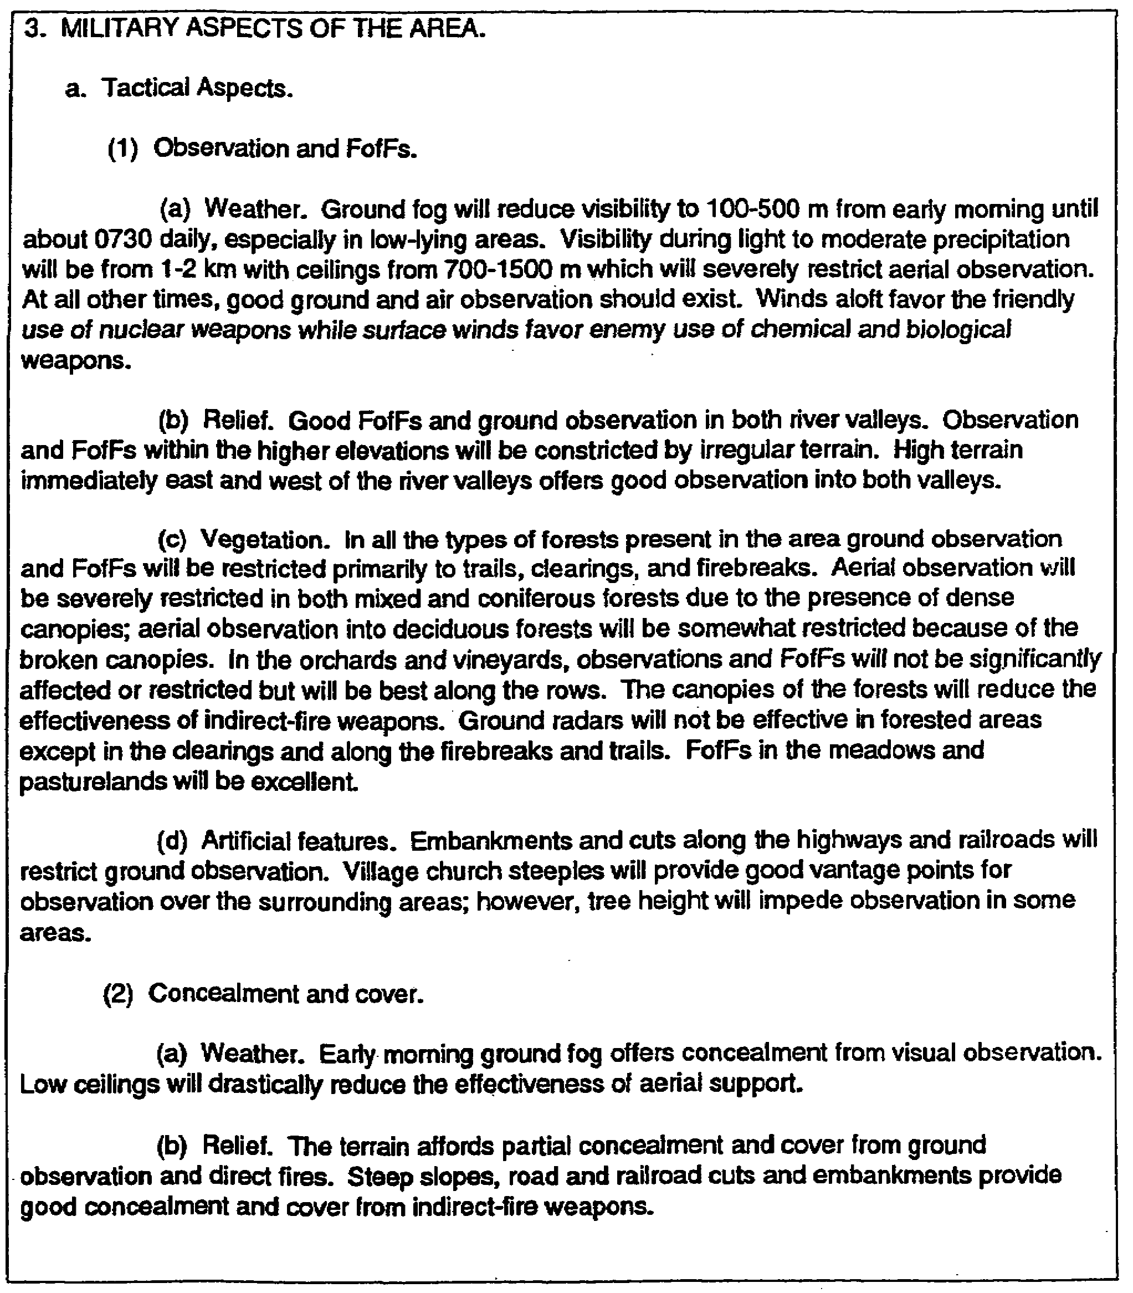

Figure 4-4.. Extract ─ Paragraph 3.

IT0566 4-10
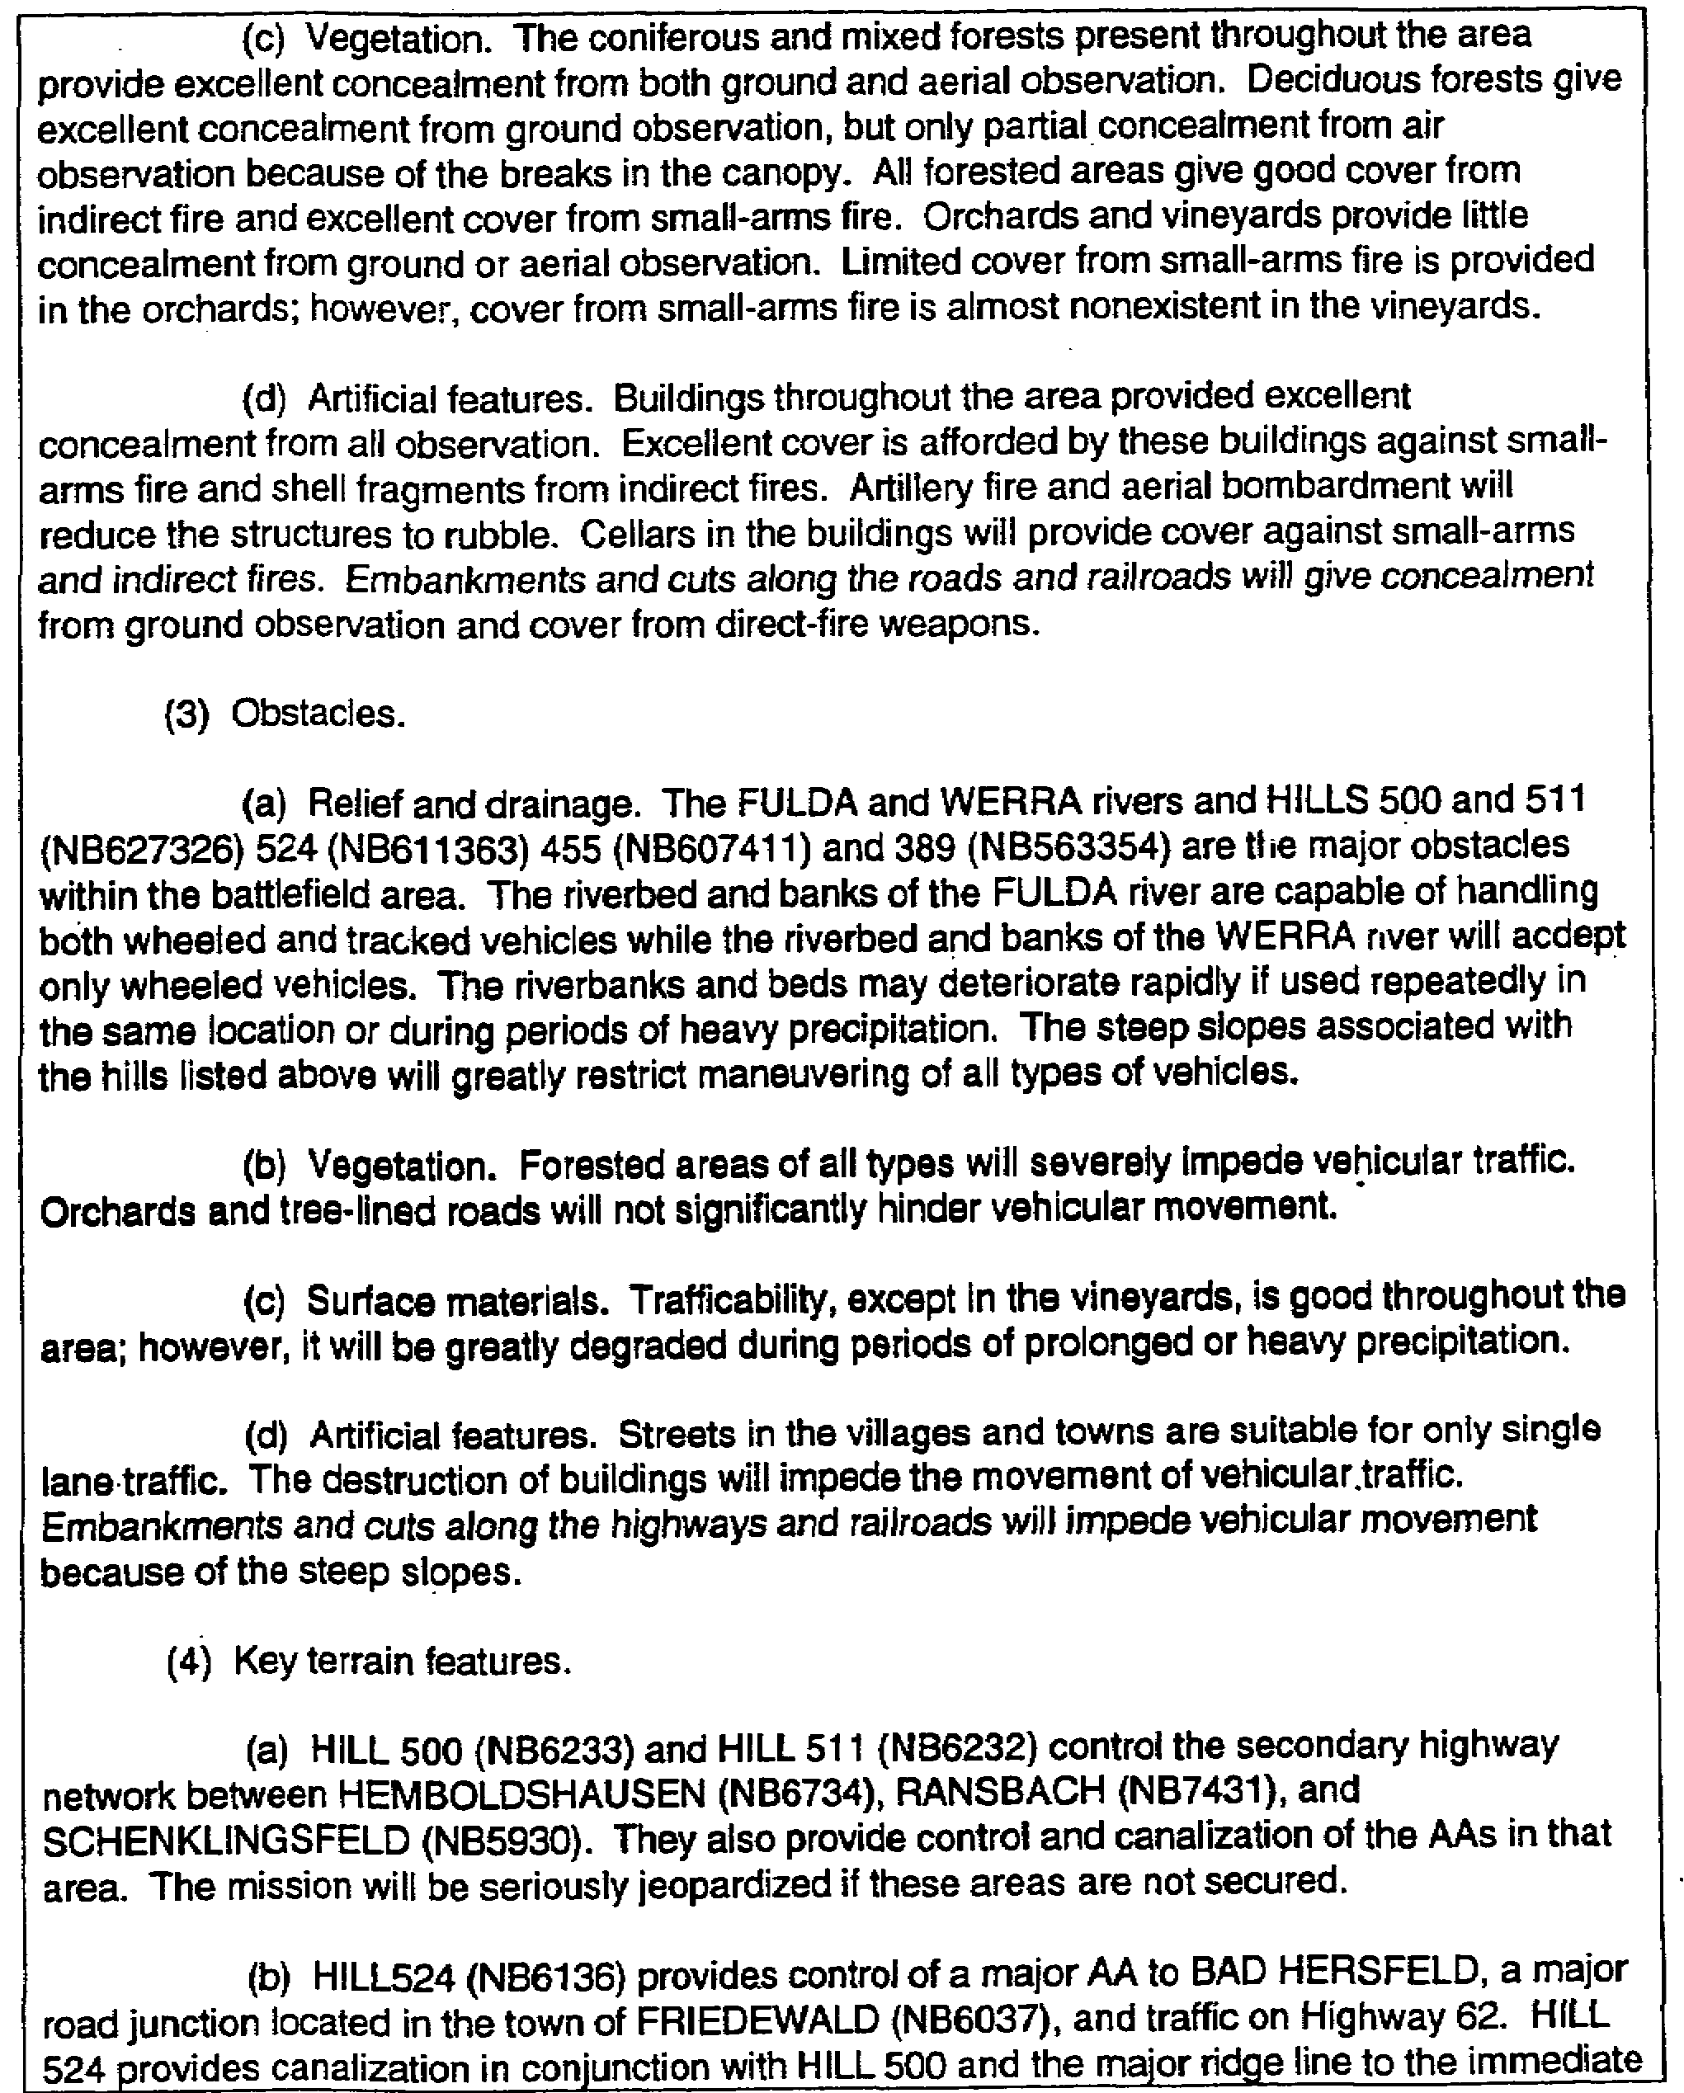

Figure 4-4. Extract ─ Paragraph 3 (continued).

4-11 IT0566
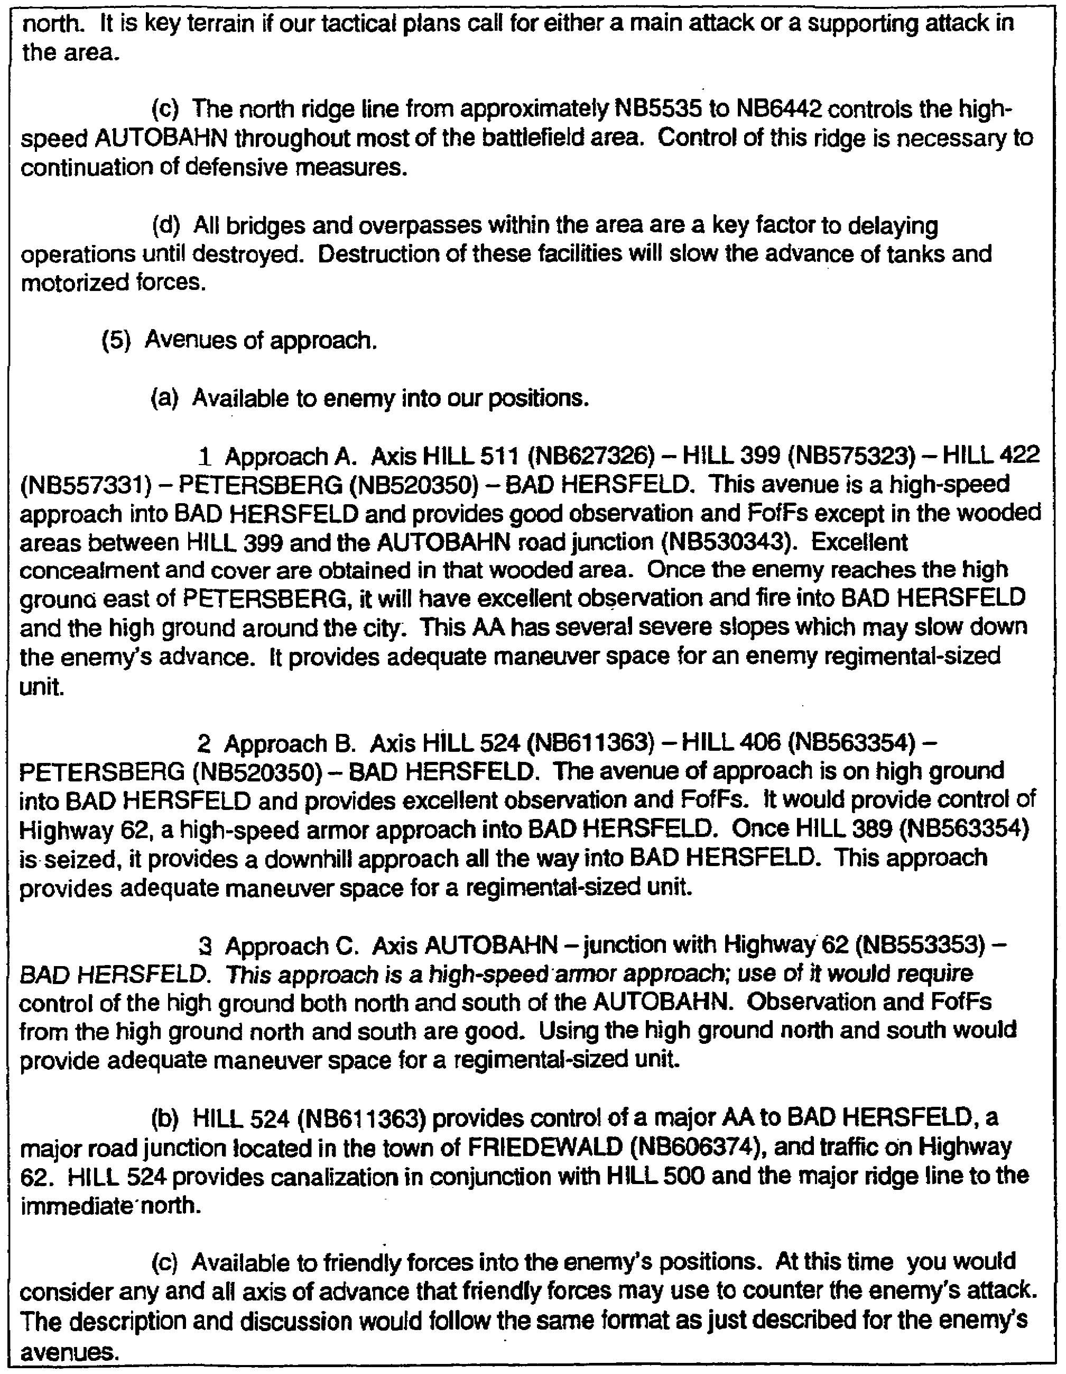

Figure 4-4. Extract ─ Paragraph 3 (continued).

IT0566 4-12
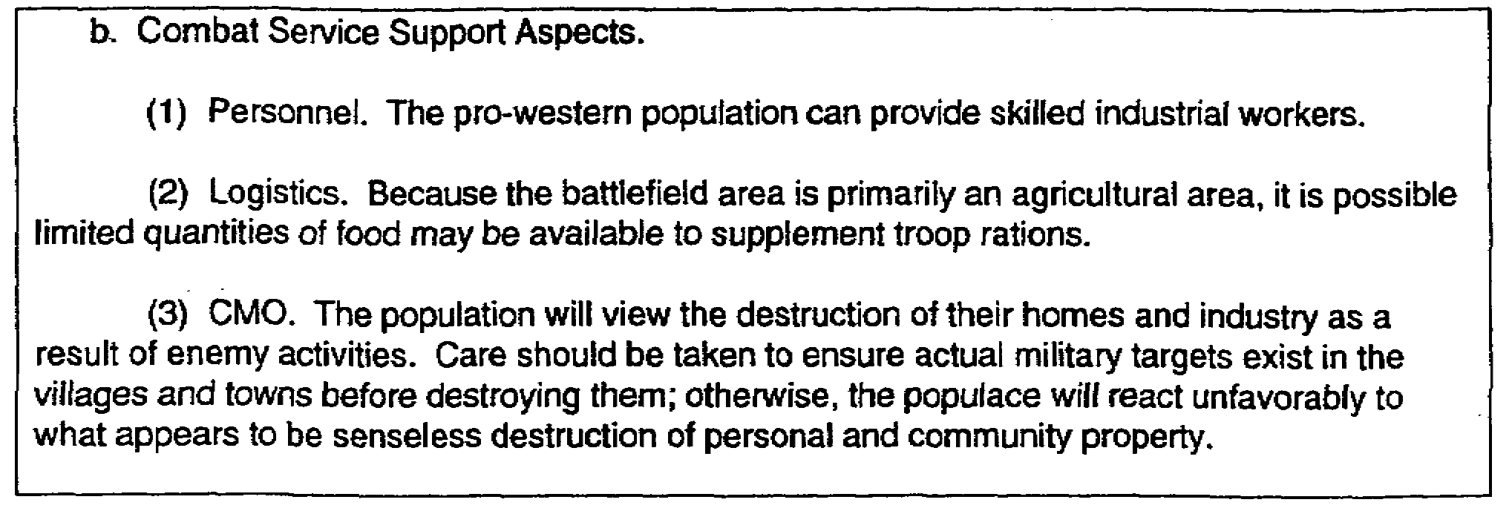

Figure 4-4. Extract ─ Paragraph 3 (concluded).

c. Paragraph 4 (Figure 4-5) is shown based on paragraph 2 (Figure 4-3) and paragraph 3 (Figure 4-4).

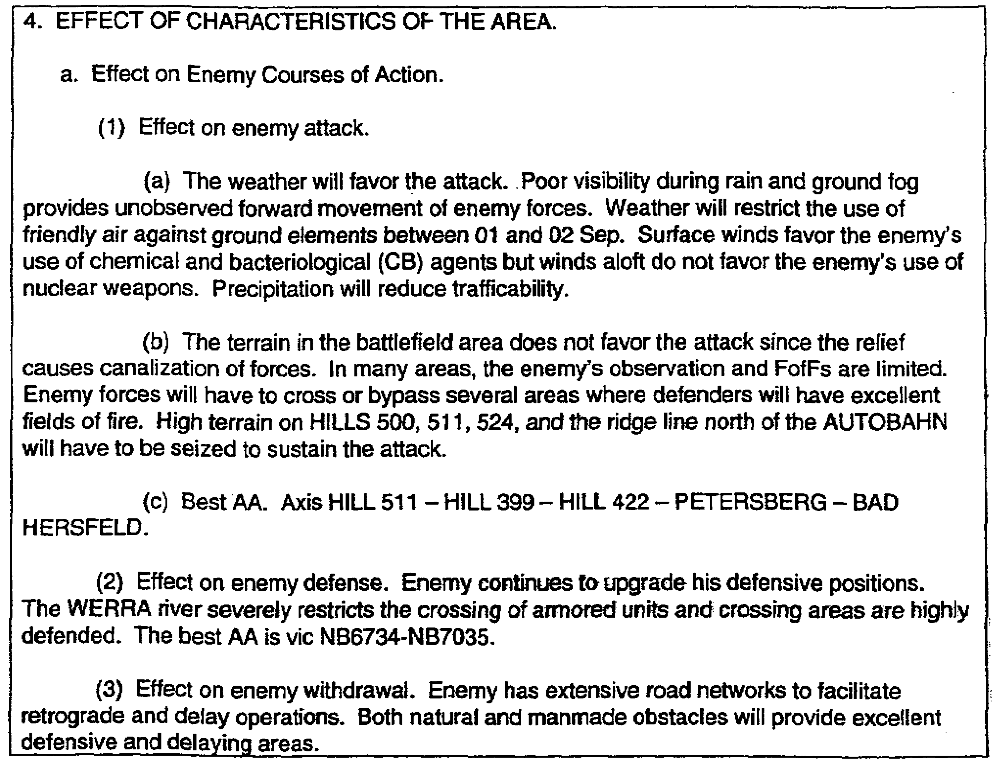

Figure 4-5. Prepared paragraph 4.

4-13 IT0566
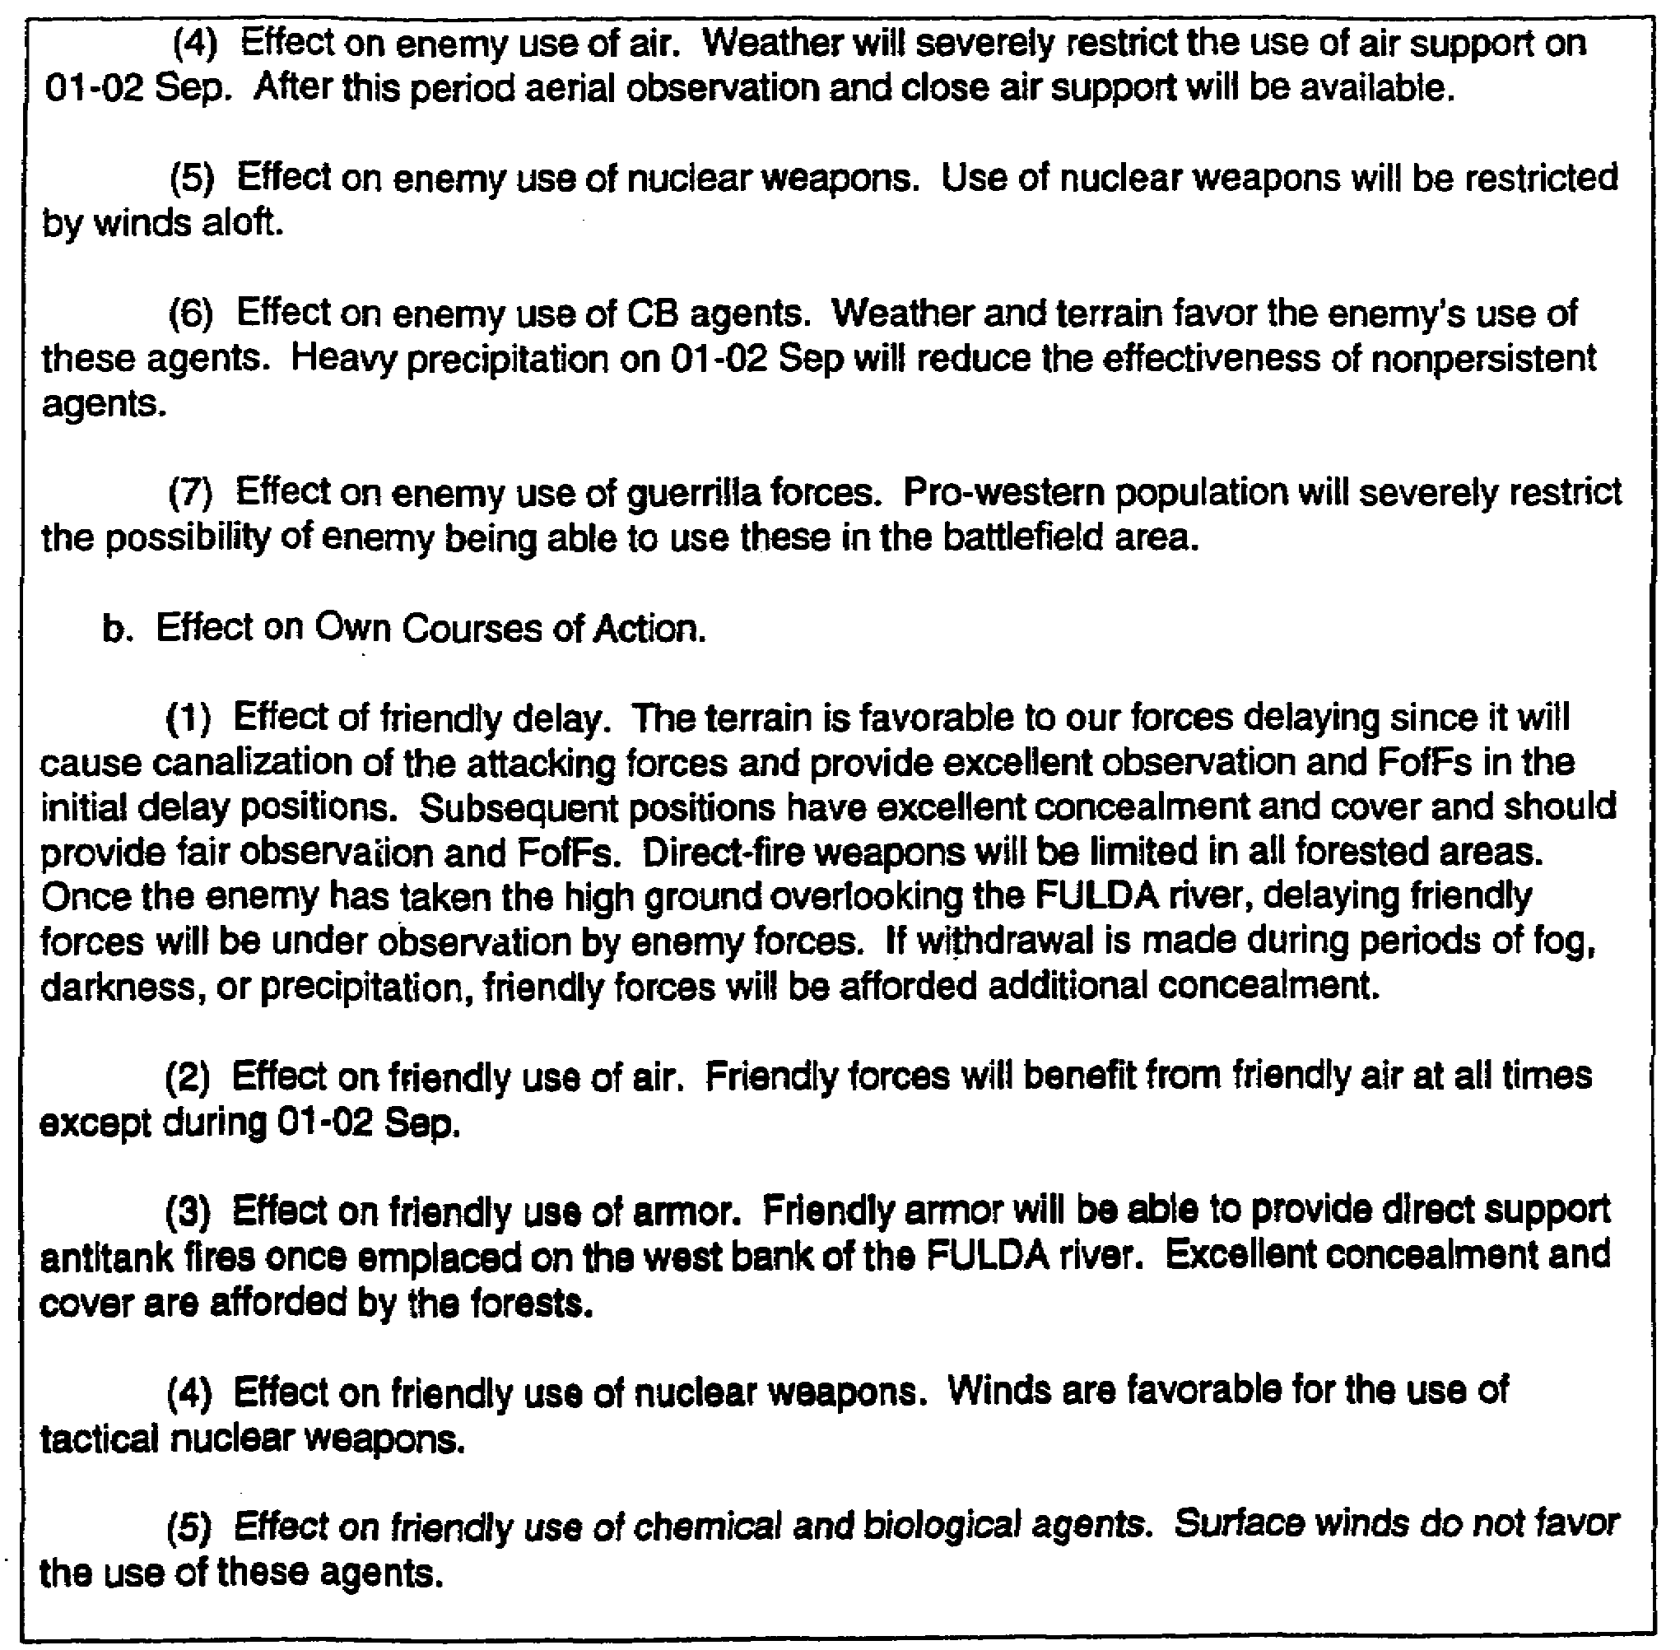

Figure 4-5. Prepared paragraph 4 (concluded).

d. As you can see from the foregoing, many possibilities are available for you to exercise your abilities in preparing paragraph 4. What is critical in this paragraph is that you discuss all the courses of action available to the enemy to include air, armor, nuclear fires, bacteriological and chemical agents, and guerrillas.

e. In the presentation of the own courses of action, the mission statement will determine what is presented. However, you must still present information on friendly air, armor, nuclear fires, bacteriological and chemical agents, and irregular forces, just as you must do for the enemy.

IT0566 4-14
PART B: ANALYSIS ENDING DATA

1. Acknowledgement instructions are included if distributed outside the headquarters. Normally, the word "Acknowledge" is sufficient.

2. The signature block contains the name and rank of the commander and appears on all copies of the analysis if distributed outside the headquarters. If not distributed outside the headquarters, it is signed by the G2/S2.

3. Authentication by the G2/S2 is required only if the analysis has not been signed by the commander and is to be distributed outside the headquarters.

4. Annexes are listed by letter and title.

5. Distribution instructions may refer to a standard distribution list.

6. Classification must be placed at the top and bottom center of both the front and back pages, in large than any other lettering (Figure 4-6).

4-15 IT0566
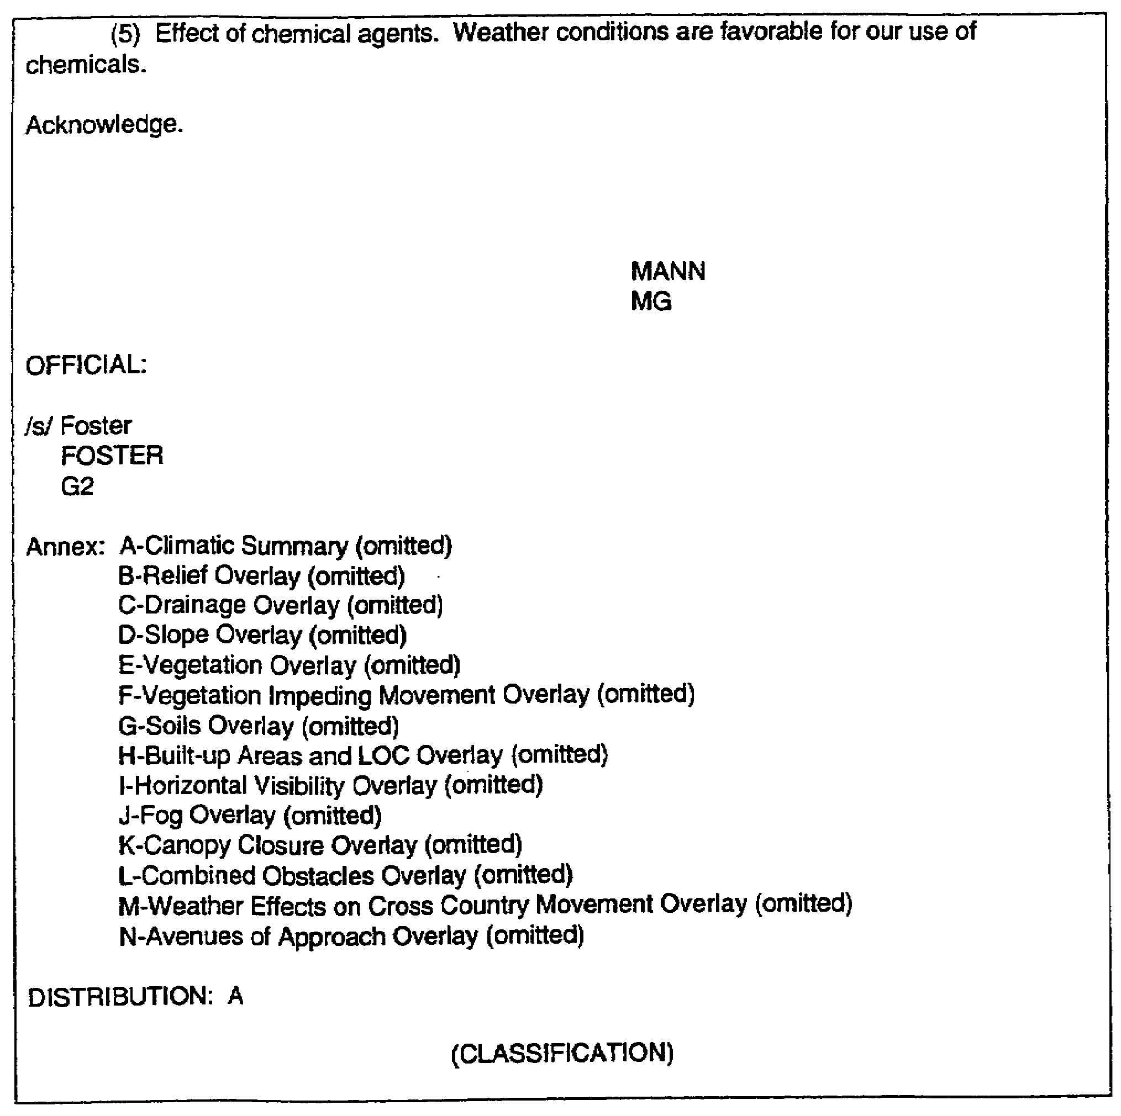

Figure 4-6. Analysis ending data.

IT0566 4-16
LESSON 4

PRACTICE EXERCISE

The following items will test your grasp of the material covered in this lesson. There is only one correct answer for each item. When you have completed the exercise, check your answers with the answer key that follows. If you answer any item incorrectly, study again that part of the lesson which contains the portion involved.

1. What should you list in the analysis for any enemy attack course of action?

A. Enemy MC.

B. Axis of advance.

C. Area of analysis.

D. Best AA.

2. What item of information dictates the course of action friendly forces will take when preparing paragraph 4b, Effects on Own Course of Action?

A. Mission statement.

B. Combat service support aspects.

C. Tactical aspects.

D. Enemy courses of action.

3. Who should sign the analysis if it is not distributed outside the headquarters?

A. Commander.

B. G2.

C. G3.

D. G5

4. Which items should you present in the analysis for defensive courses of action?

4-17 IT0566
LESSON 4

PRACTICE EXERCISE

ANSWER KEY AND FEEDBACK

Item Correct Answer and Feedback

1. D. You should always list the best AA in the analysis for any enemy attack course of action (page 4-2, note).

2. A. The mission statement dictates the course of action friendly forces must take when preparing paragraph 4b (page 4-4, para 3).

3. B. The G2 should sign the analysis if not distributed outside the headquarters (page 4-15, para 3).

4. You should present the best defensible areas and the best AAs leading to these areas (page 4-2, note).

IT0566 4-18

